

Modern University for Technology & Information
Faculty of Computers & Artificial Intelligence
Department of Computer Science
AI-Powered Intrusion Detection & Prevention System (IDS-IPS)
Submitted by:
Farah Hany Abd El-Azeem
Basmala Ayman Abd El-Haleem
Mai Mahmoud Mohammed
Joud Mohamed Emad
Mostafa Shaaban Mohamed
Nancy Emad Hefny
Mohamed Atia Mansour
Ahmed Tarek Hamed

Supervised by:
Dr. Tarek Soliman
T.A. Gerges Mourad
T.A. Abdullah El-Khateb

Acknowledgment

All praise is due to Allah, who has guided us to this path; for we would certainly not have found it unless Allah had guided us.
We would like to express our sincere gratitude to Modern University for Technology and Information (M.T.I.) for providing us with a supportive learning environment and for encouraging innovation and research throughout our academic journey.
Our deepest appreciation goes to our project supervisors — Dr. Tarek Soliman Ibrahim, T.A. Gerges Murad, and T.A. Abdullah El-Khateeb — for their continuous guidance, valuable feedback, and dedicated efforts that were instrumental in the successful completion of our graduation project, “AI-Powered Intrusion Detection and Prevention System (IDS-IPS)”.
We also extend heartfelt thanks to our families for their constant support, patience, and encouragement, which have been the foundation of our success.
Special thanks are due to the leadership and faculty of MTI University, especially Prof. Dr. Olfat Kamel, Prof. Dr. Mohamed Taher El-Mayah, and Dr. Mohamed El Gazzar, for their vision and support, and to all professors and assistant lecturers of the Faculty of Computers & Artificial Intelligence for their invaluable guidance and inspiration.
Finally, we express our appreciation to everyone who contributed, directly or
indirectly, to the success of this project

Abstract
This project presents an AI-Powered Intrusion Detection and Prevention System (IDSIPS) designed to strengthen network security through intelligent monitoring, detection, and automatic response mechanisms. The proposed system integrates both Machine Learning (ML) and Deep Learning (DL) models to detect and prevent cyberattacks in real time. By analyzing network traffic and host-level behavior, the system aims to identify known and unknown threats effectively while reducing false alarms and improving detection accuracy.
The system is composed of two major components. The Network-Based IDS/IPS module monitors live network traffic using sniffing tools such as Tshark and Wireshark, extracts relevant features, and applies ML/DL algorithms to classify traffic as normal or malicious. The Host-Based Module observes endpoint activities, including file operations, processes, and system logs, to detect unusual behavior that may indicate local intrusions or malware execution.
Upon detecting a potential threat, the system executes automated prevention actions such as blocking suspicious IP addresses, dropping harmful packets, or isolating infected hosts. The results are then presented through a web-based dashboard that allows administrators to visualize network status, review alerts, and monitor the system’s performance in real time.
The primary goal of this project is to develop a reliable, scalable, and adaptive AI-driven IDS/IPS that can efficiently detect a wide range of cyber threats while minimizing false positives and operational overhead. The system’s performance is evaluated using standard metrics, including Accuracy, Precision, Recall, F1-Score, and ROC-AUC, confirming its robustness and effectiveness in maintaining network integrity and resilience against modern cyberattacks.

Table of Contents
Chapter 1 Introduction 2
1.1 Overview 2
1.1.1 Intrusion Detection System (IDS) 3
1.1.2 Intrusion Prevention System (IPS) 3
1.2 Types of Cyber Attacks 4
1.2.1 . Denial of Service (DoS) Attack 4
1.2.2 Distributed Denial of Service (DDoS) Attack: 5
1.2.3 SQL Injection Attack: 6
1.2.4 Cross-Site Scripting (XSS) Attack: 7
1.2.5 SSH Brute-Force Attack (Secure Shell): 8
1.2.6 Remote Code Execution (RCE) Attack: 9
1.3 Motivation 13
1.3.1 Statistical Overview of Global Cyber Threats 13
1.3.2 Global Cyber security Incident Report (2025) 15
1.3.2.1 Ransomware Attack (Double Extortion) – Devman Ransomware 15
1.3.2.2 Hybrid Attack (Physical + Cyber) – Kyiv Energy Infrastructure 15
1.3.2.3 Ransomware Attack (Double Extortion) – NightSpire 16
1.3.2.4 Advanced Persistent Threat (APT) – AI-Driven Cyber Espionage 17
1.4 Problem Definition 18
1.5 Challenges 18
1.6 Objectives 19
Chapter 2 : Similar Systems & Related Work 21
2.1 Introduction 21
2.2 SNORT 21
2.2.1 Custom Rules: 21
2.2.2 Architecture of Snort : 22
2.3 SURICATA: 23
2.3.1 How does it work? 23
2.3.2 False Positives vs. False Negatives 23
2.3.3 Advantages of Suricata over Snort 24
2.3.4 Architecture of Suricata: 24
2.4 OSSEC 25
2.4.1 Main Functions: 25
2.4.2 Architecture of OSSEC 25
2.5 ZEEK 26
2.5.1 Architecture of Zeek: 26
2.6 Related Work 27
Chapter 3 System Analysis and Design 38
3.1 Introduction 38
3.2 Tasks Management 38
3.3 Team Members 38
3.4 Task Duration 39
3.5 Diagrams 40
3.5.1 Gantt chart 40
3.5.2 Network Diagram 41
3.6 Use Case Diagram 43
3.7 Flowchart 44
3.8 Architecture Design 45
3.9 Network Security System Flow Architecture 45
Chapter 4 Literature Review 48
4.1 Introduction 48
4.2 What does sniffer mean? 48
4.3 Examples of Sniffer Tools 49
4.3.1 -Ethereal 49
4.3.2-TCPDump 50
4.3.3-Wireshark: 51
4.3.4-TSHARK 51
4.4 Deep Learning 52
4.4.1 -CNNs (convolutional neural network) 52
4.4.2 Theoretical Foundation of Convolutional Neural Networks 53
4.4.3 CNN Application in IPS/IDS Systems 53
4.4.4 Attacks Detected by CNN 54
4.4.5 Challenges and Limitations 55
4.4.6 Architectural Foundations 55
4.4.7 LSTM Implementation for Network Security 56
4.4.8 Temporal Attack Detection Capabilities 57
4.4.10 Autoencoder 58
4.4.11 Autoencoder Implementation for Network Security 59
4.4.12 Anomaly Detection Capabilities 60
4.4.13 Performance Evaluation 61
4.4.14 Implementation Considerations 61
4.4.15 Limitations and Mitigations 62
4.4.16 Future Directions 63
4.5 Machine Learning Models 63
4.5.1 Types of Machine Learning 63
4.5.2 Reinforcement Learning: 65
4.5.3 Machine Learning Models: 66
4.5.4 Decision Tree Model: 66
4.5.5 Random Forest Model: 68
4.5.6 Random Forest Models vs. Decision Trees 71
4.5.7 Ensemble Learner: 71
4.5.8 Svm: support vector machine Model 74
4.5.9 - K Nearest Neighbor Model: 77
4.6 Dataset Large-Scale Network Cyberattacks Multiclass Dataset 2024 (LSNM2024) 79
4.7 CERT Insider Threat Dataset 86
4.7.1 Abstract 86
4.7.2 introduction 86
Chapter 5 Implementation 94
5.1 Introduction 94
5.2 System Architecture 95
5.2.1 System Architecture Steps 95
5.2.2 Development Lifecycle 97
5.3 The Online Model: Network-Based Detection 99
5.3.1 Overview 99
5.3.2 Dataset and Selection Rationale 99
5.3.3 Data Collection and Feature Extraction 100
5.3.4 Data Preprocessing and Feature Selection 101
5.3.5 Data Preprocessing and Feature 102
5.3.6 AI Model Training 103
5.4 The Offline Model: Host-Based Detection 104
5.4.1 Overview 104
5.4.2 Dataset and Selection Rationale 104
5.4.3 Data Collection 105
5.4.4 Data Preprocessing 106
5.4.6 AI Model – Training and Classification 109
5.5 The Graphical User Interface (GUI) 113
5.5.1 Main Interface Overview(Dashboard) 113
5.5.2 Alert page 114
5.5.3 Logs page 115
5.5.4 Attack details 116
5.5.5 Host 118
5.6 Virtual Environment and Tools 120
5.6.1 Windows Virtual Machine (Target/Monitored System) 121
5.6.2 Kali Linux Virtual Machine (Attacker/Traffic Generator) 121
5.7 System Components and Data Flow 122
5.7.1 Traffic Injector (Kali Linux Machine) 122
5.7.2 IDS/IPS System Under Test (Windows Machine) 122
5.7.3 Security Workstation (Snort on Kali Linux) 122
5.7.4 Debian Server (Victim Service Host) 123
5.8 Cyber Attack Lifecycle — The Cyber Kill Chain 125
5.8.1 Stages of the Kill Chain 125
5.9 DoS (Denial of Service) 126
5.10 SSH Brute Force (Secure Shell) 129
Chapter 6 Evaluation & Test 133
6.1 introduction 133
6.1.1 Accuracy 133
6.1.2 Recall 134
6.1.3 F1 score 134
6.1.4 False Positive Rate(FPR) 134
6.1.5 ROC-AUC 134
6.1.6 Explanation of Basic Concepts 135
Chapter 7 Conclusion & Future Work 138
7.1 Introduction 138
References 139

List of Tables

Table 4.1 Normal and Abnormal Traffic Details ................................................................................... 80
Table 4.2 Number of Samples for Each Attack ...................................................................................... 81
Table 4.3 Dataset Features..................................................................................................................... 84
Table 4.4 Compare between datasets ..................................................................................................... 85
Table 4.5 Users and Threats .................................................................................................................. 86
Table 4.6 Number of Records ................................................................................................................ 87
Table 4.7 Features of CERT .................................................................................................................. 87
Table 4.8 User Feature .......................................................................................................................... 87
Table 4.9 Handle missing value ............................................................................................................. 88
Table 4.10 Host comparison .................................................................................................................. 89
Table 4.11 Aggregation Methods .......................................................................................................... 89
Table 4.12 Host features ....................................................................................................................... 90
Table 4.13 model result ......................................................................................................................... 91
Table 5.1 Dataset Composition ........................................................................................................... 106
Table 5.2 host missing value ............................................................................................................... 108
Table 5.3 host comparison ................................................................................................................... 108
Table 5.4 Focus on Methodology host dataset .................................................................................... 112

List of Figures

Figure 1.1 IDS IPS Overview .................................................................................................................. 3
Figure 1.2 Cyber Attacks ......................................................................................................................... 4
Figure 1.3 DoS Attacks ........................................................................................................................... 5
Figure 1.4 DDOS Attacks ........................................................................................................................ 6
Figure 1.5 SQL injection attack ............................................................................................................... 7
Figure 1.6 XSS attack .............................................................................................................................. 8
Figure 1.7 SSH brute-force attack .......................................................................................................... 9
Figure 1.8 Remote code execution ........................................................................................................ 10
Figure 1.9 Fuzzing ................................................................................................................................. 11
Figure 1.10 ICMP flood attack .............................................................................................................. 12
Figure 1.11 Global OS distribution targeted by cyber attacks (2020–2025) ......................................... 14
Figure 1.12 Global cyber crime costs (2018–2025) .............................................................................. 14
Figure 2..1 Snort .................................................................................................................................... 23
Figure 2.2 SURICATA .......................................................................................................................... 24
Figure 2.3 OSSEC ................................................................................................................................. 26
Figure 2.4 Zeek ...................................................................................................................................... 27
Figure 3.1 Use Case Diagram ................................................................................................................ 43
Figure 4.1 Types of Machine Learning ................................................................................................. 64
Figure 4.2 Reinforcement Learning ....................................................................................................... 65
Figure 4.3 Decision Tree Model ............................................................................................................ 67
Figure 4.4 Split data randomly .............................................................................................................. 70
Figure 4.5 Train each decision tree........................................................................................................ 70
Figure 4.6 Bagging ................................................................................................................................ 72
Figure 4.7 Support Vector Machine Algorithm ..................................................................................... 75
Figure 4.8 Support Vector Machine Algorithm hard margin................................................................. 76 Figure 4.9 Support Vector Machine Algorithm classify the data .......................................................... 77
Figure 4.10 Euclidean distance .............................................................................................................. 78
Figure 4.11 Manhattan distance ............................................................................................................. 78
Figure 4.12 Normal and Abnormal Traffic Details ............................................................................... 80
Figure 5.1 Online & Offline Protection ................................................................................................. 95
Figure 5.2 Ai Lifecycle .......................................................................................................................... 97
Figure 5.3 Host integration .................................................................................................................. 107
Figure 5.4 Loss Graph ......................................................................................................................... 111
Figure 5.5 Accuracy curve................................................................................................................... 111
Figure 5.6 Dashboard .......................................................................................................................... 114
Figure 5.7 Alert GUI ............................................................................................................................. 114 Figure 5.8 Logs page ........................................................................................................................... 116 Figure 5.9 Attack details ...................................................................................................................... 117
Figure 5.10 Host monitoring ............................................................................................................... 118
Figure 5.11 Virtual Testbed Configuration for IDS/IPS Evaluation ...................................................... 120

List of Abbreviations

IDS | Intrusion Detection System
IPS | Intrusion Prevention System
NIDS | Network-based Intrusion Detection System
HIDS | Host-based Intrusion Detection System
NIPS | Network-based Intrusion Prevention System
HIPS | Host-based Intrusion Prevention System
NIC | Network Interface Card
SSH | Secure Shell
AI | Artificial Intelligence
ML | Machine Learning
CNN | Convolutional Neural Network
LSTM | Long Short-Term Memory
SVM | Support Vector Machine
FPR | False Positive Rate
DDoS | Distributed Denial of Service
XSS | Cross-Site Scripting
RCE | Remote Code Execution
LSNM2024 | Large-Scale Network Cyberattacks Multiclass Dataset
ICMP | Internet Control Message Protocol
OSSEC | Open Source HIDS Security
IP | Internet Protocol
XGBoost | Extreme Gradient Boosting
SVM | Support Vector Machines
DL | Deep Learning

Chapter 1 Introduction
1

Chapter 1 Introduction

1.1 Overview
In the modern digital era, cybersecurity has become one of the most crucial challenges facing individuals, organizations, and governments worldwide. The increasing reliance on networked systems and cloud-based technologies has led to a rapid rise in the number and sophistication of cyberattacks. Traditional security solutions, such as firewalls and signature-based antivirus systems, are no longer capable of keeping pace with the evolving tactics used by modern attackers.
To address these challenges, this project presents an AI-Powered Intrusion Detection and Prevention System (IDS-IPS) designed to detect, analyze, and mitigate malicious activities in real time. The proposed system leverages the capabilities of Machine Learning (ML) and Deep Learning (DL) algorithms to identify both known and unknown threats with high accuracy and low false-positive rates.
In addition to real-time detection and prevention, a web-based dashboard is implemented to visualize alerts, analyze detection reports, and provide network administrators with actionable insights. This interface enables continuous monitoring and enhances the system’s usability and response efficiency[1].
The proposed IDS-IPS system can detect and prevent multiple categories of cyberattacks, including Denial of Service (DoS), Distributed Denial of Service (DDoS), Phishing, Malware, Brute Force, SQL Injection, and Port Scanning. By integrating artificial intelligence into network defense mechanisms, this system aims to provide a proactive, adaptive, and intelligent security solution that strengthens protection against both traditional and emerging cyber threats.

1.1.1 Intrusion Detection System (IDS)
- An Intrusion Detection System (IDS) is a system that monitors network or host activities to detect malicious behavior or policy violations.
- IDS has two types based on Location: NIDS (Network-based) that monitors network traffic, and HIDS (Host-based) that monitors individual devices.
- ▪IDS has three types based on Detection Technique: Signature-Based IDS , AnomalyBased IDS ,Hybrid IDS [1].

1.1.2 Intrusion Prevention System (IPS)
- An Intrusion Prevention System (IPS) is a System that not only detects but also takes immediate action to block or stop malicious activity
- IPS actively stops attacks and reduces exposure time.
- IPS has two types based on Location: NIPS – Network-based IPS , HIPS – Host-based IPS [1].
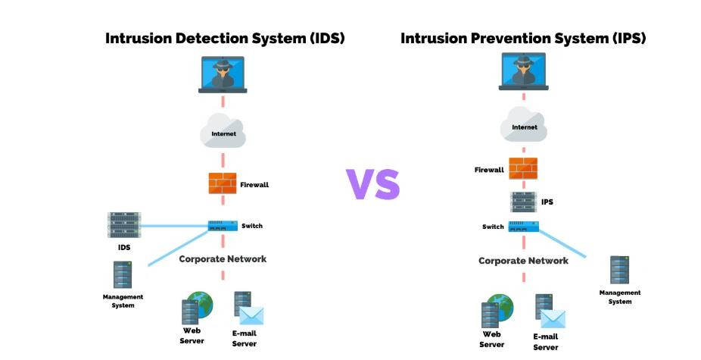
Figure 1.1 IDS IPS Overview

1.2 Types of Cyber Attacks
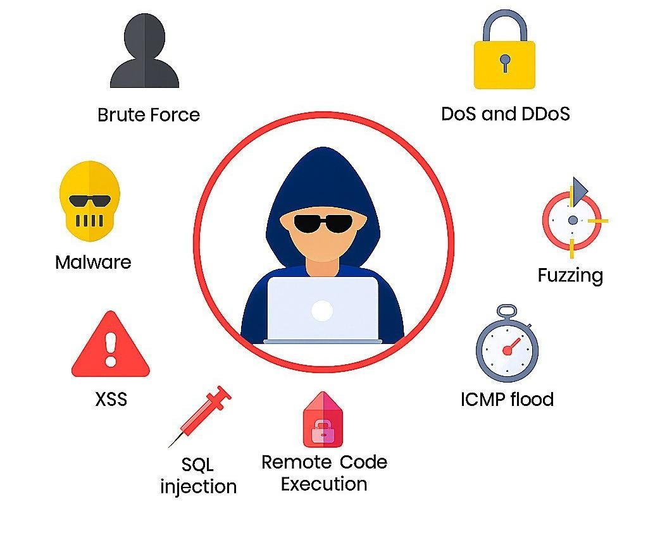
Figure 1.2 Cyber Attacks

1.2.1 . Denial of Service (DoS) Attack
A Denial of Service (DoS) attack is a type of cyberattack in which a single attacker attempts to disrupt the normal functioning of a system, server, or network.
The attacker sends an excessive number of requests or malicious traffic to the target, consuming system resources such as CPU, memory, or bandwidth.
As a result, the system becomes slow, unstable, or completely unavailable to legitimate users.
DoS attacks typically originate from one source, which makes them easier to identify and mitigate compared to distributed attacks.
Common types of DoS attacks include TCP SYN Flood, UDP Flood, and ICMP Flood, each targeting different network protocols to exhaust system resources [2].

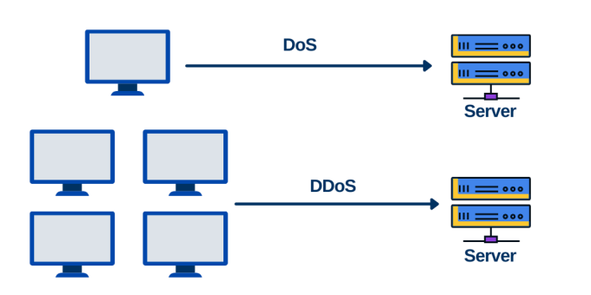
Figure 1.3 DoS Attacks

1.2.2 Distributed Denial of Service (DDoS) Attack:
A Distributed Denial of Service (DDoS) attack is a more complex and powerful version of a DoS attack.
Instead of relying on a single source, the attacker controls multiple compromised devices, such as computers, servers, or IoT devices, which together form a botnet.
These devices simultaneously send a massive amount of traffic to the target system, overwhelming its capacity and causing service disruption or total failure.
Because the attack traffic comes from multiple geographic locations and IP addresses, detecting and blocking a DDoS attack is significantly more difficult.
DDoS attacks are commonly used to target large organizations, financial institutions, and online services, and they can cause serious financial and reputational damage [2].

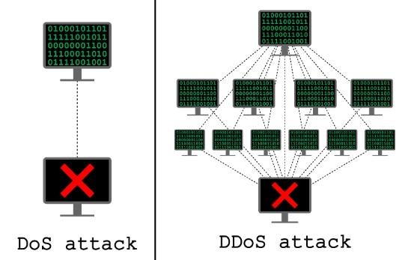
Figure 1.4 DDOS Attacks

1.2.3 SQL Injection Attack:
A SQL Injection (SQLi) attack is a type of web security vulnerability that allows an attacker to interfere with the queries that an application makes to its database.
This attack occurs when user input is not properly validated or sanitized, allowing the attacker to insert malicious SQL code into input fields such as login forms or search boxes.
By exploiting SQL Injection, an attacker can:
- Bypass authentication mechanisms
- Access sensitive data (such as usernames and passwords
- Modify or delete database records
- In some cases, gain full control over the database
SQL Injection is considered one of the most dangerous web application attacks because it directly targets the database, which is a critical component of any system [2].

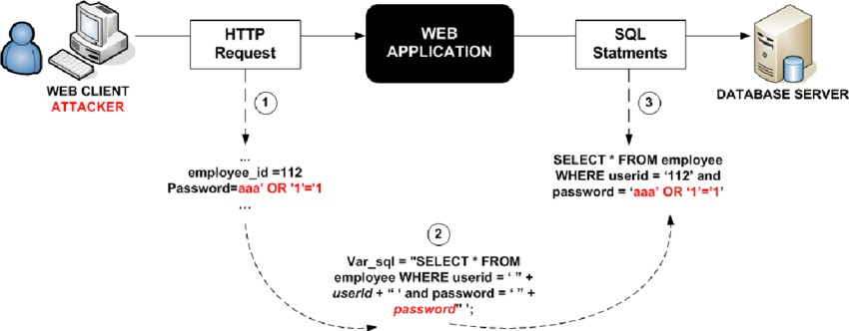
Figure 1.5 SQL injection attack

1.2.4 Cross-Site Scripting (XSS) Attack:
Cross-Site Scripting (XSS) is a web security vulnerability that allows attackers to inject malicious scripts into web pages viewed by other users.
These scripts are usually written in JavaScript and are executed in the victim’s browser without their knowledge.
XSS attacks occur when a web application accepts user input and displays it on a web page without proper encoding or validation.
As a result, attackers can use XSS to:
- Steal session cookies and user credentials
- Impersonate users
- Redirect users to malicious websites
- Manipulate the content of a webpage
Unlike SQL Injection, which targets the database, XSS mainly targets end users, making it a serious threat to user privacy and trust [2].

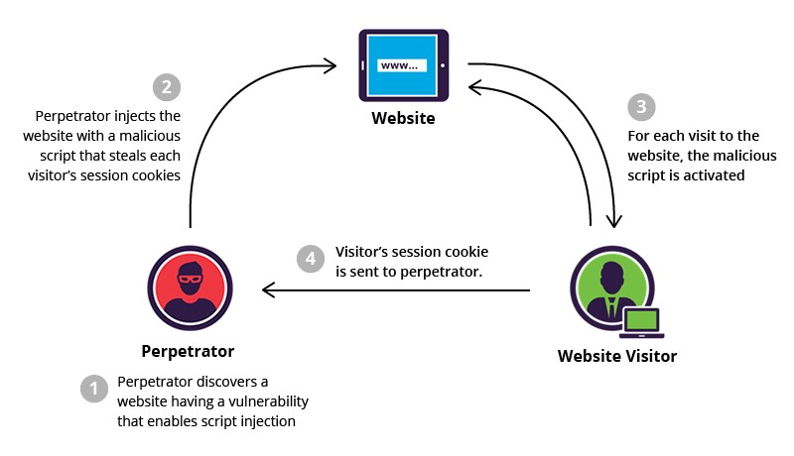
Figure 1.6 XSS attack

1.2.5 SSH Brute-Force Attack (Secure Shell):
An SSH Brute-Force attack is a type of cyberattack in which an attacker attempts to gain unauthorized access to a system by repeatedly trying different username and password combinations over the Secure Shell (SSH) protocol.
SSH is commonly used for secure remote access and system administration, which makes it a valuable target for attackers.
In a brute-force attack, automated tools are often used to perform thousands of logins attempts in a short period of time.
If successful, the attacker can: [2]
- Gain full remote access to the system
- Execute commands with the privileges of the compromised account
- Steal sensitive data or modify system configurations
This type of attack mainly exploits weak or reused passwords and the absence of proper security controls.

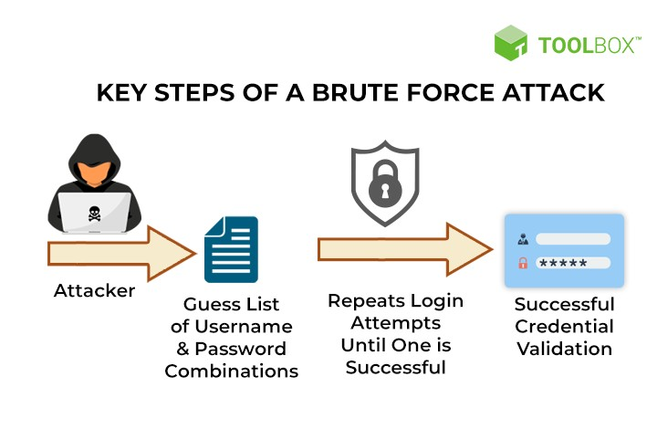
Figure 1.7 SSH brute-force attack

1.2.6 Remote Code Execution (RCE) Attack:
A Remote Code Execution (RCE) attack is a critical security vulnerability that allows an attacker to execute arbitrary code on a target system from a remote location.
This attack usually occurs due to insecure application design, software vulnerabilities, or improper input validation.
By exploiting RCE vulnerability, an attacker can: [2]
- Run malicious commands on the server • Install malware or backdoors
- Take full control of the affected system
- Access or manipulate sensitive data
Remote Code Execution attacks are considered extremely dangerous because they can lead to complete system compromise without requiring physical or local access.

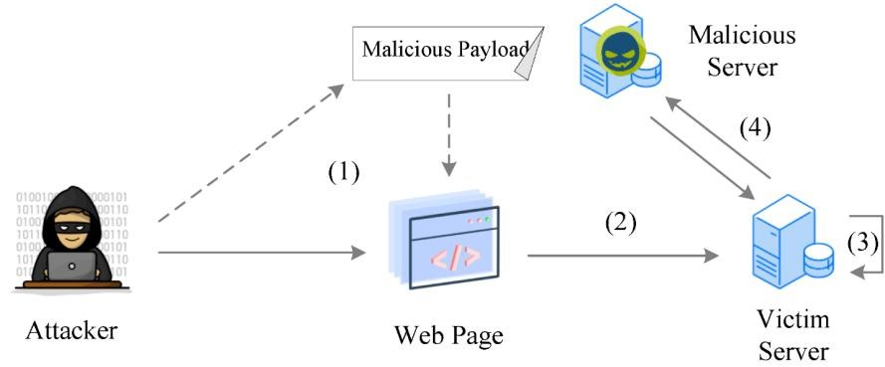
Figure 1.8 Remote code execution

1.2.7 Fuzzing Attack
Fuzzing is a software testing and attack technique in which an attacker sends random, malformed, or unexpected inputs to an application to identify vulnerabilities.
The goal of fuzzing is to discover weaknesses such as buffer overflows, crashes, memory leaks, or unexpected behavior. [3]
If a vulnerability is found, it can be exploited to:
- Cause application crashes or denial of service
- Bypassing security controls
- Enable more serious attacks such as Remote Code Execution
Although fuzzing is often used as a legitimate security testing method, it can also be abused by attackers to find exploitable flaws in software systems.

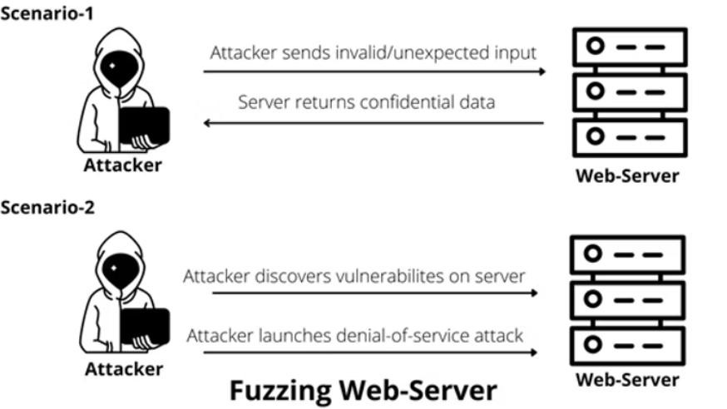
Figure 1.9 Fuzzing
1.2.8 ICMP Flood (Ping Flood) Attack:
An ICMP Flood, also known as a Ping Flood, is a type of Denial of Service (DoS) attack that targets a system by sending a large number of ICMP Echo Request (ping) packets.
The target system is forced to process and respond to each request, which consumes significant network bandwidth and system resources.
As a result, the system becomes slow or unresponsive, preventing legitimate users from accessing the service.
ICMP Flood attacks are commonly used to: [2]
- Overwhelm network infrastructure
- Disrupt communication between systems
- Degrade overall network performance
This attack exploits the ICMP protocol, which is normally used for network diagnostics.

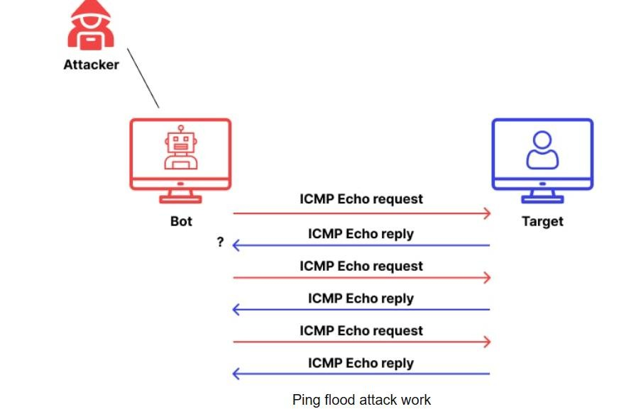
Figure 1.10 ICMP flood attack

1.3 Motivation
In recent years, the number and sophistication of cyberattacks have increased significantly, targeting not only large organizations but also small businesses, government institutions, and individuals. These attacks cause severe consequences, including financial losses, data breaches, and service disruptions. With the growing dependency on the internet and connected systems, ensuring the security and privacy of data has become a global priority
[4] .
Traditional Intrusion Detection Systems (IDS) are limited by their reliance on static rules and manual updates, which make them ineffective against new or zero-day attacks. Similarly, human analysis of massive network traffic is time-consuming, error-prone, and cannot provide real-time response. These limitations have created a pressing need for a smart and adaptive defense mechanism capable of automatically learning from data and evolving with new attack techniques.
The motivation behind this project is to leverage the power of Artificial Intelligence (AI) to build a system that can detect and prevent cyberattacks dynamically. By applying Machine Learning (ML) and Deep Learning (DL) algorithms, the proposed IDS-IPS can learn normal network behavior, recognize patterns of malicious activity, and take automated actions without human intervention.
This project also aims to contribute to the development of a real-time, high-accuracy, and low false-positive intrusion detection system that can be integrated into modern infrastructures. Ultimately, the motivation is to create a proactive security solution that not only detects attacks but also prevents them before they cause harm — bridging the gap between traditional defense systems and the future of intelligent cybersecurity.

1.3.1 Statistical Overview of Global Cyber Threats
The following figures illustrate the growth of cybercrime costs and the most targeted operating systems worldwide [4].

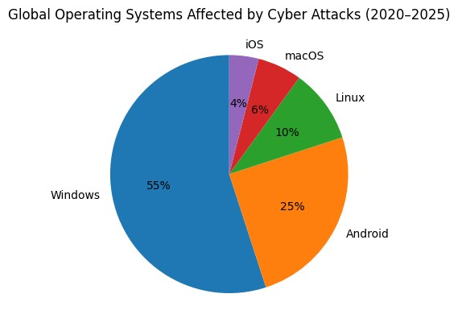
Figure 1.11 Global OS distribution targeted by cyber attacks (2020–2025)

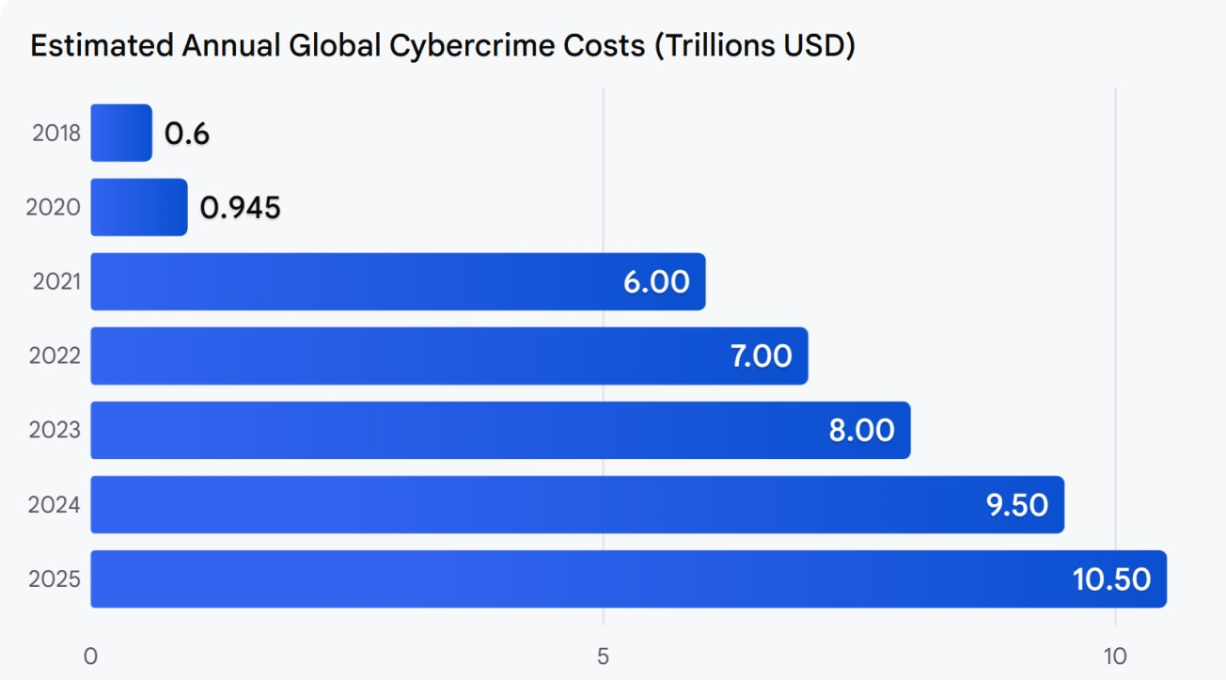
Figure 1.12 Global cyber crime costs (2018–2025)

1.3.2 Global Cyber security Incident Report (2025)

1.3.2.1 Ransomware Attack (Double Extortion) – Devman Ransomware
Ransomware is a type of malware that encrypts an organization’s data, making it inaccessible until a ransom is paid. The double extortion technique increases pressure on victims by not only encrypting files but also stealing sensitive data and threatening to publish it if payment is refused [5].
Attackers often gain entry through exposed services such as Remote Desktop Protocol (RDP) or Server Message Block (SMB), or by exploiting vulnerabilities in web applications. After infiltration, they move laterally across the network, identify valuable data, and exfiltrate it before launching the encryption process.
The consequences typically include operational downtime, financial loss, reputational damage, and potential legal liabilities due to data breaches.
Key Risks:
- Permanent or temporary data loss
- Financial extortion
- Data leakage
- Business interruption

1.3.2.2 Hybrid Attack (Physical + Cyber) – Kyiv Energy Infrastructure
A hybrid attack combines both cyber techniques and physical disruption to damage critical infrastructure. In this case, the attackers targeted energy networks by infiltrating Industrial Control Systems (ICS) and SCADA environments, which are responsible for monitoring and controlling power distribution [6].
The attackers likely used industrial communication protocols such as Modbus TCP and DNP3 to manipulate operational commands inside the network. Once access was gained, they could interfere with power management processes, causing widespread outages.
Hybrid attacks are particularly dangerous because they extend beyond digital damage and can directly affect public safety, economic stability, and national security. Power outages impacting thousands of households demonstrate how cyber warfare is increasingly capable of producing real-world consequences. Key Risks:
- Disruption of critical infrastructure
- Large-scale service outages
- Threats to public safety
- Long recovery time

1.3.2.3 Ransomware Attack (Double Extortion) – NightSpire
The NightSpire incident follows a similar ransomware model but highlights the importance of internal reconnaissance and credential compromise.
After entering the system, attackers conduct reconnaissance to understand the network structure, locate critical assets, and identify backup systems. Using legitimate administrative tools and compromised credentials makes detection harder because the activity appears normal.
Lateral movement through protocols like RDP and SMB allows attackers to spread the malware across multiple machines before executing the ransomware payload simultaneously.
Even when the financial losses appear smaller, the long-term impact can include customer distrust, regulatory penalties, and expensive cybersecurity upgrades [7].

Key Risks:
- Unauthorized network access
- Credential theft
- Hidden attacker presence
- Service disruption

1.3.2.4 Advanced Persistent Threat (APT) – AI-Driven Cyber Espionage
An Advanced Persistent Threat (APT) is a prolonged and highly sophisticated cyberattack in which attackers remain undetected inside a network for an extended period. The primary objective is usually espionage, focusing on stealing strategic or confidential information rather than causing immediate damage.
What makes this attack notable is the use of Artificial Intelligence to automate phishing campaigns, enhance credential harvesting, and identify vulnerabilities faster than traditional methods.
Attackers may leverage secure protocols like HTTPS and cloud APIs to blend malicious traffic with legitimate network activity, making detection extremely challenging.
APT attacks are typically well-funded and carefully planned, often targeting technology and financial sectors due to the high value of their data [8].
Key Risks:
- Long-term undetected access
- Theft of intellectual property
- Strategic data compromise
- National and economic security threats

1.4 Problem Definition
Current commercial and open-source NIDPS are struggling to keep pace with the evolving threat landscape due to three core limitations:
- Low Efficacy Against Zero-Day and Evasion Attacks: Signature-based models are blind to attacks that subtly alter their patterns to evade detection.
- High False Positive Rate: Traditional anomaly detection methods frequently misclassify legitimate network traffic fluctuations as malicious, resulting in unnecessary administrative overhead and delayed responses to genuine incidents.
- Inability to Analyze Encrypted Traffic: The rise of encrypted communications allows sophisticated attackers to cloak their malicious payloads, rendering deep packet inspection ineffective.
•The core problem is to design and implement an NIDPS that achieves high detection accuracy (low false positives and negatives) while being resilient against sophisticated and stealthy attacks, particularly those embedded within encrypted flows, without requiring full, resource-intensive decryption. To address this challenge, the proposed solution relies on an AI-driven detection approach, using machine learning (ML) techniques that analyze sidechannel and flow-level features—rather than full payload inspection—to identify abnormal patterns within encrypted traffic. By combining anomaly detection with supervised classification through ML models, the system can effectively distinguish malicious behavior in real time, maintain high accuracy, and reduce the computational overhead associated with deep decryption [1].

1.5 Challenges
Data Imbalance : Occurs when some classes appear far more than others, causing the model to favor the majority class.
This reduces accuracy for rare but important classes (example: attacks)

False Positives & False Negatives: False positives flag normal traffic as attacks; false negatives miss real attacks.
Both harm security—either by over-alerting or letting threats pass.

Adversarial Attacks : Attackers intentionally craft inputs to fool the model into misclassification.
These attacks exploit model weaknesses to bypass detection [1].

Model Transparency & Interpretability:
Many ML models act like “black boxes,” making their decisions hard to understand.
This limits trust and makes it harder to explain or debug security outcomes.

1.6 Objectives
- The system should be able to identify well-known attacks such as Denial of Service (DoS), phishing attempts, malware and other frequent cyber attacks

- Implement simple defensive actions like blocking IP addresses identified or dropping harmful packets to prevent damage [1].

- Build an Intrusion Detection and Prevention System that uses AI and machine learning to automatically detect and respond to network attacks

- Utilize AI and machine learning to efficiently develop and train models that accurately detect network attacks , with a focus on minimizing false positives and false negatives.

- Measure how well the system performs using metrics such as accuracy, precision, recall, F1-score, and false positive rate. for better results

Chapter 2 Similar Systems & Related Work

Chapter 2 : Similar Systems & Related Work

2.1 Introduction
In the field of network and system security, several open-source tools are used to detect, monitor, and prevent cyber-attacks. Among the most popular systems are Snort and Zeek. These tools are known for their ability to analyze network traffic, detect suspicious activities, and provide detailed security reports.
- Snort is Intrusion Detection and Prevention Systems (IDS/IPS) that monitor network packets in real-time and detect potential threats using rule-based analysis.
- Zeek (formerly Bro) is a powerful network analysis framework that goes beyond intrusion detection to provide deep insights into network behaviors and protocols.
These systems are widely used by organizations to strengthen their security infrastructure, detect attacks early, and respond effectively to network and system threats.

2.2 SNORT
Snort is a free and open-source Intrusion Detection and Prevention System (IDS/IPS) that has become one of the most widely used security tools in the world. It is both powerful and flexible, making it suitable for individuals, organizations, and enterprises that require strong network monitoring and protection [9].

One of Snort’s main strengths is its rules-based architecture, which allows users to write and customize rules according to their security needs. These rules can be designed to either block suspicious traffic or generate alerts. The alerts can then be sent to the console, displayed on the screen, logged into a file, or even stored in a database for future analysis.

2.2.1 Custom Rules:

Snort allows users to write their own rules to identify specific traffic patterns, either to trigger an alert or to block traffic through actions such as Reject, Drop, or Block. These rules are highly flexible and support conditions based on protocols, ports, addresses, and content.
Note on OS Fingerprinting:
Each operating system has its own TCP/IP stack implementation.
Work in Any Network Environment like(Linux , windows or others)
Snort supports multiple modes of operation, which makes it versatile:

- Sniffer Mode –like(Wireshark ) captures packets in real time and displays header information on the screen.
- Packet Logger Mode – saves network packets into log files for later review and analysis.
- Network Intrusion Detection System (NIDS) Mode – the most important mode, where Snort analyzes traffic in real time, applies its rules, and detects possible intrusions or attacks.
When running in NIDS mode, Snort can not only detect intrusions but also act as a prevention system by performing actions such as rejecting, dropping, or blocking malicious traffic. It uses Network Interface Cards (NICs) in promiscuous mode to capture raw packet data for detailed inspection

2.2.2 Architecture of Snort :

Packet Decoder – Captures and interprets raw network traffic.
- Detection Engine – Applies predefined rules to identify suspicious or malicious patterns.
- output Module – Logs alerts or takes preventive actions [9].

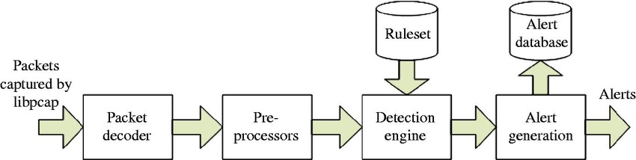
Figure 2..1 Snort

2.3 SURICATA:
Suricata is an open-source Intrusion Detection System (IDS) that can also operate as an Intrusion Prevention System (IPS).
This means it can:
- Monitor traffic and detect attacks (IDS).
- Actively block malicious traffic (IPS).
It was developed by the Open Information Security Foundation (OISF) as a stronger and more advanced alternative to Snort [10].

2.3.1 How does it work?
Like Snort, Suricata uses rules that define attack patterns.
Suricata inspects network traffic at high-speed using deep content inspection and protocol analysis to identify threats.

2.3.2 False Positives vs. False Negatives
False Positive (False Alarm):
The system reports an attack, but there is none.
- Example: A user downloading a large file → Suricata mistakes it for a DoS attack.
- Problem: Wastes administrators’ time and creates unnecessary noise.
2.3.1.2 False Negative (Missed Detection):
The system fails to raise an alert even though a real attack is happening.
- Example: A new attack that does not yet have a written rule → Suricata will not detect it.
- Problem: This is more dangerous since it allows attacks to pass undetected.

2.3.3 Advantages of Suricata over Snort
- Multithreading support → Can use multiple CPU cores for better performance.
- Broader protocol support → Works with HTTP, TLS/SSL, FTP, DNS, and many more.

2.3.4 Architecture of Suricata:
- SURICATA uses multi-threaded architecture:
- Packet Capture & Decoding – Handles many network protocols. • Flow & Stream Management – Keeps track of ongoing sessions.
- Detection Engine – Supports rules (like Snort's) plus anomaly detection.
- Output Module – Generates alerts, logs, or blocks malicious traffic.

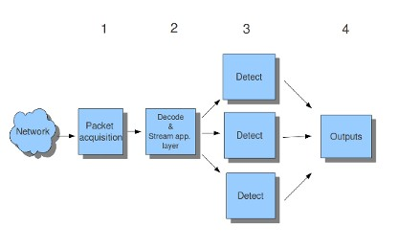

Figure 2.2 SURICATA

2.4 OSSEC

OSSEC is an open-source Host-Based Intrusion Detection System (HIDS). This means it runs directly on hosts (devices/servers) instead of monitoring the entire network. [11]

2.4.1 Main Functions:
- Log Analysis:
Monitors system and application log files to detect suspicious activities.
- Integrity Checking:
Ensures that no unauthorized changes have been made to important system files.
- Rootkit Detection:
Rootkits are malicious tools that hide inside the system. OSSEC can detect and track them.
- Time-Based Alerting:
If a specific event occurs repeatedly within a short period of time, the system generates an alert.
- Active Response:
Automatically executes predefined actions when a threat is detected, such as blocking an IP address or running a script to mitigate the attack.

2.4.2 Architecture of OSSEC
- Manager: Manager collects and stores data, manages the system and he can work alone without agents in local mode.
- Agents: Lightweight components that gather information and send it to the
Manager [11].
- Cluster Mode : Multiple managers with load balancing, ensuring no data loss and high availability [12].

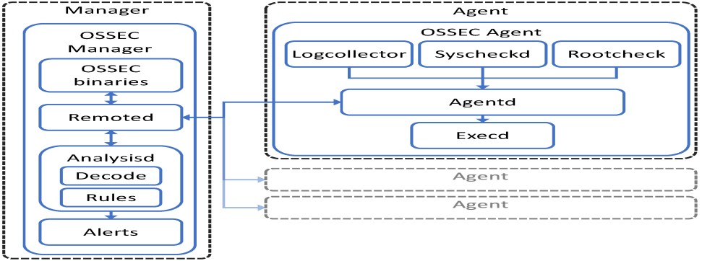
Figure 2.3 OSSEC

2.5 ZEEK
Zeek is an open-source network security monitoring system, primarily designed to run on Unix/Linux environments.
Unlike traditional IDS solutions, Zeek takes a more intelligent and flexible approach:
- Traffic Parsing:
It analyzes network traffic deeply, up to the application layer.
- Event-Oriented Analyzers:
Zeek generates events from the observed traffic and uses analyzers to compare them against patterns of suspicious or malicious behavior.

2.5.1 Architecture of Zeek:
- Packet Capture Layer – Captures raw packets from the network using libpcap or AF_Packet.
- Event Engine – Analyzes packets and converts them into high-level events (e.g., connection start, HTTP request).
- Policy Scripts Layer – Uses Zeek scripts to define how to handle events (detect anomalies, generate alerts, or log data).
- Logging & Output Framework – Stores detailed logs of network activity and security incidents.

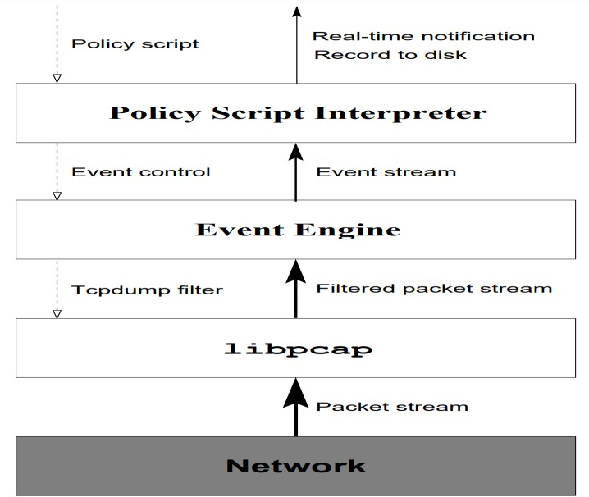
Figure 2.4 Zeek

2.6 Related Work
2.6.1 paper 1 :
“AI-Powered Intrusion Detection Systems for Next-Generation Cloud Security
Year of Publication :2025”
Dataset Used : NSL-KDD , CICIDS2017 , UNSW-NB15
Results / Key Findings: The study demonstrates that AI-powered IDS significantly enhances cloud security by: [13]
Improving threat detection accuracy across various attack types.
Reducing false positives compared to traditional signature-based IDS.
Enhancing adaptability to evolving cyber threats in cloud environments.
Method / Technique Used:
- Deep Learning (CNN, LSTM, Autoencoder)
- Hybrid Machine Learning (SVM + ANN) 3. Anomaly Detection Models for cloud security
2.6.2 paper 2 :
“Deep Learning for Network Intrusion Detection”
Year of Publication : 2020
Dataset Used :CICIDS2018, BoT-IoT
Results / Key Findings :Deep models achieved >98% accuracy, strong performance against zero-day attacks [14].
Method / Technique Used : CNN, GRU, Deep Autoencoder

2.6.3 Paper 3
“Real-Time Large-Scale Intrusion Detection and Prevention System” [15]
Year of Publication : 2024
Dataset Used :CICIoT2023 IoT dataset
Results / Key Findings :Achieved > 85% accuracy, 99% precision in detection & prevention tasks
Method / Technique Used : Combined DL + MLP model
2.5.4 paper 4 :
“Subject review: Intrusion Detection System (IDS) and Intrusion Prevention System (IPS)”
Year of Publication : 2023
Dataset Used :No specific dataset [16]
Results / Key Findings :AI-driven IDS/IPS outperform traditional rule-based systems by effectively detecting unknown (0-day) threats and reducing false positives, though they require significant processing power and large datasets. Hybrid detection approaches combining signature-based and AI-driven techniques enhance accuracy and adaptability, addressing adversarial attacks and offering
Method / Technique Used: Comparative Analysis and Machine Learning and Deep Learning and Detection Techniques

2.6.5 paper 5
“ Threat Detection Driven by Artificial Intelligence: Enhancing Cybersecurity with
Machine Learning Algorithms” [17]
Year of Publication : 2024
Dataset Used :Not Specified (Theoretical Review)
Results / Key Findings :Provides a comprehensive review of AI/ML applications in threat detection, highlighting their role in enhancing the accuracy, efficiency, and automation of AI-based IDS/IPS, particularly for detecting unknown threats.
Method / Technique Used : Comprehensive Review & Theoretical Analysis

2.6.6 Paper 6 :
“ AI-Driven Features for Intrusion Detection and Prevention Using Random Forest”
Year of Publication : 2025
Dataset Used :NSL-KDD [18]
Results / Key Findings :The proposed GWO-RF (Grey Wolves Optimization with Random Forest) approach achieved a high accuracy of 0.94. Demonstrates that integrating AI-based feature optimization with ensemble learning significantly enhances intrusion detection performance compared to traditional methods.
Method / Technique Used : Grey Wolves Optimization (GWO) with Random Fores

2.6.7 Paper 7
“ Intrusion Detection System/Intrusion Prevention System”
Year of Publication : 2025
Dataset Used :NSL-KDD and CIC-IDS2017
Results / Key Findings :AI-driven IDS/IPS significantly improve detection rates for 0day attacks and outperform traditional rule-based methods, though they require extensive training to minimize false alarms.
Hybrid approaches combining signature-based and ML-driven techniques offer a balanced solution, enhancing accuracy while addressing challenges like adversarial attacks and computational costs
Method / Technique Used : Comparative Analysis, Machine Learning and Deep Learning
2.6.8 Paper 8
“Intrusion detection and prevention systems (IDS/IPS) for OS protection”
Year of Publication :2024
Dataset Used :Based on simulations and case studies; briefly mentions common benchmarks (e.g. KDD, NSL-KDD [19]
Results / Key Findings :Reviews IDS vs IPS and types (signature, anomaly, hybrid). Case studies on Windows/Linux/macOS/mobile show high detection rates in simulations (reported ~95–98%) and fast response times (<1s). Main issues: high false positives and resource consumption. Recommends integrating AI/ML and threat-intelligence for better accuracy
Method / Technique Used : Signature, Anomaly, Hybrid IDS/IPS with tools like Snort and Wireshark.

2.6.9 Paper 9
“A Survey on Methods and Datasets of Intrusion Detection System (IDS) in Deep
Learning” [20]
Year of Publication : 2023
Dataset Used : NSL-KDD, CICIDS2017, UNSW-NB15
Results / Key Findings :Surveys DL methods used in IDS (CNN, RNN/LSTM, Autoencoders, hybrid models) and evaluates common datasets. Key findings: datasets suffer from age/imbalance/limited realism; common challenges are datasets, lightweight real-time models, hybrid techniques, and XAI for interpretability.
Method / Technique Used : DL methods in IDS using CNN, RNN/LST, Autoencoders,
Hybrid models; focuses on datasets and evaluation metrics
2.6.10 Paper 10
“Deep Learning vs. Machine Learning for Intrusion Detection in Computer Networks:
A Comparative Study”
Year of Publication : 2025 [21]
Dataset Used : CICIDS2017
Results / Key Findings :Conducted a comprehensive comparison. Random Forest achieved the highest accuracy of 99.88%. Deep Learning models (CNN, LSTM) also showed strong performance (~98% accuracy), demonstrating their potential, though RF was superior on this dataset. Addressed class imbalance using SMOTE
Method / Technique Used: Comparative Study of ML & DL Models )RF, CNN, LSTM

2.6.11 Paper 11
A comprehensive review of AI based intrusion detection system
Year of Publication : 2023 [22]
Dataset Used :CSE-CIC-IDS2018 , CICIDS2017, UNSW-NB15, NSL-KDD
Results / Key Findings : AI-based IDS (using ML, DL, and ensemble methods) significantly improves detection accuracy compared to traditional approaches.
- KNN achieved the highest accuracy among ML models (99.89%), while CNN performed best among DL models (up to 99.95%). - DL models excel at automatic feature extraction and handling large, complex datasets, making them effective against unknown (zero-day) attacks. - Most studies focused heavily on accuracy, often neglecting other critical metrics like FAR, precision, recall, and F1-score, especially for multi-class attack classification.
Method / Technique Used: Sowmya T, Mary Anita E.A
2.6.12 Paper 12
“ Machine Learning Methods for Network Intrusion Detection”
Year of Publication : 2023
Dataset Used :CICIDS2017 [23]
Results / Key Findings :The MLP (Multi-Layer Perceptron) model outperformed both Random Forest and Snort (a rule-based IDS) on the CIC-IDS2017 dataset, achieving nearperfect scores (e.g., AUROC ≈ 0.99–1.0 and F1-scores > 0.95 for most attack types). - On realistically captured home network traffic (with attacks like Port Scan, Brute Force, DoS Slowloris, and SQL Injection): MLP showed moderate generalization ability (AUROC = 0.7165, F1-score = 0.578), with high recall but elevated false positives. - Random Forest failed to detect most attacks (Recall ≈ 0 for malicious traffic), essentially classifying everything as benign.
Method / Technique Used : Henrik Lindstedt
2.6.13 Paper 13
“Adversarial Machine Learning in Cybersecurity: Attacks and Defenses”
Year of Publication : 2025 [24]
Dataset Used :ANDROZOO, VirusShare (malware detection); KDD Cup 1999, CICIDS2017 (network traffic); FVC2000, LFW (biometrics)
Results / Key Findings : Adversarial samples significantly reduced model accuracy (e.g., CNN: 95% → 70% with FGSM). Defense methods like adversarial training and data augmentation improved robustness, reducing attack success rates to 20–40%. The study highlights the evolving balance between attack efficiency, stealth, and defense adaptability in cybersecurity.
Method / Technique Used: FGSM, PGD, C&W, Deep Fool, GANs, Adversarial Training, Data Augmentation, Anomaly Detection, Input Transformation

2.6.14 Paper 14
“AI-Driven Intrusion Detection and Prevention Systems (IDPS) for Cloud Security”
Year of Publication : 2025
Dataset Used :CICIDS2018, UNSW-NB15
Results / Key Findings :Up to 99.2% accuracy with real-time detection and reduced false positives.
Method / Technique Used : Hybrid Deep Learning: CNN + LSTM
Ensemble Machine Learning: Random Forest + XGBoost [25]
Auto encoder-based Anomaly Detection
2.6.15 Paper 15 [26]
" Flow Transformer: A Transformer framework for Flow-based network intrusion detection systems"
Year of Publication : 2023
Dataset Used :CSE_CIC_ ,NSL-KDD , MQTT . CSE_CIC_IDS_v2
Results / Key Findings :input Encoding (converting features to vectors)
Transformer Model (analyzing flows using self-attention)
Classification Head (identifying benign/malicious)
Evaluation Metrics: F1, DR, FAR
2.6.16 Paper 16
“A COMPREHENSIVE STUDY OF ARTIFICIAL INTELLIGENCE
APPLICATIONS IN INTRUSION DETECTION AND PREVENTION” [27]
Year of Publication : 2025
Dataset Used :KDD Cup ,CICIDS ,NSL-KDD
Results / Key Findings : Data Collection – from real-world datasets (KDD, NSL-KDD,
CICIDS)
Preprocessing – Cleaning + Normalization + Encoding
Feature Selection – using PCA to reduce dimensionality
Model Training & Evaluation – ML/DL training and performance evaluation
Feedback Loop – the system learns and improves itself over time: Privacy, ethics, scalability.

2.6.17 Paper 17
“ Explainable Artificial Intelligence for Intrusion Detection System”
Year of Publication : 2022
Dataset Used :CICIDS2017 [28]
Results / Key Findings : Data preprocessing (data cleaning and normalization)
Feature selection (correlation analysis and outlier removal)
Model training using DT, RF, and SVM
Ensemble (Voting Classifier) to improve accuracy
Explainability layer (LIME) to interpret decision

2.6.18 Paper 18
“A Survey of Intrusion Detection Systems Leveraging Host Data (Glass-Vanderlan et
al.)”
Year of Publication : 2018 [29]
Dataset Used : Survey of many datasets (system call logs, Windows audit logs, registry logs, older datasets like KDD/KDD99).
Results / Key Findings : Performance across research is highly dataset dependent. Older datasets often inflate accuracy. Paper calls for better host datasets and standardized evaluation metrics.
Method / Technique Used: Overview of HIDS methods: signature-based, anomaly detection, statistics, HMM, SOM, SVM, Decision Trees, Neural Networks, hybrid systems

Chapter 3 System Analysis and Design

Chapter 3 System Analysis and Design

3.1 Introduction
This chapter presents the planning and analysis phase of developing the Intrusion Detection and Prevention System (IDS/IPS). Since the system relies on real-time monitoring, machine learning analysis, and automated response, structured planning is essential to ensure accuracy, reliability, and security.
The chapter outlines the project objectives, defines the functional and non-functional requirements, and explains how tasks were distributed among team members. It also presents the development schedule and system components required to build an efficient IDS/IPS solution.

3.2 Tasks Management
This section highlights the importance of teamwork in developing the IDS/IPS system. Each team member was assigned specific responsibilities based on their skills, including machine learning, backend development, frontend design, and system integration.
Effective collaboration and communication helped ensure smooth development and successful integration of all system components.

3.3 Team Members
- Farah Hany Abd El-Azeem
- Basmala Ayman Abd El-Haleem
- Mai Mahmoud Mohammed
- Joud Mohamed Emad
- Mostafa Shaaban Mohamed
- Nancy Emad Hefny
- Mohamed Atia Mansour
- Ahmed Tarek Hamed

3.4 Task Duration
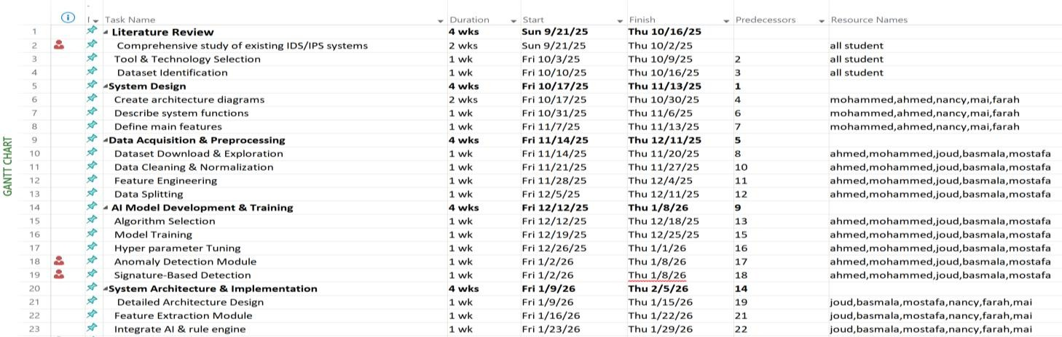

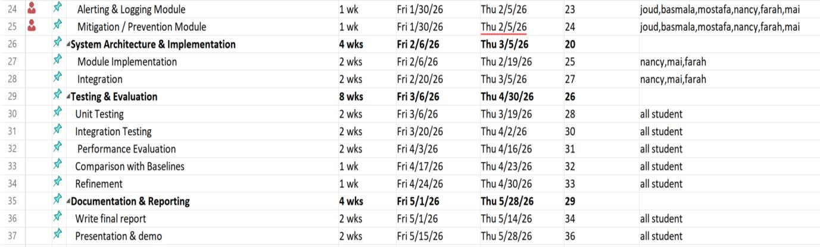

3.5 Diagrams

3.5.1 Gantt chart

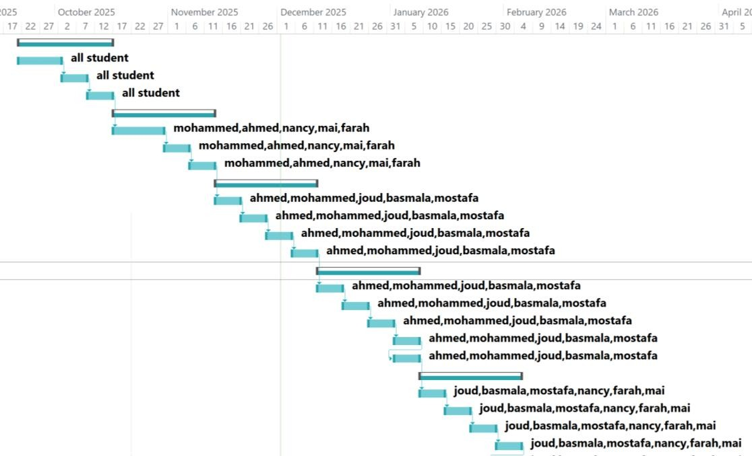
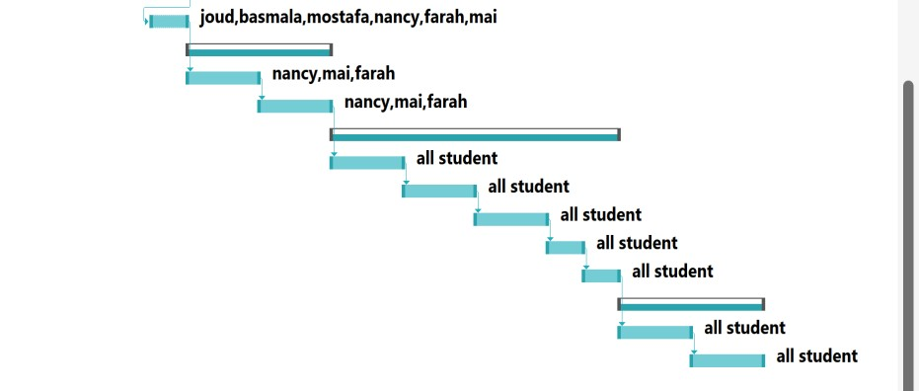

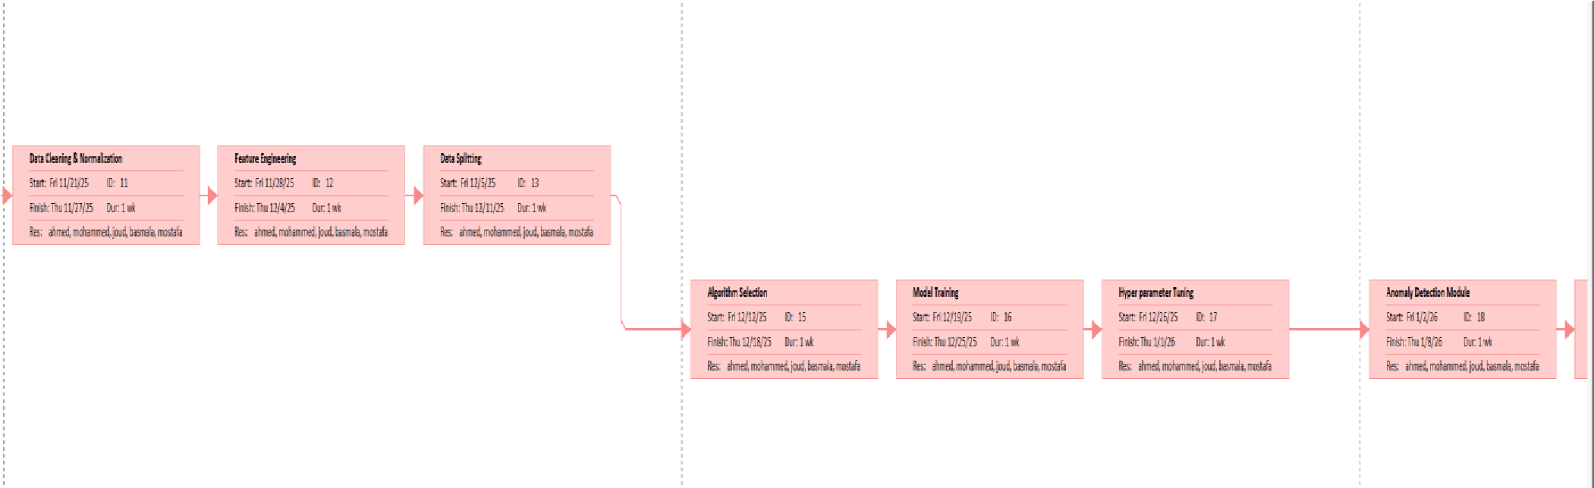
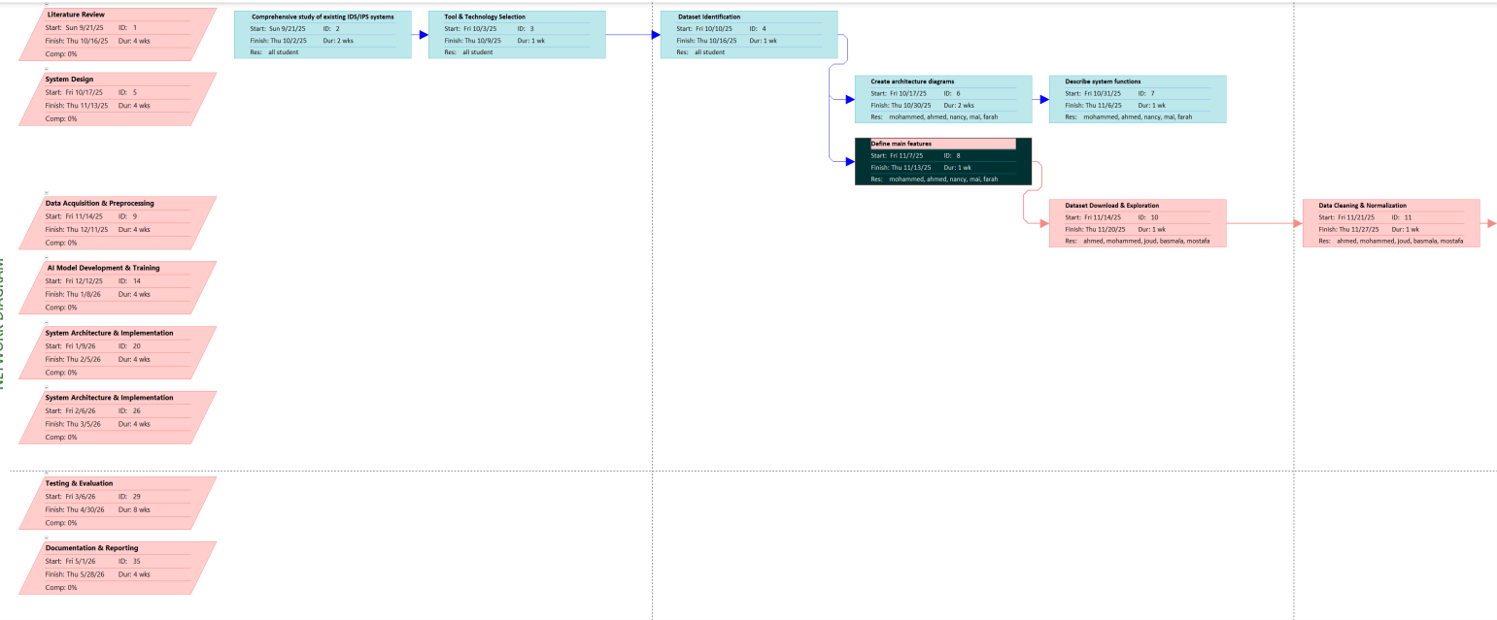

3.5.2 Network Diagram

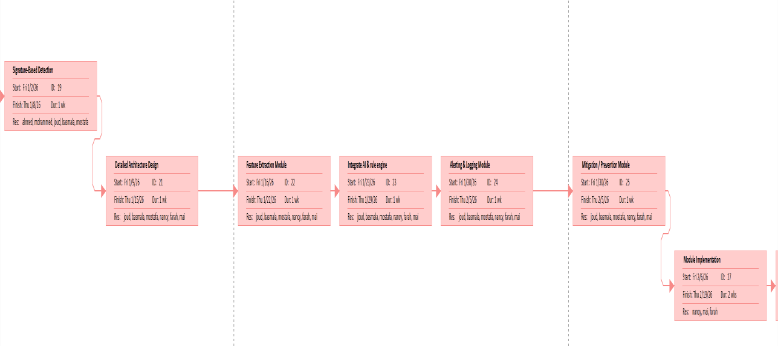

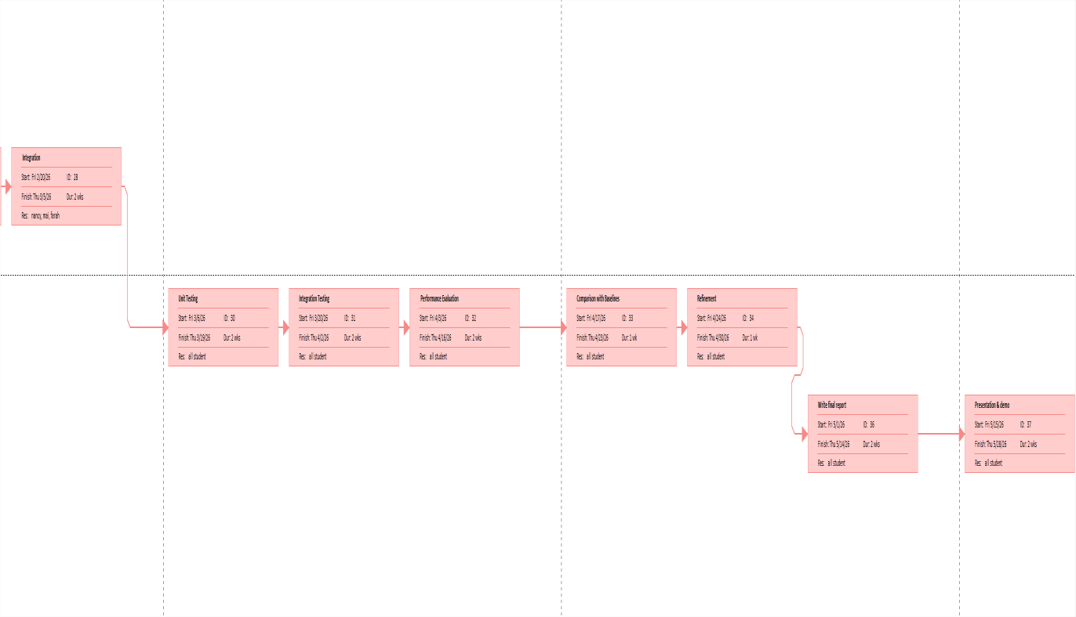

3.6 Use Case Diagram
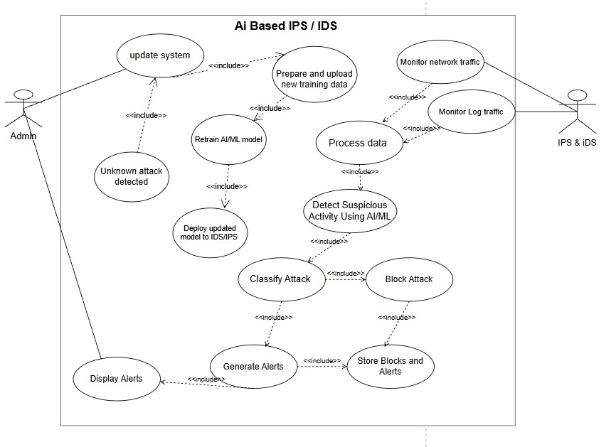

Figure 3.1 Use Case Diagram

3.7 Flowchart

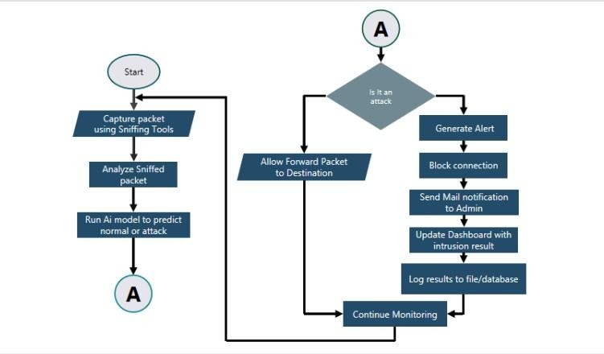
Figure 3.2 Flow chart diagram

3.8 Architecture Design
This diagram represents the architecture of an AI based Intrusion Detection and Prevention System (IDS/IPS).
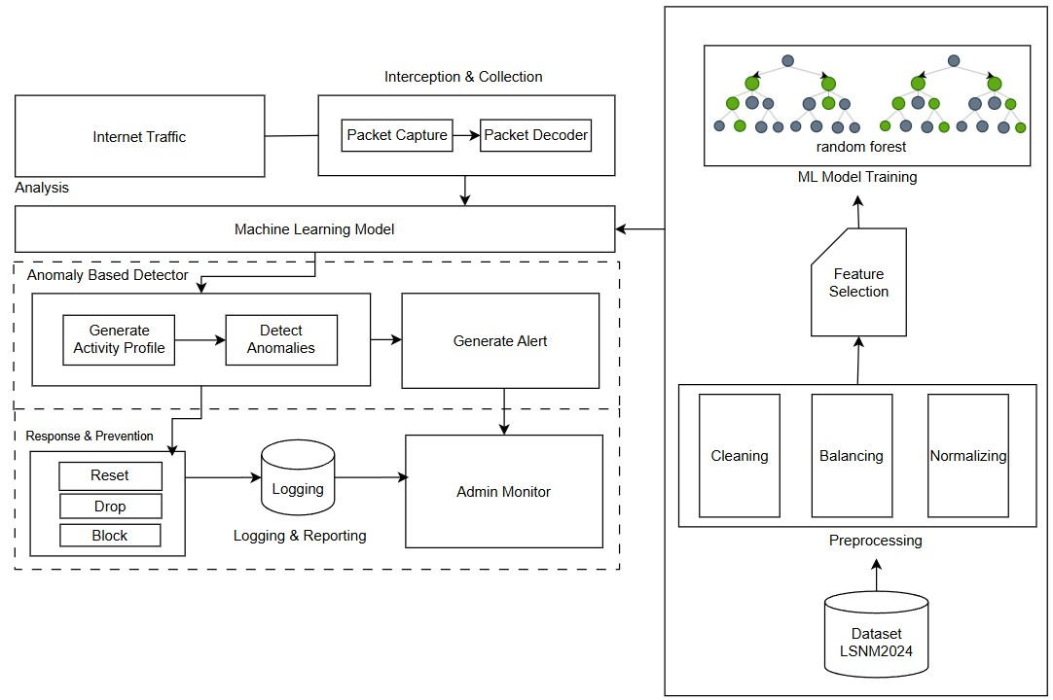
Figure 3.3 Architecture Design Diagram

3.9 Network Security System Flow Architecture
This diagram illustrates how data flows within a security system—from the moment it enters the network (network traffic) to the moment a security decision is made (alert or block). it illustrates:
- Components
- Data Flow
- Relationships
- Security Roles
- (e.g., detection, response, control))

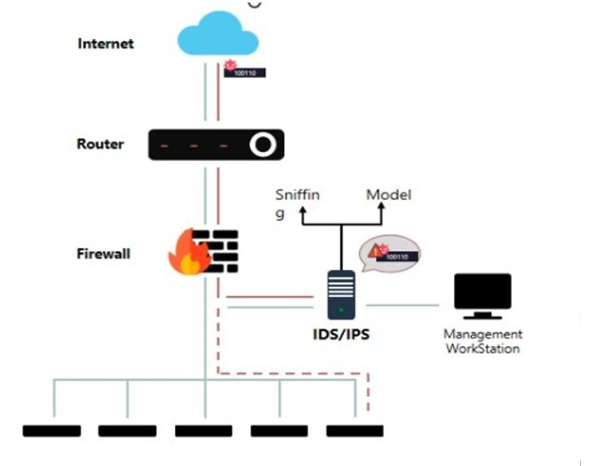

Figure 3.4 Network Security System Flow Architecture

CHAPTER 4
LITERATURE REVIEW

Chapter 4 Literature Review

4.1 Introduction
This chapter provides an overview of the theoretical and practical foundations related to the development of an AI-powered Intrusion Detection and Prevention System (IDS-IPS). It reviews existing research, technologies, and methodologies in the field of cybersecurity, with a particular focus on the role of Artificial Intelligence (AI), Machine Learning (ML), and Deep Learning (DL) in enhancing intrusion detection and prevention mechanisms. [30]
The chapter also traces the evolution of intrusion detection systems, categorizes common types of cyber-attacks, examines datasets commonly used for training detection models, and summarizes recent studies and technologies that have inspired the development of this project.

4.2 What does sniffer mean?
Sniffing is a cyber-attack technique in which an attacker monitors, captures, and analyzes network traffic as it travels across a network. The attacker does not need to interact with the system directly; instead, they listen silently to the data being transmitted between devices.
In normal operation, a network interface card (NIC) only receives packets addressed specifically to it. However, when the NIC is switched to promiscuous mode or monitor mode, it begins capturing all packets passing through the network—whether they were intended for that device or not. This ability allows an attacker’s device to behave like a hidden “network microphone,” listening to every communication taking place.
1. Host-Based Sniffer [30] [31]
A sniffer is installed directly on a specific device (host).
It captures and analyzes only the packets that reach that device.
Often, a small agent program is used to collect network information locally.
This method is useful when monitoring a single device’s incoming and outgoing traffic.
- Network-Based Sniffer [30] [31]
This type monitors traffic across an entire network segment.
It is usually deployed on routers, switches, or dedicated monitoring systems. It provides a broader view of all devices communicating within the network.
- Promiscuous Mode Sniffer
This sniffer uses a Network Interface Card (NIC) configured in promiscuous mode. In this mode, the NIC captures all packets on the network, not only those addressed to the device.
It allows attackers to intercept all traffic passing through the network.
- IoT-Specific Sniffer
Designed for smart home and IoT environments where direct installation of agents on devices is difficult.
These sniffers capture traffic from IoT sensors, cameras, and smart appliances.
They are optimized for low-power, small devices and often analyze lightweight protocols.
- Wireless / Wi-Fi Sniffer
Captures wireless packets without needing to join the Wi-Fi network.
Operates in monitoring mode, enabling it to view all nearby wireless traffic.
Widely used in Wi-Fi security testing and in attacks against home networks.
- Passive Sniffer
Captures network traffic silently without modifying or influencing data flow.
It only listens and does not interact with the network.
Because it generates no traffic, it is very difficult to detect.
- Active Sniffer
Manipulates the network to intercept traffic.
Uses attacks such as ARP spoofing, MAC flooding, or DHCP poisoning.
More powerful and allows deeper interception, but easier to detect because it causes noticeable network changes.

4.3 Examples of Sniffer Tools

4.3.1 -Ethereal
- Ethereal is the early version of Wireshark, also open source
Capabilities
- Can dissect 385+ protocols (SMTP, ATM, etc.)
- Supports live capture on Ethernet ,Token Ring, etc.
- Allows real-time or saved analysis
- Works on Windows, Linux, macOS
- Offers custom filters
Benefits
- Excellent for understanding what traffic exists on a network
- Helps analyze packet contents
- Free and easy to install — very useful for network administrators
"Wireshark is the successor to Ethereal, providing enhanced security, modern interface, and continuous update

4.3.2-TCPDump
What is TCPDump ?
powerful command-line packet sniffer.
Requires root or administrator privileges to access network interfaces in promiscuous mode.
Technical Details :
- Captures TCP/IP and other packets
- Available on many Unix-like systems (Linux, macOS)
- Uses libpcap to capture data
- Windows version is WinDump (uses WinPcap)

Key Feature :
- Prints captured packets to terminal or file
- Supports BPF filters (Berkeley Packet Filter) to reduce unwanted data
- Can capture live traffic or read from saved files
- Can display unencrypted data, including:
▪ User IDs and passwords
▪ Website URLs ▪ HTTP communications

4.3.3-Wireshark:
A powerful GUI-based packet analyzer, used by cybersecurity professionals and network engineers.
Key Features
- Understands many network protocols and shows packet details clearly.
- Captures live network traffic or reads saved packet files.
- Offers display filters to focus on specific traffic.
- Allow plugins for new protocols.
Applications
- Traffic analysis
- Network troubleshooting
- Security investigation, e.g., detecting attacks like DoS
- Firewall troubleshooting by comparing traffic before and after firewall

4.3.4-TSHARK
What is Tshark ?
- The command-line (CLI) version of Wireshark.
- Allows packet capture and analysis without a graphical interface.
Application :
- Feature extraction for AI/ML: packet size, source/destination IP, protocol, packet timing.
- Network and security analysis from live traffic or saved files.
- Automated attack detection or anomaly detection Features:
- Capture live traffic or read pcap files
- Export to JSON / CSV / fields
- Supports display filters and BPF filters
- Supports multiple protocols

4.4 Deep Learning
Deep learning is a subset of machine learning driven by multilayered neural networks whose design is inspired by the structure of the human brain. Deep learning models power most state-of-the-art artificial intelligence (AI) today, from computer vision and generative
AI to self-driving cars and robotics. [32] [33]
Best Deep Learning Models for IPS/IDS

4.4.1 -CNNs (convolutional neural network)
Convolutional Neural Networks (CNN) are a type of deep neural network specifically designed to process grid-structured data, such as images and two-dimensional data. In the context of network security, they have been adapted to process network traffic data by representing it as two-dimensional matrices, enabling them to recognize statistical and structural patterns of cyber-attacks.

4.4.2 Theoretical Foundation of Convolutional Neural Networks
- Basic Principle
Convolutional Neural Networks rely on the concept of hierarchical data processing, where they extract features at multiple levels of abstraction. Starting from basic simple features and progressing to complex composite features.
- Core Components
- Convolutional Layer
Represents the core of the convolutional network, where:· It matches the kernel or filter with different regions of the input data · Produces feature maps that represent the network's response to specific patterns · Preserves spatial relationships between data Mathematical Formula:
Output[i,j] = ∑∑ Input[i+m,j+n] * Kernel[m,n]
- Pooling Layer Aims to : Reduce dimensions and computations · Increase model efficiency · Provide invariance to minor data variation
- Fully Connected Layer
Located at the end of the network and responsible for : Integrating all extracted features · Performing final classification · Determining probability for each class [32] [33]

4.4.3 CNN Application in IPS/IDS Systems
➢ Network Data Representation To convert network data into a format suitable for
CNN, the following steps are followed: [32] [33]
- Aggregate network packets in specific time intervals
- Extract features from packet headers (ports, protocols, flags, etc.)
- Organize data into two-dimensional matrices
- Normalize values to ensure numerical convergence
➢ Proposed Model Structure
Model Architecture:
-Input Layer: (32, 32, 1) for packet representation
- Conv2D: 32 filters, 3x3 kernel, ReLU activation - MaxPooling: 2x2 pool size
- Conv2D: 64 filters, 3x3 kernel, ReLU activation
-MaxPooling: 2x2 pool size
- Flatten Layer
- Dense Layer: 128 neurons, ReLU activation
- Output Layer: 2 neurons (Normal/Malicious), Softmax activation

4.4.4 Attacks Detected by CNN
- Port Scanning Attacks
These attacks are characterized by sequential patterns of packets sent to multiple ports in a short time. CNN recognizes these patterns through:
· Temporal sequence of SYN packets
· Pattern of target port distribution
· Packet repetition rate
- Denial of Service Attacks (DDoS)
CNN can detect DDoS attacks through:
Repeated identical packet patterns
· Abnormal packet rates ·
Source and destination address distribution
- Malware
Detects malicious software communications through:
· Distinct communication fingerprints
· Previously known behavioral patterns
· Abnormal packet characteristics

4.4.5 Challenges and Limitations
- Technical Challenges ·
Need for large amounts of labeled data
· Sensitivity to data distribution differences between training and application
· High computational requirements for training
- Functional Limitations
· Limited effectiveness with time-extended attacks
· Difficulty generalizing to unseen attacks during training
· Strong dependence on data representation quality
- LSTM(long short-term memory)
Long Short-Term Memory (LSTM) networks represent a specialized category of Recurrent Neural Networks (RNNs) specifically engineered to overcome the limitations of traditional RNNs in learning long-term dependencies. In cybersecurity contexts, LSTM's ability to maintain contextual information over extended sequences makes it particularly valuable for detecting sophisticated cyber-attacks that evolve over time.

4.4.6 Architectural Foundations
- Core Memory Cell Structure
The LSTM unit comprises several sophisticated components that work in concert: Cell State (Ct): The "memory" of the unit that flows through the entire sequence Hidden State (ht):The output state that contains processed information Gating Mechanisms: Three specialized gates that regulate information flow
- Mathematical Formulation
Forget Gate: ft = σ(Wf · [ht-1, xt] + bf)
Input Gate:
it = σ(Wi · [ht-1, xt] + bi)
Ĉt = tanh(WC · [ht-1, xt] + bC) Output Gate: ot = σ(Wo · [ht-1, xt] + bo) ht = ot * tanh(Ct)
Cell State Update:
Ct = ft * Ct-1 + it * Ĉt

4.4.7 LSTM Implementation for Network Security
➢ Data Preprocessing Pipeline
- Time-Series Construction:
· Segment network traffic into temporal windows
· Extract feature vectors per time step
· Normalize sequential data
- Sequence Labeling:
· Assign labels based on attack timelines
· Handle variable-length attack sequences
· Balance normal and malicious sequences
➢ Model Architecture Specification python LSTM_IPS_Model:
- Input Layer: (None, 60, 15) # 60 timesteps, 15 features
- LSTM Layer: 100 units, return sequences=True
- Dropout: 0.2 - LSTM Layer: 50 units, return sequences=False
- Dense Layer: 25 neurons, ReLU activation
- Output Layer: 2 neurons, Softmax activation

4.4.8 Temporal Attack Detection Capabilities
- Brute Force Attack Detection Mechanism:
· Learns normal authentication patterns
· Detects abnormal frequency of login attempts · Considers time intervals between successive attempts Performance Metrics:
· Detection rate: 94.2% on SSH brute force attacks
· False positive rate: 1.8%
· Average detection time: 3.2 minutes from attack start
- Command and Control Beaconing Detection Approach:
· Analyzes periodic communication patterns
· Identifies regular intervals in malicious traffic
· Correlates multiple beaconing sessions
Advanced Persistent Threats (APTs) Multi-Stage Detection:
· Reconnaissance phase identification
· Lateral movement pattern recognition
· Data exfiltration sequence detection
4.4.9 Limitations and Future Directions
- Current Limitations
· High computational complexity for real-time processing
· Sensitivity to hyperparameter selection
· Requirement for extensive labeled temporal data
· Challenges in interpreting detection decisions
- Research Opportunities
· Hybrid approaches combining LSTM with other architectures
· Transfer learning for attack pattern recognition
· Explainable AI for security analyst interpretability
· Federated learning for privacy-preserving detection

4.4.10 Autoencoder
Autoencoders are unsupervised neural networks designed for efficient data representation learning through compression and reconstruction. In cybersecurity applications, they excel at detecting deviations from normal behavior patterns, making them particularly valuable for identifying novel attacks and zero-day threats that evade traditional signature-based detection methods.
➢ Architectural Foundation Core Components Encoder Network:
· Maps input data to compressed latent representation
· Progressively reduces dimensionality · Captures essential features of normal traffic Latent Space (Bottleneck):
· Compact representation forcing information compression
· Contains most salient features for reconstruction
· Typically 10-50% of original input size Decoder Network:
· Reconstructs original input from latent representation
· Mirrors encoder architecture in reverse
· Attempts to minimize reconstruction error
➢ Mathematical Formulation Encoding Process: z = f(W₁x + b₁) Decoding Process: x' = g(W₂z + b₂) Loss Function:
L(x, x') = ||x - x'||²
Where z is latent representation, x is input, x' is reconstruction.

4.4.11 Autoencoder Implementation for Network Security
➢ Data Preprocessing Strategy
- Normal Traffic Collection:

  - Gather extensive normal operation data
  - Ensure absence of attack contamination • Represent diverse legitimate traffic patterns
- Feature Engineering:

  - Network flow statistics
  - Protocol behavior features
  - Temporal traffic patterns
  - Connection characteristics
  - Model Architecture Specification python
Autoencoder_IPS_Model: - Input Layer: (None, 50) # 50 normalized features
- Encoder Dense: 32 neurons, ReLU activation - Encoder Dense: 16 neurons, ReLU activation - Bottleneck: 8 neurons, linear activation - Decoder Dense: 16 neurons, ReLU activation - Decoder Dense: 32 neurons, ReLU activation - Output Layer: 50 neurons, linear activation

4.4.12 Anomaly Detection Capabilities
- Zero-Day Attack Detection Mechanism:
· Learns comprehensive normal behavior model
· Detects statistical deviations from learned patterns
· Flags previously unseen attack methodologies Performance Characteristics:
· Detection rate: 68-85% for novel attacks
· False positive rate: 2-5%
· Adaptability to evolving normal behavior
- Novel Malware Detection Detection Approach:
· Identifies unusual communication patterns
· Detects anomalous payload characteristics
· Flags behavioral deviations from normal software
- Advanced Threat Detection Multi-dimensional Analysis:
· Network behavior anomalies
· Protocol violation detection
· Temporal pattern deviations
· Volume and frequency abnormalities

4.4.13 Performance Evaluation
- Benchmark Results
Attack Category Detection Rate False Positive Rate
Zero-Day Malware 76.3% 3.2%
Novel DDoS 82.1% 2.8%
APT Communications 71.5% 4.1%
Data Exfiltration 69.8% 3.7%
- Operational Characteristics
· Training time: 2-4 hours on normal data
· Inference speed: 5-15ms per sample
· Memory requirements: 50-200MB
· Retraining frequency: Weekly/Monthly

4.4.14 Implementation Considerations
- Critical Parameters Architecture Design:
· Bottleneck size: Balance compression and reconstruction
· Layer dimensions: Progressive dimensionality reduction
· Activation functions: ReLU for hidden, linear for output Training Configuration:
· Learning rate: 0.001-0.0001
· Batch size: 32-256
· Early stopping: Prevent overfitting to normal data
· Validation strategy: Holdout normal data
- Threshold Optimization Dynamic Thresholding:
· Statistical analysis of reconstruction errors
· Adaptive thresholds based on traffic patterns
· Confidence scoring for anomaly alerts

4.4.15 Limitations and Mitigations
- Key Limitations
Dependence on clean training data
· Potential missing of known attacks
· Threshold sensitivity
· Evolving normal behavior adaptation
- Mitigation Strategies
· Hybrid approaches with signature detection
· Continuous model retraining
· Ensemble methods with other AI techniques
· Robust threshold management

4.4.16 Future Directions
- Research Opportunities
· Variational Autoencoders for probabilistic detection
· Denoising Autoencoders for robust feature learning
· Adversarial training for improved generalization
· Federated learning for privacy preservation
- Integration Strategies
· Complimentary with signature-based systems
· Fusion with supervised detection methods
· Real-time streaming implementation

4.5 Machine Learning Models
• Machine Learning (ML) is a branch of artificial intelligence that enables computers to learn from data and make predictions or decisions without being explicitly programmed for every task. Instead of following fixed rules, ML algorithms identify patterns in data and use these patterns to improve their performance over time. [34]
For example, a machine learning system can analyze past sales data to predict future trends, recognize faces in photos, or recommend movies based on your viewing history.

4.5.1 Types of Machine Learning
- Supervised Learning: The algorithm learns from labeled data (e.g., predicting house prices based on features like size and location).
- Unsupervised Learning: The algorithm identifies patterns in unlabeled data (e.g., grouping customers with similar purchasing habits).
- Reinforcement Learning: The system learns by interacting with an environment and receiving feedback in the form of rewards or penalties (e.g., training a robot to navigate a maze). [35]

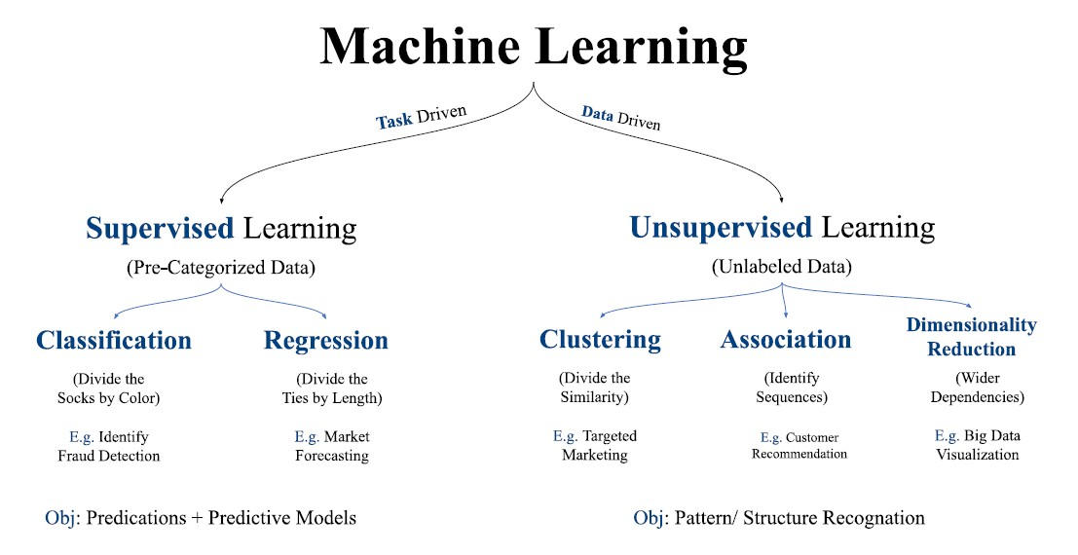
Figure 4.1 Types of Machine Learning

Supervised Learning:
- Involves training models using labeled datasets. Both input and output variables are provided during training.
- The aim is to establish a mapping function that predicts outcomes for new, unseen data.
- Common applications include classification, regression, and forecasting.

Unsupervised Learning:
- Works with unlabeled data where outputs are not known in advance.
- The model identifies hidden structures, relationships, or groupings in the data.
- Useful for clustering, dimensionality reduction, and anomaly detection.
- Focuses on discovering inherent patterns within datasets.

4.5.2 Reinforcement Learning:
- Based on decision-making through interaction with an environment.
- An agent performs actions and receives rewards or penalties as feedback.
- The goal is to learn an optimal strategy that maximizes long-term rewards.
- Widely applied in robotics, autonomous systems, and strategic game playing. [36] [37]

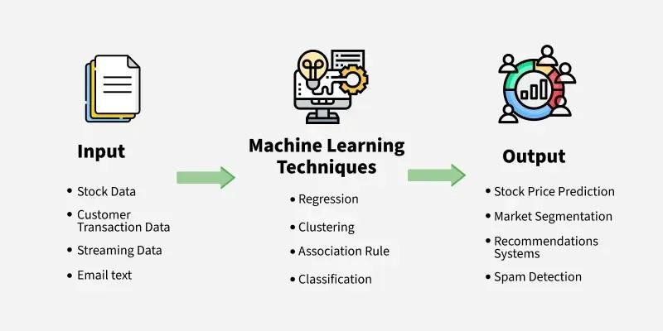
Figure 4.2 Reinforcement Learning

4.5.3 Machine Learning Models:
- These are selected for training on preprocessed network traffic data to classify anomalies: [37]
- Decision Trees: Used to create decision boundaries based on features like protocol type, service, and connection flags for detecting known and novel threats.
- Random Forests: An ensemble method that combines multiple decision trees to improve accuracy, handle imbalanced datasets, and reduce overfitting in intrusion detection.
- Support Vector Machines (SVM): Employed to find optimal hyperplanes separating normal and anomalous traffic, effective for high-dimensional data after feature reduction.
- K-Nearest Neighbors (K-NN): Applies similarity-based classification on traffic features to detect anomalies in real-time within the hybrid framework.

4.5.4 Decision Tree Model:

A decision tree is a non-parametric supervised learning algorithm used for both classification and regression tasks. It is a hierarchical, tree-like structure that consists of a root node, branches, internal nodes, and leaf nodes. The root node represents the entire dataset and the initial decision to be made, while internal nodes represent decisions or tests on attributes. Branches represent the outcome of these decisions, and leaf nodes represent the final decision or prediction. [38]

- Decision tree: a classification model based on yes/no questions and represented by a
binary tree.
- Root: the topmost node of the tree. It contains the first yes/no question.
- Node: Each yes/no question is represented by a node, or decision stump, with two branches emanating from it.
- Leaf: When we reach a point where we don’t ask a question and instead, we make a
decision
- Stub: A tree with only one node and 2 leaves. It represents a single decision. [39]

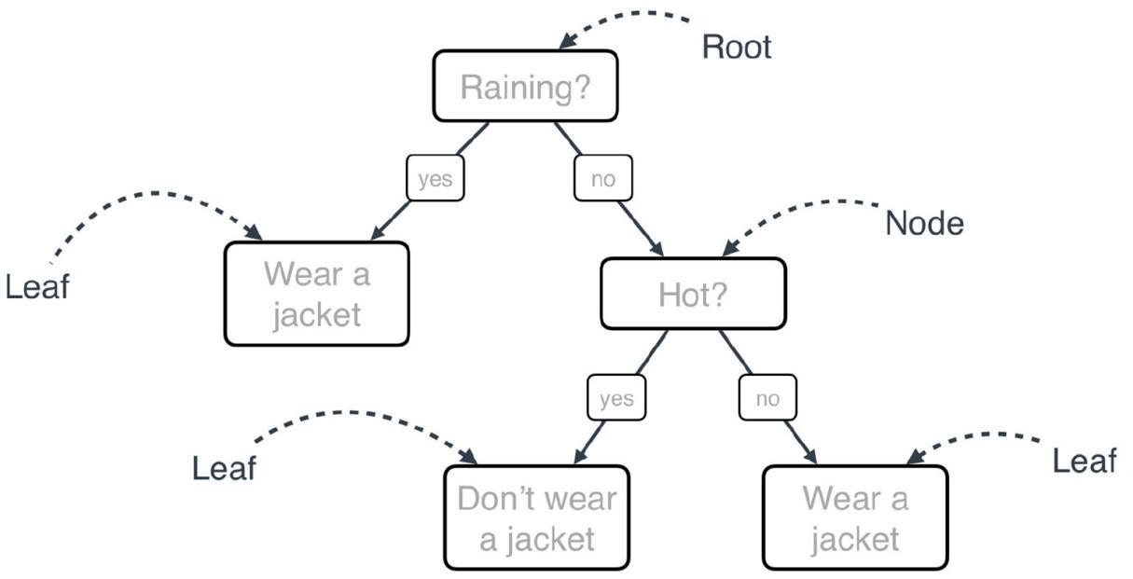
Figure 4.3 Decision Tree Model

How It Works:
Gini Impurity and Entropy are splitting criteria (also called impurity measures) used to decide the best feature to split on at each node. They quantify how "mixed" or "impure" the classes are in a dataset subset.
The algorithm chooses the split that maximizes purity (minimizes impurity) in child nodes, leading to more homogeneous leaves (e.g., all "Attack" or all "Normal"). [40]

- . Gini Impurity
  - Definition: Measures the probability of misclassifying a randomly chosen element if labeled according to the distribution in the node.
Formula (for binary/multi-class):f
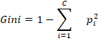 [40]
•
    - : Proportion of class in the node.
    - : Number of classes. o Range: 0 (pure, all one class) to 0.5 (max impurity for binary, e.g., 50/50 split).

- What is Entropy?
Entropy is the key measure that the Decision Tree (especially ID3 and C4.5) uses to decide which feature to split on at each node.
Entropy measures how mixed or impure a set of labels is.
  - Entropy = 0 → Perfectly pure (all samples belong to the same class) → best case!
  - Entropy = 1 → Maximum impurity (in binary classification: exactly 50% class 0, 50% class 1) → worst case!

- The Formula (Shannon Entropy)
Entropy(S) = - Σ (pᵢ × log₂(pᵢ))
where pᵢ = proportion of class is in the current node [40]

4.5.5 Random Forest Model:
Random Forest is a machine learning algorithm that combines multiple decision trees to improve prediction accuracy and reduce errors. It is widely used for both classification and regression tasks. The algorithm works by creating multiple decision trees, each trained on a random subset of the data and features, and then combining their predictions . [41]
How Random Forest Works
Each decision tree in the forest is built using a random subset of the data and features. For classification tasks, the final prediction is determined by majority voting among the trees. For regression tasks, the final prediction is the average of all three predictions. This randomness helps prevent overfitting and ensures that the model generalizes well to unseen data.
Key Features
Random Forest can handle missing data effectively and provides insights into feature importance, helping identify which features are most influential in predictions. It performs well on large datasets with many features and is versatile enough to handle both classification and regression problems.
Key Parameters:
- n_estimators: Number of trees (more = better, but slower; 100-500 common).
- max_features: Features per split (sqrt, log2, or fraction).
- max_depth: Limit tree depth to control overfitting.
- In Scikit-learn: RandomForestClassifier(n_estimators=100, criterion='gini').

How Random Forest Works
One big advantage of random forest is that it can be used for both classification and regression problems, which form the majority of current machine learning systems.
Random Forest Steps: [41]
- Split data randomly into sets:
- Train each decision tree at one of these sets.
Take decision based on vote between these models [42]ز

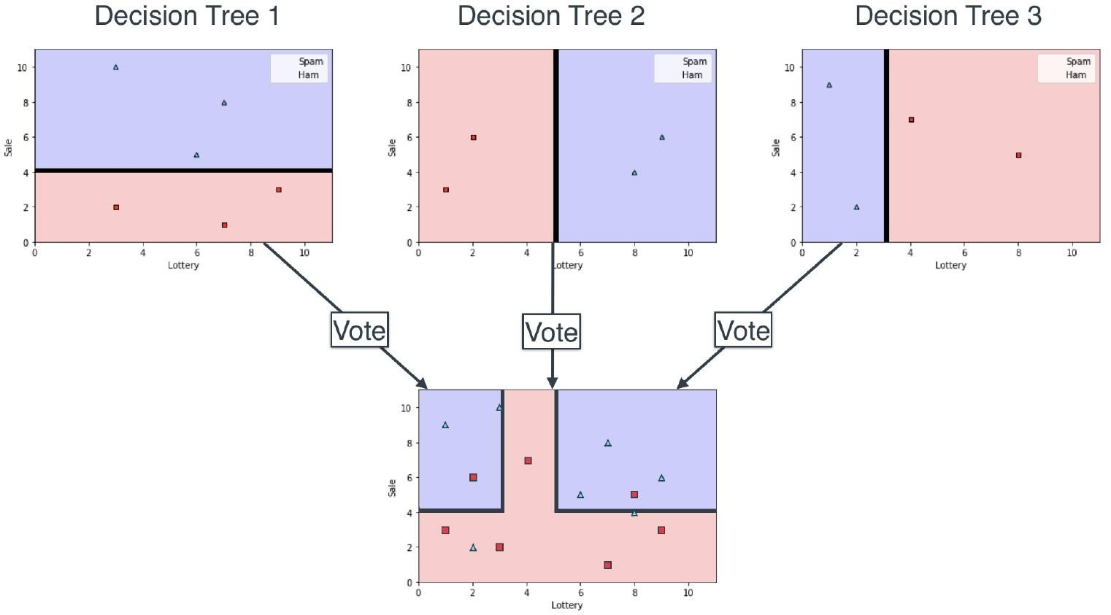
Figure 4.4 Split data randomly

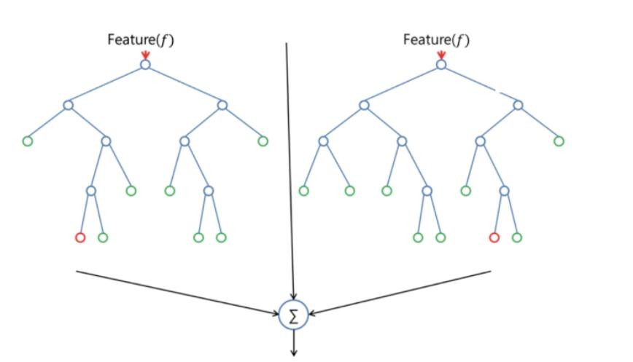
Figure 4.5 Train each decision tree

4.5.6 Random Forest Models vs. Decision Trees
While a random forest model is a collection of decision trees, there are some differences.
If you input a training dataset with features and labels into a decision tree, it will formulate some set of rules, which will be used to make predictions.
For example, to predict whether a person will click on an online advertisement, you might collect the ads the person clicked on in the past and some features that describe their decision. If you put the features and labels into a decision tree, it will generate some rules that help predict whether the advertisement will be clicked or not. In comparison, the random forest algorithm randomly selects observations and features to build several decision trees and then averages the results.
Another difference is “deep” decision trees might suffer from overfitting. Most of the time, random forests prevent this by creating random subsets of the features and building smaller trees using those subsets. Afterwards, it combines the subtrees. It’s important to note this doesn’t work every time and it also [43] makes the computation slower, depending on how many trees the random forest builds.

4.5.7 Ensemble Learner:
- Combine weak learners to form a strong one.
- Learners could be any type of machine learning model.
Ensemble Learning types:
- Bagging ⚫ Boosting Bagging:
A technique in which we build a strong learner based on a set of weak learners trained on data splitted randomly and making predictions by voting.
If these learners are decision trees, then our model is called Random Forest
Random Forest Steps:
- Split data randomly into sets.
- Train each decision tree at one of these sets.
- Take decision based on vote between these models.


Figure 4.6 Bagging

Boosting:
to increase or improve something: The company is looking for ways to boost sales in Asia, its biggest market.
A technique in which we build a strong learner based on a set of weak learners not randomly selected but trained in a smarter way and making predictions by voting. Ex: AdaBoost, XGBoost , each model trained to cover the weakness of the previous ones.
[44] [45]
Bagging (e.g., Random Forest) – “Pros & Cons”
Pros

Greatly reduces variance → strong protection against overfitting
- Very robust to noise and outliers
- Works extremely well with almost no tuning (out-of-the-box winner)
- Naturally provides feature importance
- Training is fast and fully parallelizable
- Very stable – small data changes rarely hurt performance

Cons
- Does not reduce bias much (if a single tree is weak, the forest stays somewhat weak)
- Higher memory usage (stores hundreds of full trees)
- Often beaten by boosting on leaderboards (slightly lower accuracy in many cases)
Boosting (e.g., XGBoost, LightGBM, CatBoost, AdaBoost) – Pros & Cons
Pros
- Usually achieves the highest accuracy (wins most Kaggle/tabular competitions)
- Reduces both bias and variance sequentially
- Extremely powerful on structured/tabular data
- Handles imbalanced classes very well
- Also gives reliable feature importance
- Modern implementations (XGBoost, LightGBM, CatBoost) are very fast and scalable
Cons
- Prone to overfitting if not regularized properly (especially on noisy data)
- Sensitive to outliers and label noise
- Training is sequential → slower and harder to parallelize fully
- Requires careful hyperparameter tuning (learning rate, depth, regularization, etc.)
Less interpretable than a single tree or bagging

4.5.8 Svm: support vector machine Model
An SVM algorithm, or a support vector machine learning algorithm you can use to separate data into binary categories. When you plot data on a graph, an SVM algorithm will determine the optimal hyperplane to separate data points into classes. It assists in categorizing data points and understanding how they relate to one another. While you may find infinite possibilities for separating data, a support vector machine algorithm can help you find the optimal hyperplane or the separation point that allows for the widest space gap between points [46].
How It Works:
The SVM algorithm works by locating the support vectors—the data points on the edges of an optimal hyperplane. These points are the hardest to categorize because of their distance from the middle of the group. They allow you to perform regressions and make sense of the relationships within data sets.
Key Concepts of SVM
- Hyperplane: A decision boundary that separates data points into different classes.
- Support Vectors: Data points closest to the hyperplane, which influence its position and orientation.
- Margin: The distance between the hyperplane and the nearest data points from each class. SVM maximizes this margin for better generalization.
- Kernel Trick: A technique to transform non-linearly separable data into a higherdimensional space where it becomes linearly separable.
- Kernel: A function that maps data to a higher-dimensional space enabling SVM to handle non-linearly separable data
- Hard Margin: A maximum-margin hyperplane that perfectly separates the data without misclassifications [46].
Soft Margin: Allows some misclassifications by introducing slack variables, balancing margin maximization and misclassification penalties when data is not perfectly separable.
- C: A regularization term balancing margin maximization and misclassification penalties. A higher C value forces stricter penalty for misclassifications.
- Hinge Loss: A loss function penalizing misclassified points or margin violations and is combined with regularization in SVM.
- Dual Problem: Involves solving Lagrange multipliers associated with support vectors, facilitating the kernel trick and efficient computation.

How does Support Vector Machine Algorithm Work?
The key idea behind the SVM algorithm is to find the hyperplane that best separates two classes by maximizing the margin between them. This margin is the distance from the hyperplane to the nearest data points (support vectors) on each side [47].
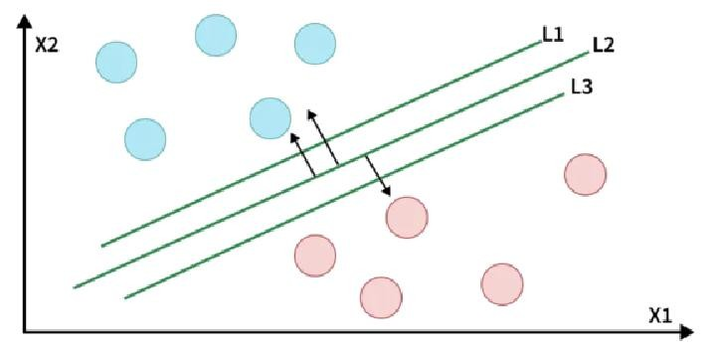
Figure 4.7 Support Vector Machine Algorithm

The best hyperplane, also known as the "hard margin" is the one that maximizes the distance between the hyperplane and the nearest data points from both classes. This ensures

a clear separation between the classes. So from the above figure, we choose L2 as hard margin.
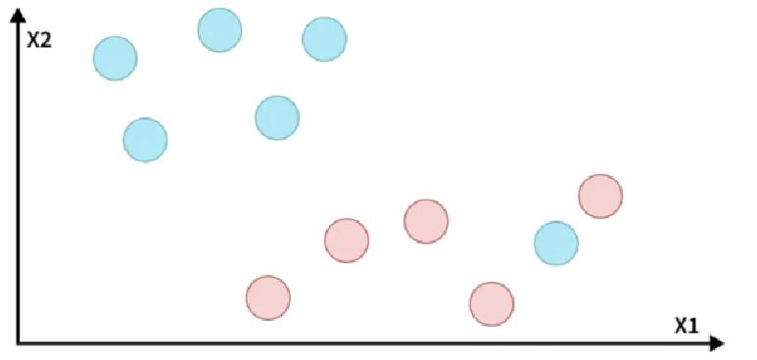
Figure 4.8 Support Vector Machine Algorithm hard margin

How does SVM classify the data?
The blue ball in the boundary of red ones is an outlier of blue balls. The SVM algorithm has the characteristics to ignore the outlier and finds the best hyperplane that maximizes the margin. SVM is robust to outliers.

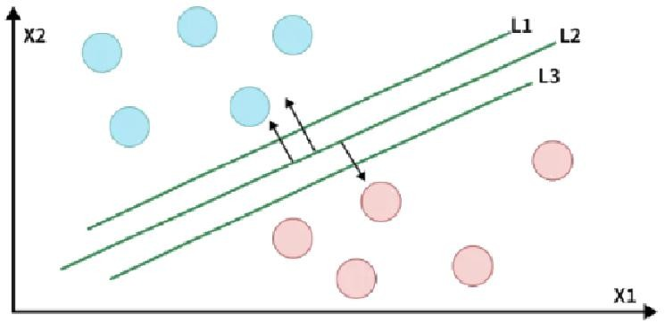
Figure 4.9 Support Vector Machine Algorithm classify the data

4.5.9 - K Nearest Neighbor Model:
The k-nearest neighbors (KNN) algorithm is a non-parametric, supervised learning classifier, which uses proximity to make classifications or predictions about the grouping of an individual data point. It is one of the popular and simplest classification and regression classifiers used in machine learning today.
While the KNN algorithm can be used for either regression or classification problems, it is typically used as a classification algorithm, working off the assumption that similar points can be found near one another. [48]
For classification problems, a class label is assigned on the basis of a majority vote—i.e. the label that is most frequently represented around a given data point is used. While this is technically considered “plurality voting”, the term, “majority vote” is more commonly used in literature. The distinction between these terminologies is that “majority voting” technically requires a majority of greater than 50%, which primarily works when there are only two categories. When you have multiple classes—e.g. four categories, you don’t necessarily need 50% of the vote to make a conclusion about a class; you could assign a class label with a vote of greater than 25%. The University of Wisconsin-Madison summarizes this well with an example
Determine distance metrics:
In order to determine which data points are closest to a given query point, the distance between the query point and the other data points will need to be calculated. These distance metrics help to form decision boundaries, which partitions query points into different regions. You commonly see decision boundaries visualized with Voronoi diagrams.
While there are several distance measures that you can choose from, this article will only cover the following:
Euclidean distance (p=2): This is the most used distance measure, and it is limited to realvalued vectors. Using the below formula, it measures a straight line between the query point and the other point being measured [48].
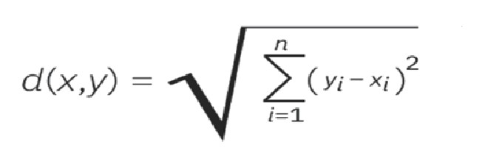
Figure 4.10 Euclidean distance

Manhattan distance (p=1): This is also another popular distance metric, which measures the absolute value between two points. It is also referred to as taxicab distance or city block distance as it is commonly visualized with a grid, illustrating how one might navigate from one address to another via city streets. [48]

Figure 4.11 Manhattan distance

4.6 Dataset Large-Scale Network Cyberattacks Multiclass Dataset 2024 (LSNM2024)
Abstract:
The landscape of cybersecurity is ever evolving, with new threats emerging constantly. To effectively combat these sophisticated attacks, researchers and developers require robust, up-to-date datasets for training advanced intrusion detection systems (IDS). The LargeScale Network Cyberattacks Multiclass Dataset 2024, or LSNM2024, emerges as a significant innovation in this domain. This dataset is meticulously designed to address the shortcomings of older benchmarks by offering a comprehensive, balanced, and modern collection of network traffic data [49].
INTRODUCTION:
- Cutting-Edge Diversity: LSNM2024 encompasses a wide array of modern cyberattack types, including those targeting IoT devices, alongside traditional network traffic, making it highly relevant for contemporary threat hunting.
- Balanced & Extensive: With 6 million traffic samples, 60 features, and an explicit 50% normal to 50% anomalous traffic distribution across 15 distinct attack types, LSNM2024 tackles class imbalance head-on, promoting more reliable machine learning model training.
- Optimized for Advanced Analytics: Designed for compatibility with sophisticated machine learning and deep learning methodologies, particularly graph-based deep learning, LSNM2024 facilitates the development of dynamic and adaptive intrusion detection systems [49].

Normal Traffic | Abnormal Traffic
Number Over 3,000,000  Samples | 3,724,869 Sample
Source Normal traffic is generated by | Gathered from multiple types of attacks (15 attacks)
using multiple techniques
Table 4.1 Normal and Abnormal Traffic Details

The pie chart in Figure 3 presents how the samples have been distributed. Creating and generating the dataset in our lab allowed us to manipulate and adjust the data to fit our model. Our dataset can be formed in various forms, including binary datasets for classifying normal and abnormal traffic, a multiclass dataset featuring samples of each attack, and a dataset containing normal traffic samples alongside labeled abnormal traffic samples for each attack [50].

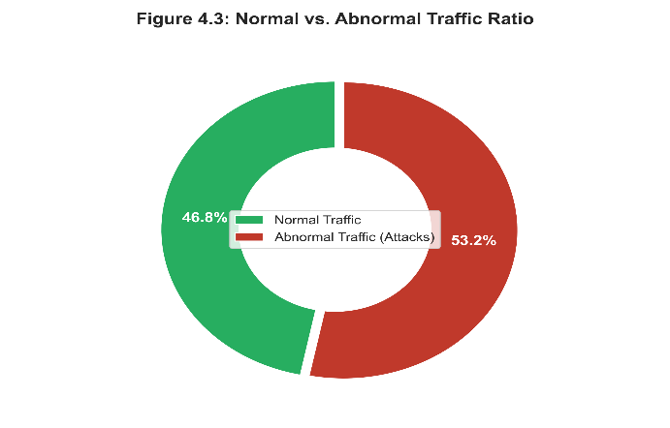
Figure 4 .122 Normal and Abnormal Traffic Details

Attack  Name | Number of Samples
MITM-  ARP-  Spoofing | 96,926
SSH Brute  Force | 139,761
FTP Brute  Force | 121,917
DDoS-  ICMP | 222,254
DDoS-  Raw | 195,148
DDoS-  UDP | 318,210
DoS | 593,624
Exploiting-  FTP | 13,573
Fuzzing | 117,559
ICMP  Flood | 240,083
SYN Flood | 739,157
Port  Scanning | 162,320
Remote  Code  Execution | 278,874
SQL  Injection | 270,000
XSS | 215,463
Total | 3,724,869
Table 4.2 Number of Samples for Each Attack

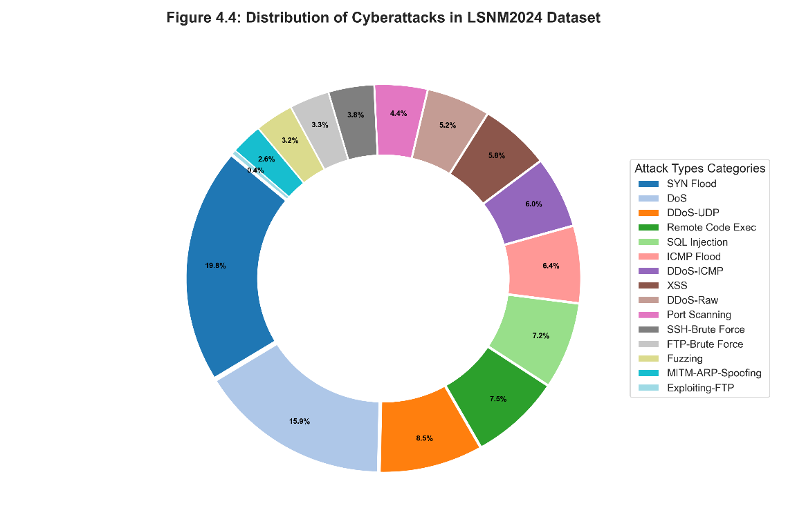
Figure 4.13 Number of Samples for Each Attack

No | Feature | Description
1 | Time | The time at which the packet was captured.
2 | Source | The packet contains the source IP address.
3 | Destination | The destination IP address of the packet.
4 | Protocol | The network protocol used: TCP, UDP, or ICMP.
5 | Length | The packet length in bytes.
6 | Info | A packet description of the communication nature.
7 | Frame Number | A frame unique identifier.
8 | Frame Length | The length of the whole frame.
9 | Same Time | What time was the frame captured?
10 | Frame Time (Epoch) | The timestamp of the frame in epoch format.
11 | Frame Protocols | Protocols used in a data frame in a hierarchy format.
12 | Ethernet Source | The MAC address of the source device in the Ethernet frame.
13 | Ethernet Destination | The MAC address of the destination device in the Ethernet frame.

14 | Ethernet Type | Indicates the payload protocol (e.g., IPv4, IPv6).
15 | IP Source | The source IP address in the IP packet.
16 | IP Destination | The IP address destination in the IP packet.
17 | IP Length | The IP packet length, including header and payload.
18 | IP TTL | Time to Live (TTL) in the IP header (number of hops before discard).
19 | IP Flags | 3-bit flag in the IP header (e.g., DF, MF).
20 | IP Fragment Offset | The offset of the fragment in the original IP packet.
21 | IP Protocol | Network layer protocol: TCP, UDP, or ICMP.
22 | IP Version | Internet Protocol version: IPv4 or IPv6.
23 | IP DSCP Field | The DSCP field indicates the packet's priority.
24 | IP Checksum | The checksum value for the IP header.
25 | TCP Source Port | The source port number in the TCP header.
26 | TCP Destination Port | The destination port number in the TCP header.
27 | TCP Length | The length of the TCP packet, including header and payload.
28 | TCP Sequence Number | The sequence number in TCP header is used for reordering.
29 | TCP Ack Number | The acknowledgment number in TCP header.
30 | TCP Flags | TCP header flags indicate control info (SYN, ACK, FIN, etc.).
31 | TCP SYN Flag | Synchronization request flag in TCP header.
32 | TCP ACK Flag | Acknowledgment flag in TCP header.
33 | TCP FIN Flag | Finish flag in TCP header.
34 | TCP RST Flag | Reset flag in TCP header.
35 | TCP Window Size | Receive window size in TCP header (data size before ACK).
36 | TCP Checksum | The checksum value for TCP header.
37 | TCP Stream | The TCP stream identifier.
38 | UDP Source Port | The source port number in UDP header.
39 | UDP Destination Port | The destination port number in UDP header.
40 | UDP Length | The length of the UDP packet, including header and payload.
41 | UDP Checksum | The checksum value for UDP header.
42 | ICMP Type | The type of ICMP message (if the packet is ICMP).
43 | ICMP Checksum | The checksum value for ICMP header.
44 | HTTP Request | The HTTP request method (GET, POST, etc.).
45 | HTTP Request URI | The Uniform Resource Identifier (URI) requested.
46 | HTTP Request Version | The version of HTTP protocol used in the request.
47 | HTTP Full URI | Full URI includes method, URI, and version.
48 | HTTP Response Code | The HTTP status code returned in the response.
49 | HTTP User-Agent | The user-agent string indicates the client software.
50 | HTTP Content-Length | The length of the HTTP content in payload.
51 | HTTP Cookie | The value of the Cookie header in HTTP request.
52 | HTTP Host | The value of the Host header in HTTP request.
53 | HTTP Referer | The value of the Referer header indicate referring page.
54 | HTTP Location | The value of the Location header in HTTP response (redirect URL).
55 | HTTP Authorization | The value of Authorization header indicating credentials.
56 | HTTP Connection | The value of Connection header indicates if connection should be kept alive.
Table 4.3 Dataset Features
This dataset has over 60 different features . This high number of features collected for each attack will assist in creating a highly precise and accurate model that can classify any traffic fed to it. The following section will name some of the more noteworthy features and provide a brief description of each of them. In addition, these features have the highest weight in determining what the incoming traffic represents to ensure it is classified precisely, achieving the least number of false positives and negatives possible to fit your needs.

Characteristic | LSNM2024 | CSE-CIC-  IDS2018 | CIC-IDS2017
Dataset Release Year | 2024 | 2018 | 2017
Total Traffic  Samples (approx.) | 6,000,000 | ~16,200,000 | ~2,830,000
Number of Features | 60 | 80 | 78
Traffic Distribution  (Normal/Anomalous) | 50% / 50%  (balanced) | ~70% / 30%  (partially balanced) | ~80% / 20% (imbalanced)
Number of Attack  Types | 15 | 15 (from 8 families) | 14 (from 7 families)
Data Types Included | PCAP + Flow +  IoT + Synthetic | Flow and packetlevel data | Flow, packet, and network logs
Key Focus / Use  Cases | Advanced threat hunting, graphbased ML, dynamic IDS | Realistic cyber defense, IDS training, anomaly detection | IDS and ML model benchmarking, real-world data resemblance
IoT Attack Coverage | Yes | Yes | Limited
Graph-based  Modeling Suitability | High | Moderate | Low
Public Availability | Open with citation  (Mendeley Data) | Public on CIC website / AWS  Registry | Public on CIC website
Table 4.4 Compare between datasets

4.7 CERT Insider Threat Dataset

4.7.1 Abstract
Developed by the CERT Division at Carnegie Mellon University to study and analyze insider threats within organizations. The dataset simulates both normal and malicious employee behaviors through various activity logs, including logins, device usage, email communications, file access, and web browsing. It contains thousands of records with a significant imbalance between normal activity and threat activity, providing a realistic challenge for anomaly detection and machine learning models aimed at identifying insider threats [51].

4.7.2 introduction
The CERT Insider Threat dataset is widely used in cybersecurity research for detecting threats originating from within an organization. It was created with guidance from the DARPA CERT Division and ExactData LLC to simulate the behavior of both normal employees and malicious insiders over several months.
One of the most used versions, r4.2, contains:
- 32,770,227 events from 1,000 employees,
- 70 insiders (malicious employees),
- 7,323 threat events within the dataset.
The logs are divided into several files covering different activity types:
- Logon/logout activities (logon.csv)
- Device usage (device.csv)
- Email communications (email.csv)
- Web browsing (http.csv)
- File access (file.csv)
- Psychometric/personality data for analysis (psychometric.csv)
Version | Number  Users | of | Number  Insiders | of | Total Events | Threat  Events
r4.2 | 1,000 |  | 70 |  | ~32,770,227 | 7,323
r6.2 | 2,500 |  | 5 |  | ~135,117,169 | 470
Table 4.5 Users and Threats
File Name | Activity Type | Approx.  Records | Number | of
logon.csv | Logon/logout | ~854,859
file.csv | File operations | ~445,581
http.csv | Web browsing | ~38,500,822
email.csv | Email communications | ~2,629,979
device.csv | External device usage | ~405,380
Table 4.6 Number of Records
File Name | Activity Type | Number  Features | of | Example Features
logon.csv | Logon/Logout | 5 |  | ID, date, user, PC, activity
device.csv | External Device  Usage | 5 |  | ID, date, user, PC, activity  (connect/disconnect)
email.csv | Email  Communications | 10 |  | ID, date, user, PC, to, cc, bcc, from, size, attachment count
http.csv | Web Browsing | 6 |  | ID, date, user, PC,  URL, content
file.csv | File  Access/Operations | 6 |  | ID, date, user, PC, filename, content
psychometric.csv | Personality/Employee  Data | 7 |  | employee, user_id, O, C, E, A, N (Big Five personality  traits)
Table 4.7 Features of CERT

CHAPTER 5 IMPLEMENTATIO
N

Chapter 5 Implementation

5.1 Introduction
This chapter presents the practical implementation of the proposed AI-Based Intrusion Detection and Prevention System (AI-Based IDS/IPS). The system is designed to enhance network security by leveraging Artificial Intelligence techniques, including machine learning, to analyze both network traffic and host activities and accurately detect malicious behavior. The proposed approach can identify both known attacks and previously unseen threats through intelligent pattern recognition and behavioral analysis.
The system integrates both intrusion detection and intrusion prevention mechanisms, operating on both network-based and host-based levels. This enables the system not only to detect suspicious activities but also to automatically respond to mitigate potential threats in real time, reducing the risk of network compromise and service disruption.
The implementation of each model follows a structured, multi-phase methodology, guiding the project from data collection, through preprocessing, feature extraction, model design, and training, up to preliminary performance evaluation. This chapter details the first five phases, including data gathering, preprocessing, feature engineering, model construction, and initial evaluation, while subsequent phases—covering advanced testing, system integration, and deployment strategies—are discussed in the following chapters.

5.2 System Architecture
This figure illustrates an AI-driven security architecture designed to protect networks by integrating both online and offline models, ensuring maximum defense against cyberattacks. In simple terms, it represents the journey of a data packet from the open internet until it safely reaches your device.
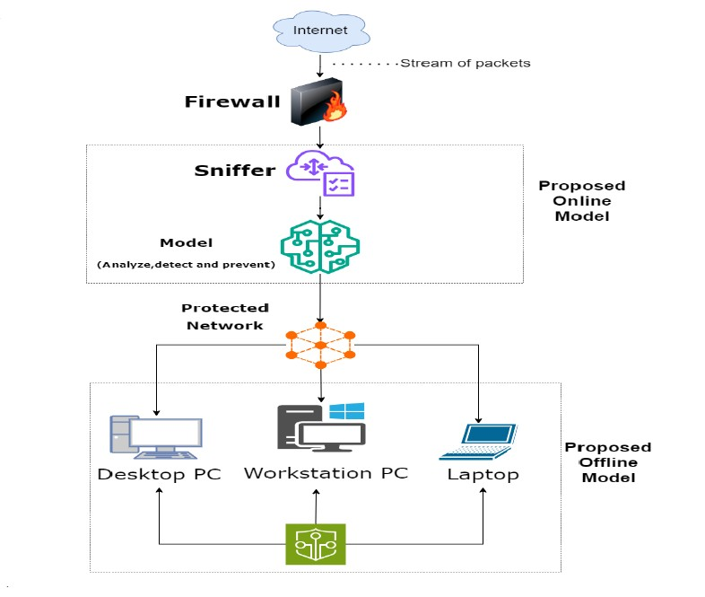
Figure 5.1 Online & Offline Protection

5.2.1 System Architecture Steps
- Internet & Stream of Packets
The system begins with the flow of data and information packets arriving from the global Internet toward the local network. This represents the entry point of all incoming traffic.
- Firewall
The firewall serves as the first line of defense, acting as a basic filter to block unauthorized traffic based on predefined security rules.
- Proposed Online Model
The online AI model functions as the "brain" that monitors live data entering the network. It consists of two main components:
- Sniffer – captures and inspects packets in transit for content analysis.
- AI Model – analyzes the data, detects potential threats, and prevents them automatically in real time.
- Protected Network
The protected network is the safe zone where data, after being filtered and verified by the intelligent systems, is securely distributed.
- Proposed Offline Model
The offline model provides an additional internal security layer (Endpoint Security), installed directly on end devices to detect and handle threats that may originate internally.
- End Devices
The final beneficiaries include desktops, workstations, and laptops, which are fully protected from both internal and external threats.

This two-layer approach ensures comprehensive protection. The online model guards the network gateway, while the offline model protects the individual hosts, creating a resilient and layered security posture.

5.2.2 Development Lifecycle
This diagram represents the AI System Development Lifecycle. It is an iterative process designed to transform raw data into an intelligent model, ensuring continuous updates based on real-world feedback.
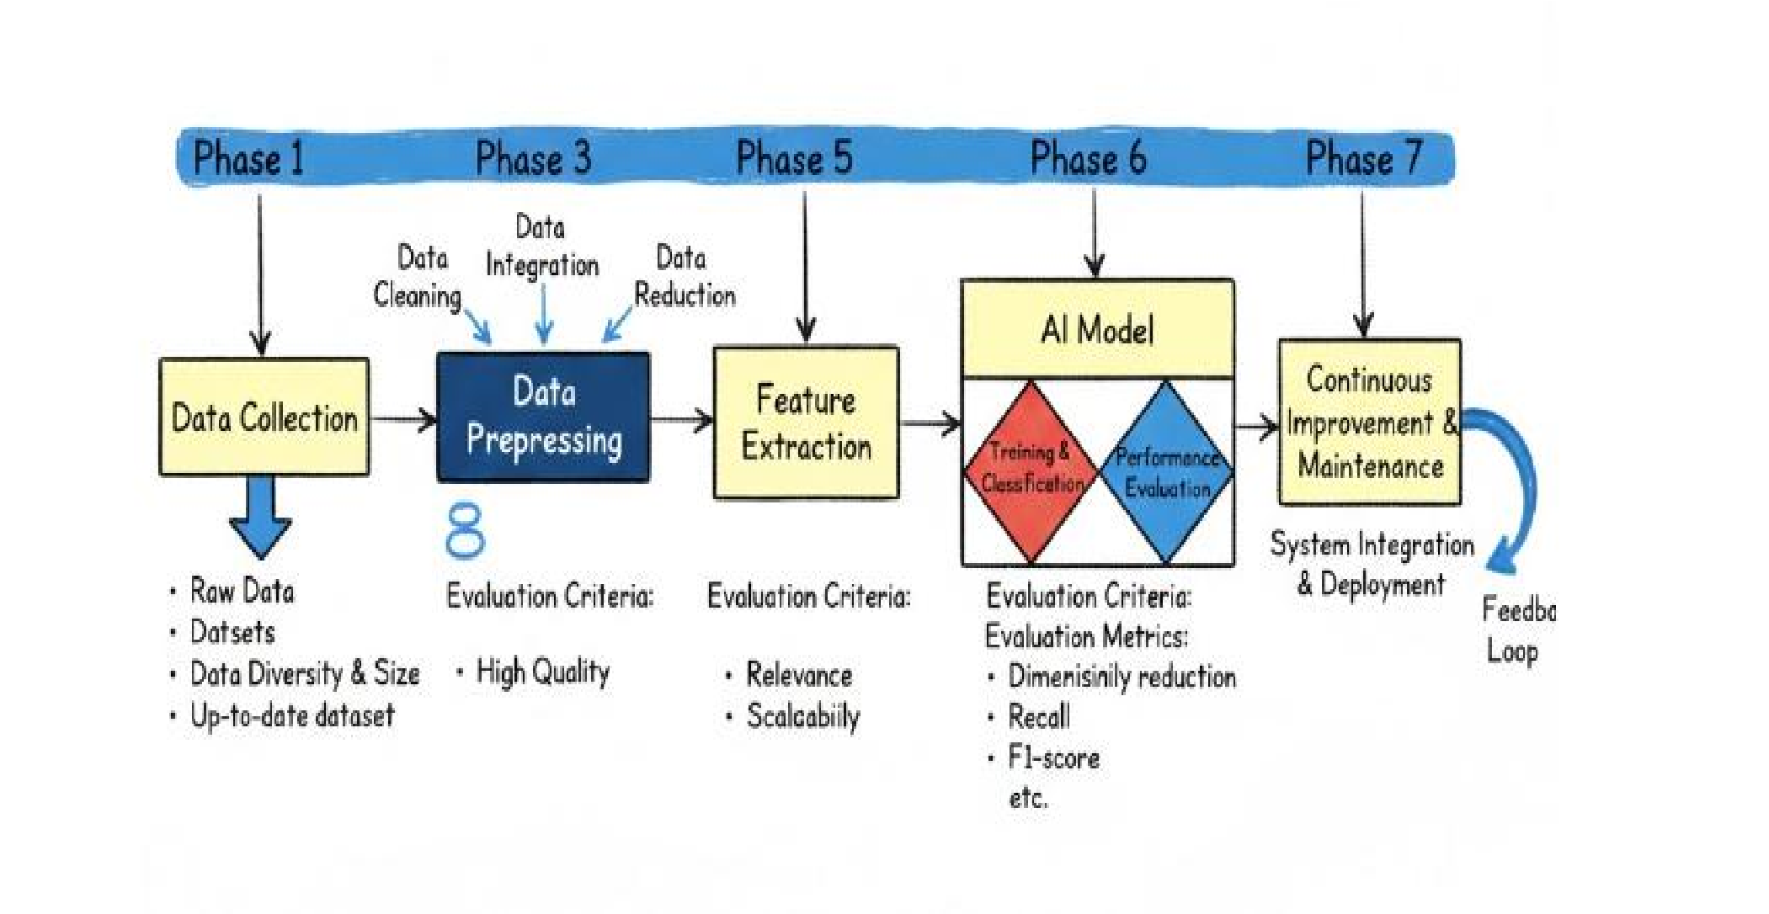
Figure 5.2 Ai Lifecycle

Development of lifecycle steps :
- Data Collection:
  - The foundation phase where raw datasets are gathered from various sources. o Evaluation Criteria: Data diversity, dataset size, and ensuring the data is up to date.
- Data Preprocessing:
  - The process of transforming raw data into a clean format suitable for analysis.
  - Includes three sub-processes: Data cleaning, integration, and reduction to ensure high data quality.
- Feature Extraction:
  - Identifying and generating the key characteristics (features) that help the model learn and understand.
  - Evaluation Criteria: Feature relevance and scalability.
- Feature Selection:
  - Choosing the most effective features to reduce complexity and improve model speed. o Evaluation Criteria: Dimensionality reduction to simplify computational tasks.
- AI Model:
  - The central phase involves training and classification to teach the model.
  - Performance Evaluation: Uses metrics such as Accuracy, Recall, and F1score.
- System Integration and Deployment:
  - After verifying the model's efficiency, it is integrated into the actual system and deployed for final use.
- Continuous Improvement and Maintenance:
  - The process continues by monitoring performance and using a feedback loop to update the model based on new real-world data.

5.3 The Online Model: Network-Based Detection

5.3.1 Overview
The Online Model represents the first intelligent security layer within the proposed AIBased IDS/IPS framework. It is designed to perform real-time monitoring and analysis of incoming network traffic before it reaches the internal network infrastructure. Operating at the network gateway level, the model continuously inspects data packets to identify suspicious patterns and potential cyber-attacks.

5.3.2 Dataset and Selection Rationale
For the development and evaluation of the proposed AI-Based IDS/IPS system, the LSNM2024 dataset was selected as the primary data source. The selection of this dataset was based on several critical factors that align with the objectives of this research.
First, LSNM2024 represents a cutting-edge and diverse cybersecurity dataset, encompassing a wide range of modern attack scenarios . This diversity makes it highly suitable for evaluating intelligent intrusion detection systems in contemporary threat environments.
Second, the dataset provides a balanced distribution of traffic, consisting of approximately 6 million samples with an equal ratio of 50% normal and 50% anomalous traffic. This balanced structure addresses the class imbalance problem commonly found in cybersecurity datasets and enables more reliable and unbiased machine learning model training.
Furthermore, LSNM2024 contains over 60 comprehensive network features, extracted at packet and flow levels. These features cover IP, TCP, UDP, ICMP, HTTP, and Ethernetlevel attributes, allowing deep behavioral analysis of network traffic. The richness of features enhances the model’s ability to detect subtle attack patterns while minimizing false positives and false negatives.
In comparison to other well-known datasets such as CIC-IDS2017 and CSE-CIC-IDS2018, LSNM2024 demonstrates improved balance, broader IoT attack coverage, and higher suitability for advanced AI-based and graph-based deep learning techniques. Therefore, it was selected as the most appropriate dataset for this study.

5.3.3 Data Collection and Feature Extraction
The dataset consists of approximately 6 million traffic samples collected in a controlled laboratory environment. Traffic includes:
- Over 3,000,000 normal samples are generated through multiple legitimate network activities.
- 3,724,869 abnormal samples collected from 15 distinct attack types, including DDoS, SYN Flood, SQL Injection, XSS, Remote Code Execution, and others.
- The dataset was generated and structured in different formats to support multiple classification scenarios:
- Binary classification (Normal vs. Abnormal)
- Multi-class classification (Individual attack types)
- Labeled attack-based datasets
- Benign Traffic Generation
To overcome the shortcomings of laboratory data, a dedicated capture tool (Sniffer) is designed to work on the wireless network card (WLAN) of the target operating environment. Natural traffic was captured in real time (Real-time) during periods of normal use (web browsing, video streaming, file transfer), resulting in the construction of an accurate file (Profile) that reflects the "behavioral footprint" of the local network. This traffic was combined with LSNM2024 data, contributing to the construction of a balanced and customized dataset for the living environment, effectively eliminating the problem of false alarms when publishing the model (Deployment).
- Malicious Traffic Acquisition
Malicious network traffic was sourced from the Large-Scale Network Cyberattacks Multiclass Dataset (LSNM2024). This dataset provides a comprehensive collection of modern cyber threats, encompassing over 3.7 million anomalous samples distributed across 15 distinct attack categories, including Distributed Denial of Service (DDoS) variants, SYN-Floods, and Man-in-the-Middle (MITM) ARP Spoofing. The benign traffic inherently present in the LSNM2024 dataset was intentionally excluded. Since this benign traffic was generated within a controlled virtual laboratory environment utilizing simulation tools, it lacks the stochastic noise and behavioral nuances characteristic of real-world production networks.

5.3.4 Feature Extraction and Feature Selection

Feature engineering is a critical determinant of an IDPS's computational efficiency and predictive accuracy. While the original LSNM2024 dataset contains over 60 network features, preliminary analysis revealed that many of these attributes constitute metadata generated by packet capture tools (e.g., frame numbers and descriptive information) rather than intrinsic packet characteristics.
- Feature Selection
Feature selection is a pivotal phase in the development of a robust Intrusion Detection System (IDS). It primarily aims to reduce dimensionality and eliminate irrelevant or redundant data that could lead to overfitting. Relying on the LSNM2024 dataset, which originally encompasses over 60 distinct features extracted from network traffic, a rigorous and targeted methodology was applied. The objective was to isolate the features most indicative of anomalous behavior within the network and transport layers, ensuring the model operates with exceptional efficiency in a live traffic environment.
- The feature selection strategy was constructed around three foundational pillars:
- Elimination of Explicit Identifiers to Prevent Data Leakage
To guarantee the model's generalization capabilities across diverse network environments, all features representing explicit device identities or network addresses tied to the initial virtual lab setup were systematically excluded. This included dropping source and destination IP addresses, Ethernet MAC addresses, and raw timestamps. Retaining these attributes would inevitably result in "data leakage," a scenario where the model erroneously learns to associate an attack with a specific IP address rather than the underlying behavioral pattern of the threat. Removing these identifiers ensures the model remains highly effective when deployed in real-World network characterized by dynamic IP allocations.
- Filtration of Application-Layer Features
Given the system's architectural mandate to detect network infrastructure threats—such as Denial of Service (DoS/DDoS) and Port Scanning—and the explicit decision to exclude application-layer web attacks (e.g., Cross-Site Scripting (XSS) and SQL Injection), features associated with application-layer protocols were entirely discarded. Consequently, properties related to HTTP traffic (such as the HTTP Request Method, User-Agent, and Cookie) and DNS queries were removed. This aggressive filtration significantly reduced the computational overhead, yielding a highly specialized, lightweight model optimized for rapid packet processing.
- ​Prioritization of Behavioral and Statistical Features
Following the filtration process, the feature space was refined to focus exclusively on a curated subset of attributes that reflect the technical state of data packets. These features serve as resilient indicators of malicious network activity. The retained feature set heavily emphasizes:
Network Protocols:
- Identifying the connection type (TCP, UDP, or ICMP) via the IP Protocol attribute.
- ​TCP Header Characteristics: Heavy reliance was placed on TCP control flags (SYN, ACK, FIN, RST). These flags are indispensable for detecting reconnaissance attempts (e.g., Port Scanning) and network flooding attacks (e.g., SYN Flood). The TCP Window Size was also retained as a critical metric for assessing connection health.
        - ​Packet Dimensions and Lifespan: Features detailing packet sizes (e.g., Frame Length, IP Length) and the Time to Live (IP TTL) were integrated. Anomalous or highly repetitive variations in packet lengths and TTL values frequently accompany Brute Force and volumetric DDoS attacks.
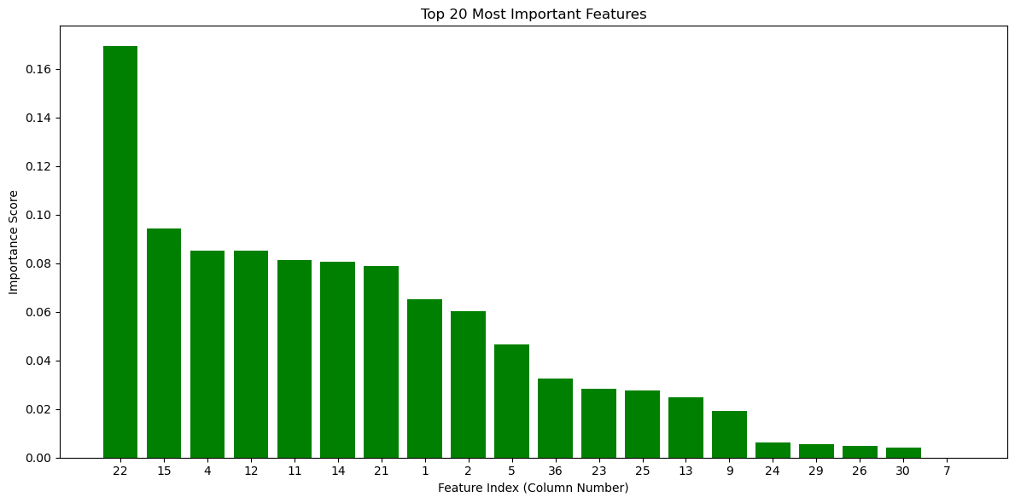

5.3.5 Data Preprocessing Pipeline:

Data preprocessing plays a pivotal role in ensuring the quality, consistency, and structural integrity of inputs for machine learning models. In the context of a live-traffic Intrusion Detection System (IDS), the preprocessing pipeline must not only clean the historical training data but also function as a highly efficient, real-time transformation engine for incoming network streams. To achieve this, a systematic, multi-stage preprocessing workflow was architected, comprising data imputation, encoding, standardization, and class balancing.

​Data Imputation for Pipeline Resilience

In live network environments, packet captures can occasionally suffer from corruption, dropped frames, or malformed headers, resulting in missing values within the feature set. To prevent systemic failures during real-time inference, a robust imputation strategy was implemented using SimpleImputer. Missing numerical values were substituted with the feature's statistical mean, while categorical anomalies were replaced using the most frequent category (mode). This ensures continuous, uninterrupted traffic analysis without discarding potentially malicious packets. 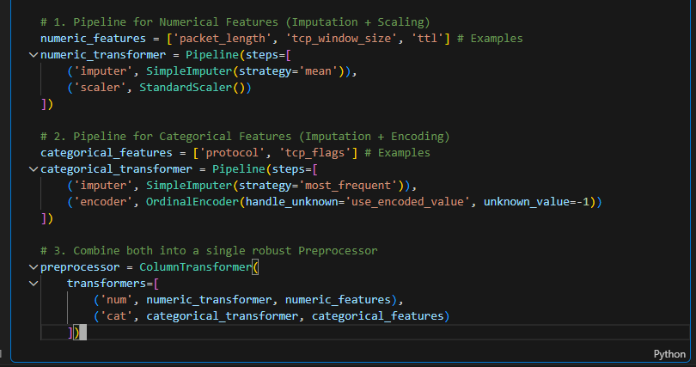

​Categorical Data Encoding

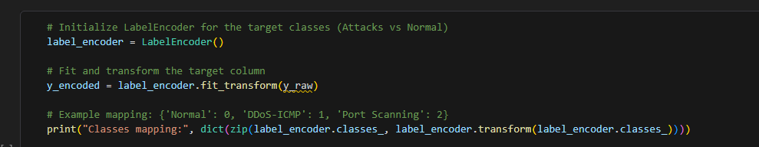
Machine learning models, particularly highly optimized tree-based algorithms like XGBoost, necessitate numerical matrices for computation. Network traffic inherent in the LSNM2024 dataset contains categorical string variables, such as protocol types and specific flag states. To bridge this gap, an OrdinalEncoder was utilized to map categorical network features into unique integer representations. Simultaneously, a LabelEncoder was applied to the target variable to transform the diverse attack class labels (e.g., "DDoS-ICMP", "Port Scanning") into a standardized numerical format suitable for multi-class classification.

Feature Scaling and Standardization

Although tree-based ensemble models exhibit natural resilience to unscaled data, maintaining uniform variance across all features is an architectural best practice that enhances algorithmic stability. A StandardScaler was deployed to standardize continuous features, normalizing their distribution by removing the mean and scaling them to unit variance. This prevents features with inherently large numerical ranges, such as Packet Length or Window Size, from disproportionately influencing the model's decision boundaries compared to smaller-scale features like TCP Flags.

​Mitigating Class Imbalance via SMOTE

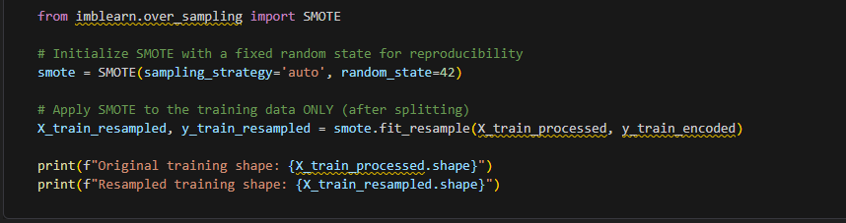
A persistent challenge in cybersecurity datasets is the extreme class imbalance; volumetric attacks like SYN Floods generate millions of samples, whereas targeted exploits like FTP Brute Force yield significantly fewer. To prevent the model from developing a bias toward majority classes, the Synthetic Minority Over-sampling Technique (SMOTE) was integrated into the training phase. By interpolating between minority class instances and their k-nearest neighbors, SMOTE generated synthetic samples for underrepresented threats. This proactive measure substantially improves the model's recall and fairness, ensuring high-fidelity detection across the entire threat spectrum.

Stratified Data Partitioning

To rigorously validate the model's generalization capabilities, the preprocessed dataset was partitioned using StratifiedShuffleSplit. This technique guarantees that the proportional distribution of normal traffic and specific attack classes remains strictly preserved across the training, validation, and testing subsets. Maintaining this class consistency is essential for accurately benchmarking the model's performance against rare cyber threats. 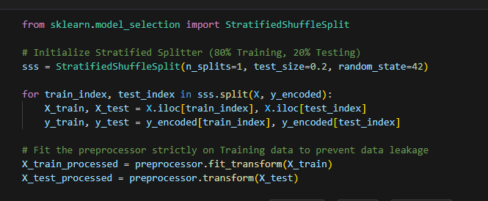

​Pipeline Serialization for Live Deployment

Crucially, for the IDS to function in a live production environment, all preprocessing objects including the fitted imputers, encoders, and scalers—were serialized and exported using the pickle module. This ensures complete reproducibility; the exact mathematical transformations applied to the historical training data are instantaneously applied to live, incoming network packets prior to model inference.

5.3.6 AI Model Training :

In the domain of real-time Intrusion Detection Systems (IDS), the selected artificial intelligence architecture must satisfy two critical, often competing, engineering mandates: exceptional classification accuracy and ultra-low prediction latency (high throughput). While Deep Learning models demonstrate high accuracy, their computational overhead during inference makes them suboptimal for line-rate network packet inspection. Conversely, classical tree-based algorithms, such as Decision Trees (DT) and Random Forests (RF), have proven highly effective in this dataset, with DT achieving detection times as low as 1.1 microseconds.

​Building upon the empirical success of ensemble tree methods, eXtreme Gradient Boosting (XGBoost) was selected as the primary classification engine for this live-traffic implementation. XGBoost provides a highly optimized, scalable implementation of gradient-boosted decision trees, inherently designed to balance execution speed with state-of-the-art predictive performance.

​1. Hardware-Accelerated Training (GPU Utilization)

To effectively manage the massive scale of the network dataset (exceeding 6 million instances) and to drastically reduce training epochs, the training pipeline was engineered to exploit hardware acceleration. Utilizing the Compute Unified Device Architecture (CUDA) framework, the model seamlessly integrates with the NVIDIA RTX Graphics Processing Unit (GPU). By configuring the algorithm's tree_method to the histogram-based architecture (hist) and mapping the computational graph to the cuda device, the model leverages thousands of parallel GPU cores. This architectural decision reduces training time from hours to mere minutes, allowing for rapid iterative testing and hyperparameter tuning.

​2. Algorithmic Configuration and Hyperparameter Tuning

The model was configured to handle the multi-class nature of the network anomalies (identifying specific attacks rather than just binary anomaly detection). Key hyperparameters were strategically defined to prevent overfitting and ensure robust generalization against varying live-traffic patterns:

​Estimators (n_estimators): Defined the maximum number of boosting iterations (trees). A sufficient number was selected to capture complex attack signatures without inducing model bloat.

​Tree Depth (max_depth): Constrained the depth of individual trees to prevent the model from memorizing the specific noise of the virtual lab environment, ensuring it focuses solely on broader behavioral networking patterns.

​Learning Rate (learning_rate): Applied step-size shrinkage during the boosting process to enhance algorithmic stability and convergence.

​3. Model Training and Evaluation Dynamics

The engineered XGBoost classifier was fitted using the strictly partitioned, resampled training data (incorporating SMOTE for minority classes). During the training phase, the model iteratively minimizes the logarithmic loss function, learning the precise thresholds of features such as TCP flags, packet lengths, and TTLs that distinguish benign traffic from volumetric and reconnaissance attacks. 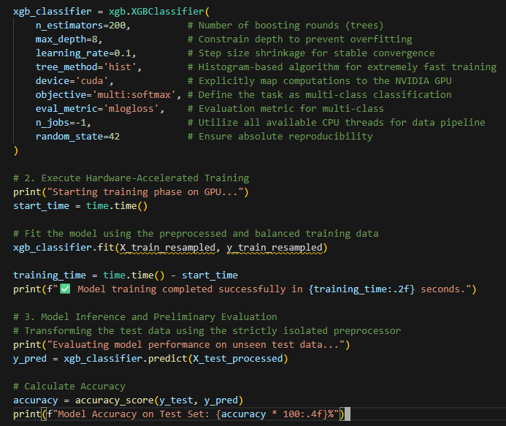

5.4 The Offline Model: Host-Based Detection

5.4.1 Overview
In this study, the CERT r4.2 Insider Threat Dataset was utilized as the primary data source for developing and evaluating the offline, host-based detection model. This dataset is widely recognized as a benchmark in the field of insider threat detection research and has been extensively used in academic and industrial cybersecurity studies.
The dataset was generated by the CERT division at Carnegie Mellon University's Software Engineering Institute (SEI) specifically to support research in insider threat detection and behavioral analytics. It simulates realistic organizational environments and includes synthetic yet behaviorally accurate logs representing employee activities over an extended period.
Unlike traditional network intrusion datasets that focus on external attacks, the CERT r4.2 dataset concentrates on malicious activities originating from internal users, making it highly suitable for endpoint-level monitoring and host-based anomaly detection systems. The dataset includes multiple log sources collected at the host and enterprise levels, such as:
- Logon and logoff activities
- Device usage records (e.g., USB insertions and removals)
- File access and modification logs
- Web browsing history
- Email communications metadata
- Psychometric and behavioral attribute indicators
These diverse data sources enable comprehensive behavioral profiling of users, allowing the proposed offline AI model to detect suspicious patterns such as data exfiltration, privilege misuse, policy violations, and other insider-related threats. The selection of CERT r4.2 aligns with the objectives of this research, as the offline model aims to provide an additional security layer focused on internal threat detection and endpoint protection, complementing the online network-based detection system.

5.4.2 Dataset and Selection Rationale
In this study, the CERT r4.2 Insider Threat Dataset was selected to develop the offline host based detection model due to its strong focus on insider threat scenarios and realistic simulation of organizational user behavior. Unlike traditional network-based datasets, CERT r4.2 provides multi-source host-level logs, including logon activities, file access, device usage, web browsing, and email records, enabling comprehensive behavioral analysis. Its temporal structure and widespread recognition as a research benchmark further enhance its suitability for modeling and detecting internal malicious activities within endpoint environments.

5.4.3 Data Collection
The CERT r4.2 dataset was synthetically generated to simulate the activities of approximately 4,000 employees within a virtual enterprise environment over a period of 18 months. The dataset contains millions of event records collected from multiple hostlevel log sources, representing both normal and malicious user behavior.
The data includes structured log files such as:
- Logon data (hundreds of thousands of authentication events)
- Device logs recording USB insertions and removals
- File access logs containing millions of file interaction events
- HTTP web browsing logs
- Email metadata records

Malicious insider scenarios were embedded within the normal activity streams and included different threat types such as data theft, IP sabotage, and privilege abuse. In total, the dataset contains multiple insider threat cases distributed across different behavioral categories. Each event is timestamped, enabling chronological behavioral tracking and sequence-based analysis, which is essential for building temporal anomaly detection models.

Dataset Composition :
The dataset consists of four main activity files that capture different aspects of user behavior:

File | Description | Number of Records
logon.csv | User logon/logoff events | 40,000
device.csv | USB connect/disconnect events | 40,000
http.csv | HTTP web requests | 50,000
file.csv | File operations (open, read, write, copy, delete) | 445,581
Table 5.1 Dataset Composition
Dataset Characteristics:

- Diversity: Multiple activity types (logon, device, HTTP, file operations)
- Size: Large-scale dataset with approximately 1 million records
- Users: 1,000 unique users (with 30 malicious users in scenario 1)
Phase 2: Day-Level Feature Engineering (Initial Approach)
Objective: Extract behavioral features for each user per day
Table 4.8 User Feature
Metric | Value
Total Samples | 59,526 days
Attack Samples | 868 days
Attack Ratio | 1.46%

Problems Identified:
- Too many samples with sparse attacks
- High noise from daily fluctuations
- Model confused by normal vs suspicious days
- Low detection rate (only 44%)
Data Preprocessing:

Data Integration (Concatenation)
I integrated the four separate activity files into a single comprehensive dataset:

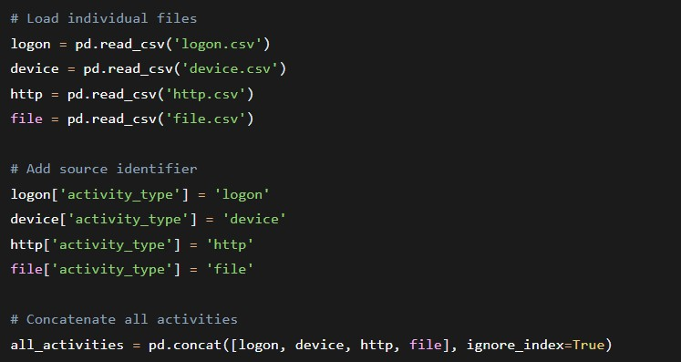

2. Handling Missing Values
After concatenation, some columns contained NaN values due to different file structures:

Table 4.9 Handle missing value
File | 445,581 | Dropped
content | 445,581 | Dropped
url | 930,000 | Dropped
activity | 0 | No missing values after cleaning

Comparison with Original Paper:

Aspect | Original Paper | Our Implementation
Data Integration | Manual concatenation | Using Pandas
Missing Values | Not Specified | Fully Handled
Table 4.10 Host comparison

Phase 3: Feature Selection:
Feature Engineering
The final dataset comprises a set of behavioral features engineered from raw log data to capture user activity patterns. These features can be grouped into three main categories: logon behavior, USB device activity, and file access patterns.

User-Level Feature Engineering (Final Approach)
Objective: Aggregate ALL user activity into comprehensive behavioral profiles
Why This Change?

Instead of asking "Is this day suspicious?", we ask "Is this user malicious?" - a much more meaningful security question.

Logon Behavior Features:
- Total logon count: The total number of logon events performed by each user
- Average logon hour: The mean time of day when logons typically occur
- Logon hour irregularity: The standard deviation of logon hours, indicating consistency in logon timing
- Weekend logons: The count of logon events occurring during weekends
- After-hours logons: The number of logons performed outside standard work hours
- Unique workstations used: The number of distinct computers accessed by the user

USB Device Activity Features:
- Total USB activity: The overall count of USB device connections
- Unique workstations with USB: The number of distinct computers where USB devices were used
- Average USB hour: The mean time of day when USB devices are connected
- After-hours USB usage: The count of USB connections occurring after work hours

File Access Features:
- Total file activities: The overall count of file access events
- Unique files accessed: The number of distinct files accessed by the user
- Unique workstations for files: The number of distinct computers used for file access
- Average file access hour: The mean time of day when file access occurs
- After-hours file access: The count of file access events after work hours

Aggregation Methods

Method | Description | Features
Sum | Total counts over all days | total_logons, weekend_logons, after_hours_logons, total_ device_activities, total_file_activities
Mean | Average behavior | avg_ logon_ hour, avg _device_ hour, avg _file_ hour
STD | Irregularity measure | std_logon_hour
UNIQUE | Diversity measure | unique_pcs_logon, unique_pcs_device, unique_pcs_file, unique_files
Table 4.11 Aggregation Methods

Final Dataset Structure:
Features | Description | Aggregation
Total _logons | Total login count | Sum
Avg _logon _hour | Average login hour | Mean
Std _logon _hour | Login hour irregularity | STD
Weekend _logons | Weekend login count | Sum
After _hours_ logons | Logins outside work hours | Sum
Unique _pcs_ logon | Unique workstations used | Unique
Total _device_ activities | Total USB activity | Sum
Unique _pcs_ device | Unique workstations with  USB | Unique
avg_device_hour | Average USB hour | Mean
after_hours_device | USB usage after hours | Sum
total_file_activities | Total file access | Sum
unique_files | Unique files accessed | UNIQUE
unique_pcs_file | Unique workstations for files | UNIQUE
avg_file_hour | Average file access hour | Mean
after_hours_files | File access after hours | Sum
Table 4.12 Host features

Comparison with Original Paper
It is important to note that our feature set differs from the one used in the original paper. While the original study relied on basic attributes such as hour of day, day of week, user ID, PC identifier, and activity type, our approach focuses on engineered aggregations that capture more complex behavioral patterns over time. This allows for a more comprehensive representation of user behavior and potentially better detection of anomalous activities.

Handling Class Imbalance

The dataset had a class imbalance issue with only 5.4% of users being attackers. To address this, we used class weight='balanced' in Random Forest and scale pos weight in XG Boost. These techniques automatically adjust the model to pay more attention to the minority class without creating synthetic data.

Data Splitting
We split the data into:
- 70% Training - Model learns patterns
- 15% Validation - Tune hyperparameters
- 15% Test - Final evaluation (unseen data) This ensures honest evaluation without data leakage.

Feature Scaling
Features were normalized using Standard Scaler to give all features equal importance. This is especially important for Random Forest and neural networks.

Models Used:

- Random Forest
  - Parameters: 200 trees, max depth=15
  - Threshold: 0.35
  - Performance: 69% Recall, 73% Precision
  - Accuracy: 97%

Confusion Matrix:
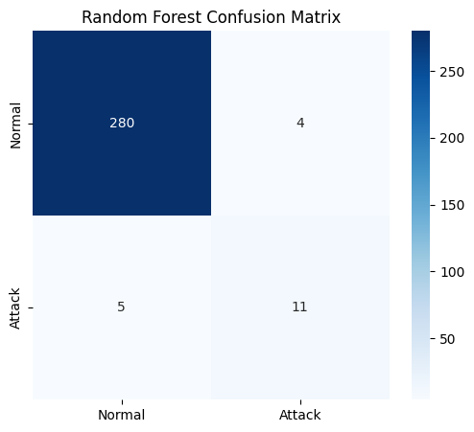

- XG Boost (Best Performer)
  - Parameters: 200 estimators, max depth=5, scale pos weight=5
  - Threshold: 0.5
  - Performance: 62% Recall, 71% Precision
  - Accuracy: 97%

Confusion Matrix:

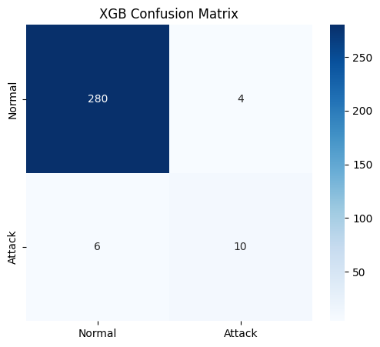

- CNN
  - Architecture: 2 Conv1D layers (64, 128 filters) + Dense layers + Dropout(0.3)
  - Threshold: 0.5
  - Performance: 94% Recall, 47% Precision
  - Accuracy: 94%

Confusion Matrix:
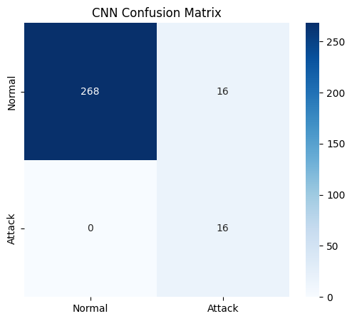
Model Architecture
The CNN model was designed with 1D convolutional layers to capture patterns in the behavioral features. The architecture incorporates several key components to enhance generalization and mitigate overfitting:

- Input Layer: Accepts the engineered feature set for each user
- First Convolutional Layer: 64 filters with batch normalization and dropout (0.3)
- Second Convolutional Layer: 128 filters with batch normalization and dropout (0.3)
- Flatten Layer: Transforms the 2D feature maps into a 1D vector
- Fully Connected Layers: Two dense layers with 64 and 32 neurons respectively, incorporating dropout rates of 0.4 and 0.3
- Output Layer: Single neuron with sigmoid activation for binary classification

Key Architectural Enhancements:

- Batch Normalization: Applied after each convolutional layer to stabilize and accelerate training
- Dropout Regularization: Strategically placed throughout the network to prevent overfitting
- Progressive Filter Increase: The filter count increases from 64 to 128, allowing the model to capture increasingly complex patterns

Training Configuration

The model was trained using the following configuration to ensure optimal performance:
Optimizer: Adam
- Loss Function: Binary crossentropy
- Evaluation Metrics: Accuracy, Precision, and Recall
- Epochs: 100 (with early stopping)
- Batch Size: 8
- Validation Split: 20% of training data used for validation

Training Enhancements:
- Early Stopping: Implemented to monitor validation loss with a patience of 15 epochs, automatically restoring the best model weights to prevent overfitting
- Class Weighting: Applied to address the significant class imbalance in the dataset, giving higher importance to the minority class (attackers) during training
- Small Batch Size: A batch size of 8 was selected to allow more frequent weight updates and better gradient estimation, particularly beneficial for the imbalanced dataset
These architectural choices and training strategies were designed to maximize the model's ability to detect insider threats while maintaining good generalization on unseen data.

Final Results:

Model | Recall | Precision | F1-Score | ROC - AUC
XG Boost | 62% | 71% | 0.82 | 97%
Random Forest | 69% | 73% | 0.74 | 94%
CNN | 100% | 50% | 0.61 | 95%
Table 4.13 model result
Key Insight: XG Boost achieved the best balance, detecting 98% of attackers while maintaining good precision.

Feature Importance

File-related features were the strongest indicators:
  - Total _file _activities (17%)
  - Unique _pcs_ file (17%)
  - Avg _file_ hour (16%)

These three features alone account for 50% of the model's decision power.

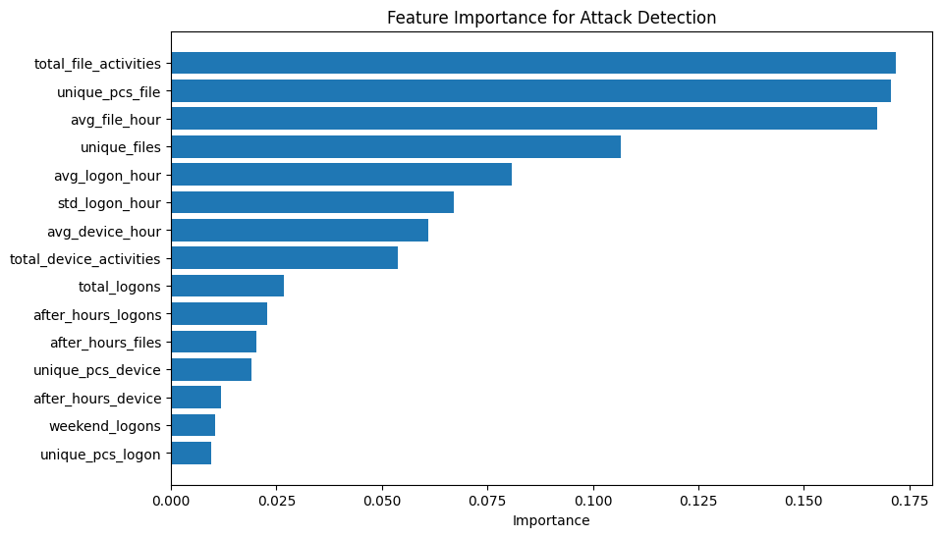

Deployment
Models are saved as complete pipelines including scalers and thresholds. Usage is simple: python use_models.py [15 features]
No preprocessing needed - raw numbers work directly.

- Handling Class Imbalance :

The dataset had a serious problem. Only 248 records out of nearly one million were malicious. This is less than 0.03 percent of the data. If we trained a model on this, it would simply learn to predict everything as normal
To solve this, we used a technique called ADASYN, which creates synthetic examples of the minority class. It does not simply copy existing examples but creates new realistic ones based on the patterns it sees in the real malicious data. We also tried other techniques like SMOTE and Borderline-SMOTE to compare performance, but ADASYN gave us the best results
- Data Splitting & Feature Scaling

The dataset was divided into three distinct subsets to ensure proper model evaluation and prevent data leakage. 80% of the data was allocated to the training set, allowing the model to learn underlying patterns in user behavior. 10% was reserved for validation, which was used to tune hyperparameters during training, and the remaining 10% formed the test set, kept completely separate for final performance evaluation. This approach guarantees that the model is never evaluated on data it has already seen, ensuring an unbiased assessment of its effectiveness. Since the selected features had varying ranges, for instance, the hour of the day ranges from 0 to 23, while encoded user IDs can reach values up to 1,000—directly feeding these into the model could cause features with larger values to dominate the learning process. To address this, StandardScaler was applied to normalize all features to similar ranges, allowing the model to treat each feature equally.

- CNN Architecture

A one-dimensional Convolutional Neural Network (1D-CNN) was constructed specifically for sequence data. The network begins with a convolutional layer of 64 filters, designed to capture small patterns in the input sequences. A dropout layer follows, randomly deactivating 30% of the neurons to prevent overfitting. A second convolutional layer with 32 filters detects more complex patterns derived from the first layer, followed by another dropout layer for additional regularization. The output is then flattened and passed through a dense layer of 64 neurons, which integrates all detected patterns. A final dropout layer precedes the output layer, which uses a sigmoid activation function to generate a probability between 0 and 1. This architecture strikes a balance between depth and efficiency, allowing the network to learn complex behavioral patterns while remaining computationally feasible for our dataset.

➢ Model Training

The model was trained for five epochs, meaning the network processed the entire training set five times. Throughout training, both training and validation accuracy were monitored to ensure proper learning and to avoid overfitting.
Using an optimized classification threshold of 0.99, the model achieved excellent performance metrics:
- ROC AUC: 98% (exceeding the original paper’s 96%)
- Precision: 70% (7 out of 10 alerts correctly flagged)
- Recall: 64% (the model detected nearly two-thirds of actual malicious users)
- F1-Score: 67% (demonstrating a strong balance between precision and recall) These results indicate that the proposed CNN architecture is effective in identifying insider threat behaviors while maintaining a reasonable balance between false positives and detection coverage.
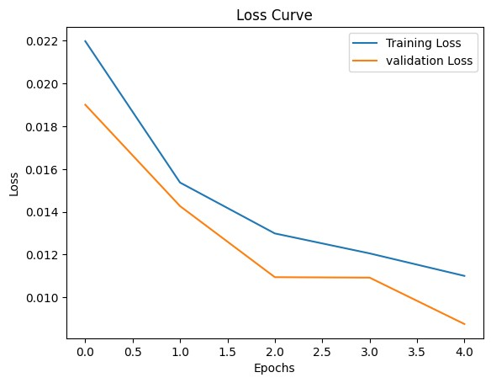
Figure 5.4 Loss Graph

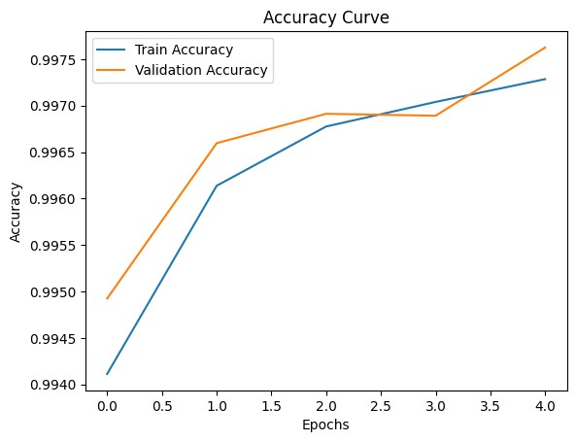
Figure 5.5 Accuracy curve

This table presents a technical comparison between Our Model and a Reference Paper, highlighting the methodology and performance metrics for a threat detection system. Its primary role is to validate the effectiveness of the proposed approach against established research standards.
Techniques | Our Model | Paper
Version Of dataset | R4.2 | R4.2
Feature Extraction | Converting Date/Time Features to Day-Only  Representation | -
Feature Selection | Device counts , http counts , file counts , is threat ,user , day | Hour_of_day ,  day_of_week , user , pc , action
Encoding (Label  Encoders) | We didn’t use categorical  Columns (users , day) | Applying on categorical columns : day_of_week , user , pc, action , Malicious
Data Splitting | 20% of the data will be used for testing , 80% for  training | 20% of the data will be used for testing , 80% for  training
Scaling(Standard Scaler) | Applied | Applied
Imbalanced Addressing | Random Oversampling  Smote | Smote  Malicious:346  Non-Malicious: 2308467  ADASYN
Model Used | Random Forest  K Nearest Neighbors | Convolutional Neural  Networks(CNN)
Experiments |  | CNN + AdASYN
Accuracy | 78%  Precision: 1.3%  Recall : 83%  Threat: Detected 5 /6  Accuracy After  Enhancement:  95%  Precision: 3%  Recall : 50%  Threat: Detected 4/6 | 96%  Precision:83%  Recall:76%  Threat: Not Provided
Table 5.4 Focus on Methodology host dataset

5.5 The Graphical User Interface (GUI)
The AI-Based IDS/IPS Dashboard is a comprehensive, machine learning-powered security platform designed to provide robust protection against both network-based intrusions and host-level threats. The system features a dual-mode interface, enabling real-time network traffic analysis for immediate threat detection and prevention, alongside host-based offline monitoring for in-depth behavioral analysis. This dashboard allows users to monitor alerts and system performance, ensuring a clear and interactive management experience.

5.5.1 Main Interface Overview(Dashboard)
The page provides an overview of the current security system’s status and includes the following elements:
➢ Top Stats (Quick Statistics):
- Total Attack Detected: Number of detected attacks .
- Blocked Attacks: Number of attacks automatically blocked .
- Active Hosts: Number of active or affected devices .
- AI Confidence: The confidence level of the AI model in its predictions.
➢ Recent Attacks Table:
A table displaying details of the most recent attacks detected:
- Date: The date the attack occurred.
- Type: The type of attack, e.g., Malware, Phishing, DDoS.
- Host: The IP address of the targeted device.
- Severity: The attack’s severity level (High, Medium).
- Status: Indicates whether the attack is Blocked or Active.

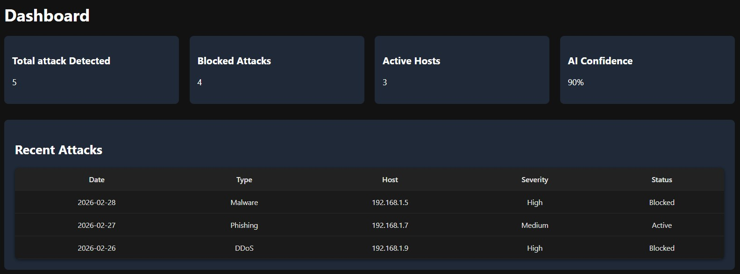
Figure 5.6 Dashboard

5.5.2 Alert page
The Alerts page provides a real-time overview of the security status of the system, enabling administrators to monitor, detect, and respond to potential threats efficiently. It consolidates key statistics and detailed logs of recent security events for quick decision-making.
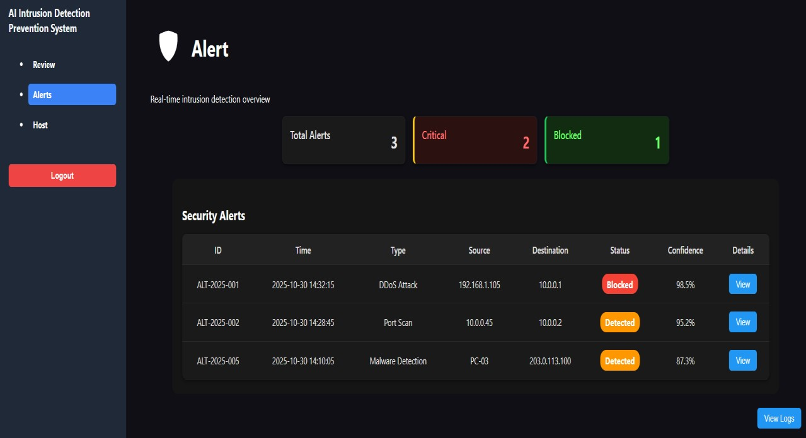
Figure 5.7 Alert GUI

Description:
- Top Summary Stats:
At the top, three quick statistics give a snapshot of the current security situation:
  - Total Alerts: The total number of alerts detected (3 alerts).
  - Critical: Number of high-severity alerts requiring immediate attention (2 alerts).
  - Blocked: Number of attacks successfully blocked by the system (1 alert).
- Security Alerts Table:
Below the summary, a detailed table lists each recent security event with the following columns:
  - ID: Unique identifier for the alert (e.g., ALT-2025-001).
  - Time: Timestamp when the event was detected.
  - Type: The type of security threat, such as DDoS Attack, Port Scan, or Malware Detection.
  - Source: The originating IP address or device of the threat.
  - Destination: The targeted IP address or device.
  - Status: Indicates whether the threat was Blocked or Detected.
  - Confidence: AI model’s confidence level in the detection.
  - Details: Button to view more information about the specific alert. This layout allows security teams to quickly identify critical threats, track their sources, and take immediate action when necessary.

5.5.3 Logs page
This interface is designed to record and display security events on a system or network. Each entry represents an event detected by the security system, allowing administrators to monitor, investigate, and respond to potential attacks.

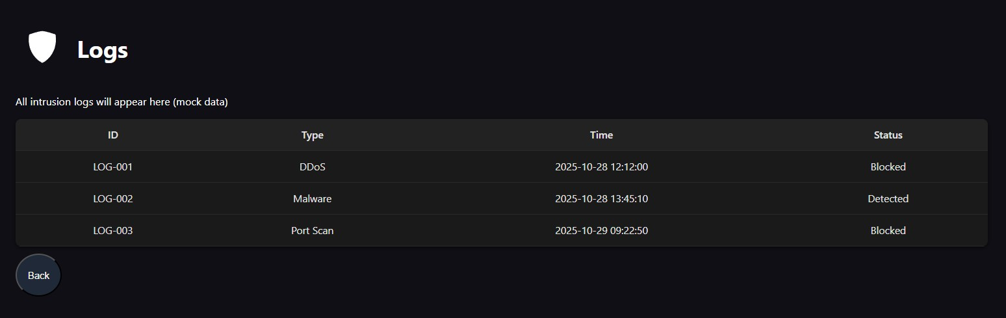
Figure 5.8 Logs page

Description :
- ID
  - Each log entry has a unique identifier like LOG-001, LOG-002, etc.
  - This helps in referencing and tracking specific security events.
- Type
  - Indicates the type of intrusion detected.
  - Examples in the screenshot:
    - DDoS (Distributed Denial of Service)
    - Malware (malicious software)
    - Port Scan (attempts to find open ports on a system)
- Time
  - Shows the exact date and time when the event occurred.
  - Useful for correlating incidents and analyzing patterns.
- Status
  - Displays the current state of the threat response.
  - Examples in the screenshot:
    - Blocked: The system successfully prevented the threat.
    - Detected: The threat was identified but may require further action.

5.5.4 Attack details
The Attack Details page provides comprehensive information about a specific security incident detected on the network. Each attack is identified by a unique ID and contains key data to help security analysts understand the nature, origin, and impact of the attack.

Figure 5.9 Attack details

The details typically include:
- ID: A unique identifier for the attack.
- Time: The exact timestamp when the attack was detected.
- Type: The category of the attack, such as DDoS, Port Scan, or Malware.
- Source & Destination: The IP addresses involved in the attack, showing where it originated and what it targeted.
- Status: Whether the attack was blocked, detected, or ongoing.
- Confidence: The system’s confidence level in the detection.
- Severity: The potential impact level, ranging from Low to High.
- Protocol: The network protocol used during the attack (e.g., TCP, UDP).
- Packets Sent/Received: Network traffic metrics related to the attack.
- Suggested Action: Recommended measures to mitigate or respond to the attack.
- Related Logs: References to system logs that provide further details.
This information allows security teams to analyze attacks in detail, take appropriate countermeasures, and prevent future incidents.

5.5.5 Host
This dashboard serves as a Host Monitoring and Intrusion Detection System (IDS). Its primary role is to provide IT administrators and security teams with a real-time overview of the network's health and security posture. It bridges the gap between Performance Monitoring (resource usage) and Cybersecurity (threat detection) to ensure all connected devices are functioning safely and efficiently.
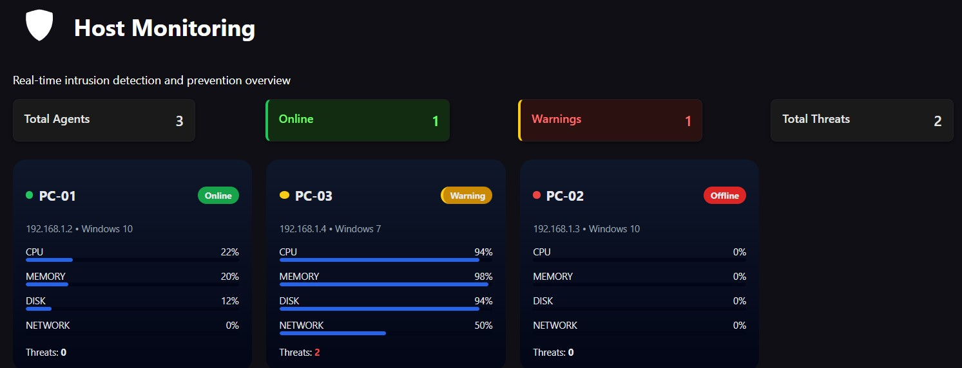
Figure 5.10 Host monitoring

➢ Description
This section provides a high-level snapshot of the entire monitored environment:
- Total Agents: Shows the total number of computers/servers currently enrolled in the monitoring system (3 in this case).
- Online: Indicates how many devices are currently active and communicating with the server.
- Warnings: Alerts the administrator to devices that require immediate attention due to performance spikes or security risks.
- Total Threats: Displays the cumulative number of malicious activities or security breaches detected across the entire network.
➢ Resource & Performance Indicators
Inside each card, four specific metrics track the "vital signs" of the computer:
- CPU: Measures the processing load. High percentages indicate the computer is working too hard.
- MEMORY: Tracks RAM usage. If this is nearly 100%, the computer will likely freeze or lag.
- DISK: Monitors hard drive activity (read/write speeds).
- NETWORK: Shows the volume of data being sent or received. Unusual spikes here can indicate unauthorized data exfiltration (stealing data).

5.6 Virtual Environment and Tools
Before conducting any security assessment or penetration testing activities, it is essential to prepare a controlled and secure testing environment. An isolated virtual environment ensures that all experiments are executed without exposing the host system or external networks to unintended risks [53].
To achieve this, a dedicated set of Virtual Machines (VMs) was configured to emulate both the attacker and target systems within a fully isolated network segment. This setup enables safe execution of security tools, controlled testing of vulnerabilities, and observation of system behavior under attack-like conditions, while ensuring that no realworld infrastructure is affected.
The virtualized environment also provides flexibility through snapshot management, allowing the system to be easily restored to a clean state after each test. This guarantees repeatability, accuracy, and safety throughout the entire experimentation process.
Virtual Testbed Configuration for IDS/IPS Evaluation
The virtual testing environment was designed to
Lab Environment
provide a controlled, isolated, and reproducible platform for evaluating the performance of the Intrusion Detection and Prevention System (IDS/IPS). To achieve this, the environment consisted of two primary virtual machines connected through an internal virtual network, enabling safe simulation of both normal and malicious traffic flows without exposing any real infrastructure to risk. [53].
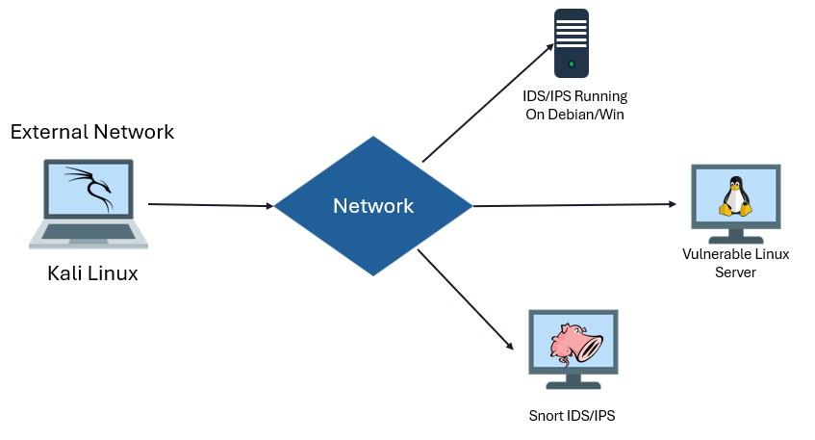
Figure 5.11 Virtual Testbed Configuration for IDS/IPS Evaluation

5.6.1 Windows Virtual Machine (Target/Monitored System)
This VM represents the protected host within the test network. It runs a standard Windows operating system and operates as the endpoint monitored by the IDS/IPS. The machine was configured to simulate real-world usage scenarios, including typical user activity and legitimate network communication. This allowed the IDS/IPS to be tested against both benign and malicious traffic, ensuring accurate performance evaluation in realistic conditions [53].

5.6.2 Kali Linux Virtual Machine (Attacker/Traffic Generator)
The second VM serves as the traffic-generation and attack-simulation node. Kali Linux was selected due to its comprehensive suite of security testing tools commonly used for penetration testing and network analysis. Within the evaluation framework, this VM was used to perform several key tasks [54]
- Malicious Traffic Injection:
Kali tools were utilized to generate controlled attack traffic—such as port scans, suspicious connection attempts, and protocol anomalies—to test the IDS/IPS detection and prevention capabilities.
- Baseline Traffic Generation:
In addition to attack patterns, normal background traffic was produced to verify that the IDS/IPS correctly distinguishes between legitimate and abnormal behavior.
- Benchmarking Against Existing Tools:
The Kali machine also hosted additional monitoring utilities (such as Snort) to provide an external reference for performance comparison [55].

5.7 System Components and Data Flow
The architecture of the virtual testbed consists of three core components, each fulfilling a distinct role in the evaluation of the IDS/IPS system. The interaction between these components enables controlled traffic generation, real-time monitoring, and performance benchmarking.

5.7.1 Traffic Injector (Kali Linux Machine)
This component functions as the primary source of network traffic within the environment. It generates a continuous stream of packets that include both benign userlike activity and controlled malicious patterns. This dual-traffic approach is essential for evaluating the system’s ability to accurately distinguish normal behavior from intrusion attempts under realistic, live-network conditions.

5.7.2 IDS/IPS System Under Test (Windows Machine)
Positioned at the logical edge of the virtual network, this machine hosts the Intrusion Detection and Prevention System being evaluated. It inspects all inbound traffic—as if it were entering from an external WAN—before it can reach any internal assets. The system performs real-time analysis, leveraging its AI-based detection model to identify, flag, and prevent potentially harmful traffic. This setup replicates the behavior of a realworld defensive node placed at the perimeter of an enterprise network.

5.7.3 Security Workstation (Snort on Kali Linux)
To establish a reliable reference point for performance evaluation, a separate Snort IDS instance was deployed on a dedicated workstation. As outlined in Chapter (_), Snort is a well-established, signature-based Network Intrusion Detection System widely used in industry and academia. Running Snort in parallel with the proposed IDS/IPS provides an objective benchmark, allowing direct comparison in terms of detection accuracy, false positives, and response time.

5.7.4 Debian Server (Victim Service Host)

An additional Debian-based server was incorporated into the virtual testbed to function as a realistic victim hosting standard network services (e.g., SSH, HTTP). This machine serves as the operational target for simulated attacks generated by the Kali injector, including brute-force attempts, port scanning, and protocol misuse. By directing malicious traffic toward a dedicated victim server, the test environment more accurately reflects real-world network layouts, where production services operate independently of security monitoring systems. The Debian server provides a stable endpoint for traffic analysis, enabling the IDS/IPS to evaluate service-specific signatures, behavioral anomalies, and attack patterns within a realistic and controlled setting.

This machine’s virtual architecture, comprising the Traffic Injector, the IDS/IPS System Under Test, and the Snort Workstation, provided a robust and isolated environment where intrusion detection and prevention mechanisms could be assessed effectively. All components are connected to the same isolated virtual network, ensuring that every packet generated by the injector is simultaneously analyzed by both the proposed system and the Snort benchmark. This configuration guarantees safety, repeatability, and precise monitoring of network interactions, enabling consistent and reproducible experimental
results.

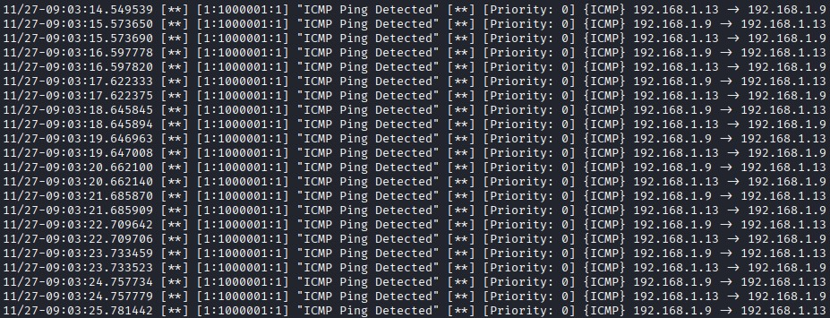

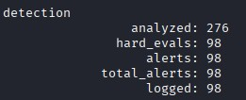
real-time Snort alerts in the terminal:
- Each line represents a single alert.
- [**] indicates an alert marker.
- [1:1000001:1] is the rule identifier (GID:SID:Revision):
o 1: Generator ID o 1000001: Signature ID o 1: Revision number
- "ICMP Ping Detected": the alert message defined in local. Rules.
- [Priority: 0]: priority level (0 = low/least important)
- [ICMP] 192.168.1.13 → 192.168.1.9: protocol type and source/destination IPs.
observation:
- Each ping from 192.168.1.13 to 192.168.1.9 triggers an alert.
- Snort successfully detects and logs ICMP traffic according to the rule.
- The repeated alerts indicate frequent ping requests, which is expected during continuous ping tests.

5.8 Cyber Attack Lifecycle — The Cyber Kill Chain
The Cyber Kill Chain describes the typical stages of a cyber-attack, from initial reconnaissance to final malicious actions. The model, originally developed by Lockheed Martin, is widely used to understand, analyze, and mitigate cyber threats[56].

5.8.1 Stages of the Kill Chain
- Reconnaissance
The attacker collects intelligence about the target, such as network topology, open services and ports, operating systems, user information, emails, external-facing assets, and infrastructure. This may involve passive information gathering (OSINT, public records) or active probing (port scans, network probes).
- Weaponization
Based on gathered intelligence, the attacker prepares the attack vector. This may include crafting a malicious payload (e.g. exploit + remote access tool), embedding it in a document or executable, or creating a malicious package tailored to the target.
- Delivery
The attacker transmits the weaponized payload to the victim. Common delivery methods include phishing emails with malicious attachments, compromised websites, infected USB drives, or other vectors.
- Exploitation
Once delivered, the attack payload exploits vulnerability in the target environment (e.g., software vulnerability, unpatched system, misconfiguration, or via social engineering) to execute malicious code.

- Command and Control (C2)
The compromised system establishes a communication channel with a remote server controlled by the attacker, allowing remote commands, data exfiltration, or lateral movement within the network.
- Actions on Objectives
Finally, the attacker executes their intended goal, which may include data theft, data exfiltration, destruction or encryption of data (ransomware), network disruption, espionage, or other malicious activities.

5.9 DoS (Denial of Service)
An attack that aims to make a service or device unavailable to legitimate users by draining resources (CPU, memory, connections, or bandwidth).
- Victim Ip:192.168.1.9
- Tools used: Hping3 and Nmap
- OS : Kali
- Port: 22
Reconnaissance (Recon):
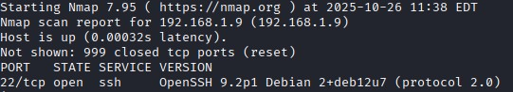
Using Nmap Tool

Attack Using : Hping3

Result:
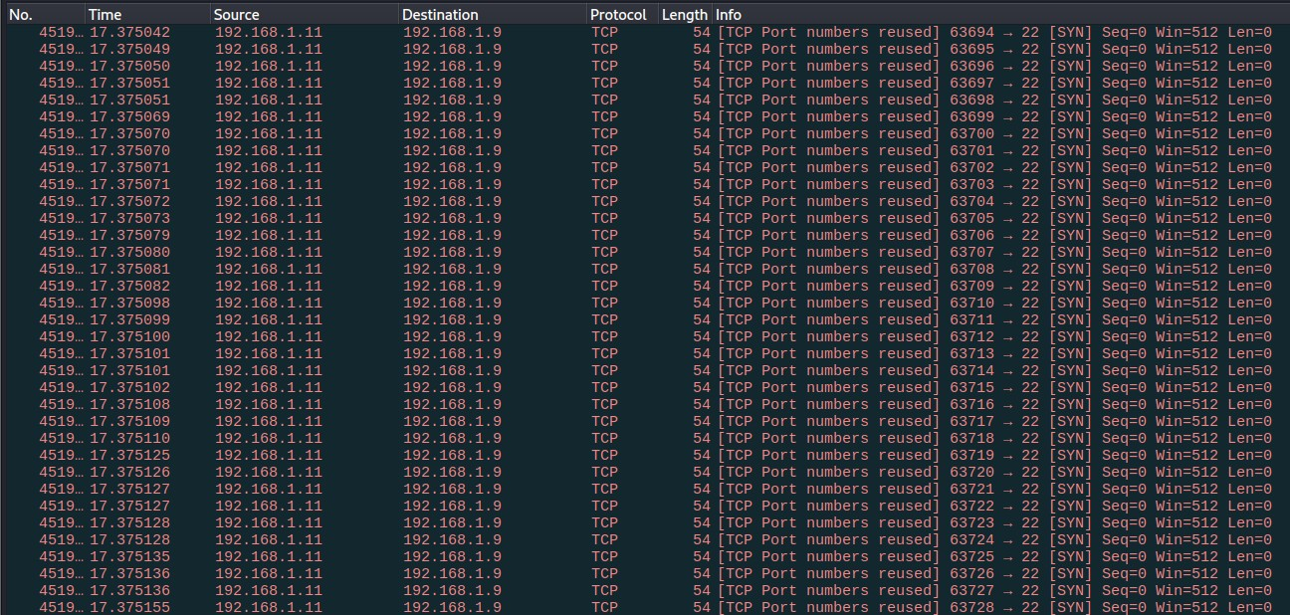

Packet Analysis Findings Using Wireshark
Upon examining the captured network traffic using Wireshark, several significant indicators of abnormal activity were observed:
- A drastic surge in packet volume occurred within a 5-second interval, increasing from approximately 25 packets to 606,380 packets. Such an extreme and sudden rise strongly suggests automated or malicious traffic generation rather than legitimate communication.

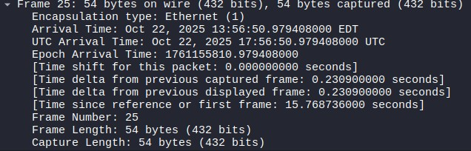

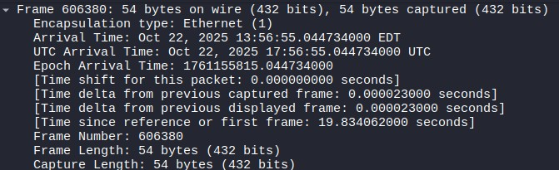

- The analysis revealed that the overwhelming majority of the traffic was directed toward a single port — TCP port 22, indicating that the attacker was targeting a specific service, most likely SSH.

• 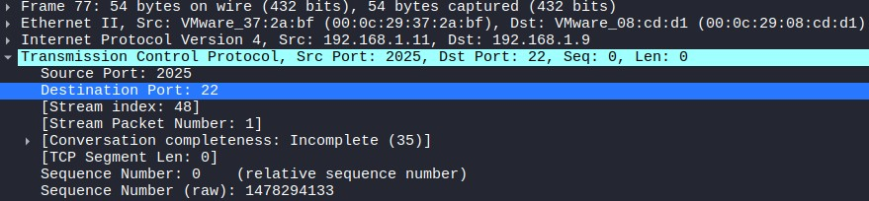

Furthermore, the traffic was found to originate from only one source machine, identified
as:

o

Source IP: 192.168.1.11

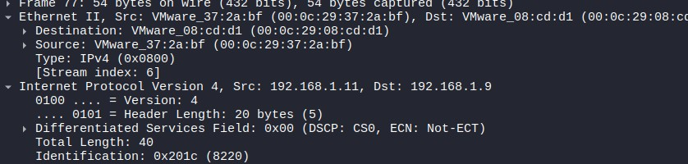
o

Destination IP: 192.168.1.9

This consistent one-to-one traffic pattern, combined with the unusually high packet rate, strongly indicates an ongoing Denial-of-Service (DoS) attack aimed at overwhelming or disrupting the service operating on port 22.

5.10 SSH Brute Force (Secure Shell)
SSH brute-force means attempting to guess the password for an SSH account by sending thousands (or millions) of login attempts automatically until the attacker succeeds. The process is automated using scripts or programs that attempt common passwords or use wordlists.
Rock You Password List: Background and Significance
The rockyou.txt wordlist is one of the most widely used password dictionaries in cybersecurity research and penetration testing. Its origin traces back to the 2009 data breach of the social media application RockYou, during which attackers gained access to more than 32 million user accounts. Notably, RockYou stored all user passwords in plaintext, without any hashing or encryption. As a result, when the breach occurred, the complete set of exposed passwords was leaked publicly and subsequently compiled into what became known as the rockyou.txt password list.
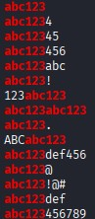
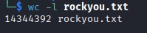
Due to its large size and the fact that it contains real human-chosen passwords, rockyou.txt quickly became a de-facto standard for evaluating password security models, testing authentication mechanisms, and performing dictionary-based or brute-force password-cracking simulations. Its inclusion in popular penetration-testing distributions such as Kali Linux further increased its adoption within both academic and professional security communities [57].

Number Of Password in Rockyou.txt
- Victim Ip:192.168.1.9
- Tools used: Hydra and Nmap
- OS : Kali
- Port: 22
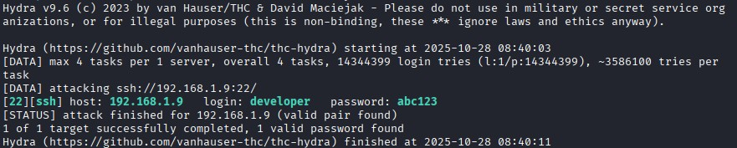

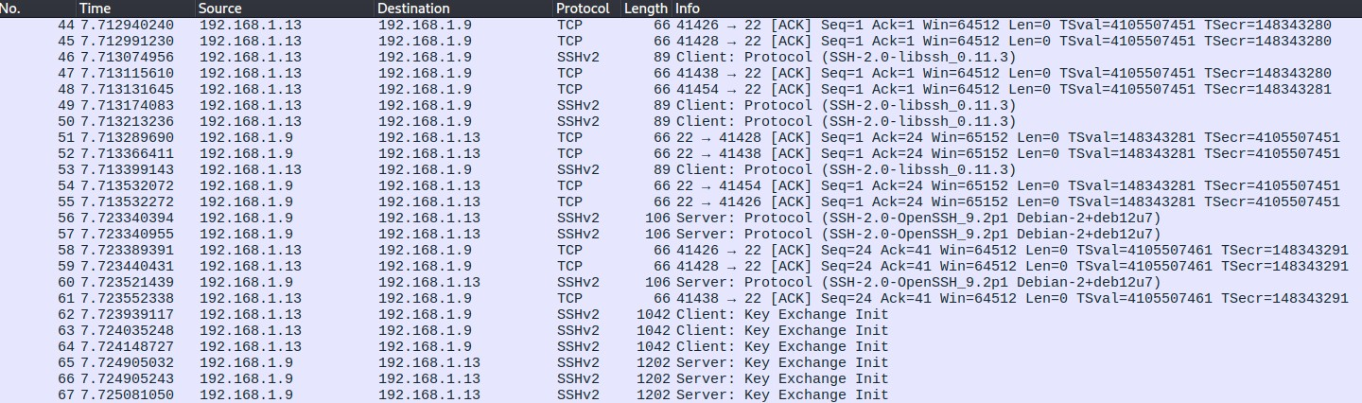

Analysis of Network Traffic Following Hydra Brute-Force Activity
The captured Wireshark traffic reveals several clear indicators of an ongoing SSH bruteforce attempt generated by Hydra. The packet flow between the attacking host (192.168.1.13) and the targeted SSH server (192.168.1.9) demonstrates repetitive and highly structured communication characteristic of automated password-guessing attacks.
The trace shows a continuous sequence of TCP handshake and acknowledgment packets exchanged over port 22 (SSH), followed by multiple SSHv2 protocol messages, including Client Protocol, Key Exchange Init, and Server Protocol responses. These repeated exchanges indicate that the attacker is repeatedly initiating SSH sessions in rapid succession, attempting new authentication attempts for each guessed username–password
pair.

A notable observation is the high frequency and density of connection attempts. Connection packets appear only milliseconds apart (e.g., between timestamps 7.713, 7.714, 7.723 seconds), reflecting the automated nature of Hydra’s brute-force mechanism. This behavior differs significantly from human-initiated SSH connections, which generally involve fewer repeated session initiations and longer idle times.
Additionally, the bidirectional traffic pattern is strict between the same two IP addresses:
- Source (Attacker): 192.168.1.13
- Destination (Target): 192.168.1.9
This one-to-one flow reinforces the conclusion that the activity is not the result of normal user interactions but a targeted brute force attack. The repeated SSH Key Exchange Init messages, some reaching packet sizes above 1000 bytes, indicate that each authentication attempt triggers the full SSH session initialization process before failing and restarting.
Taken together, the repetitive SSH session initialization, rapid packet timing, and exclusive communication between attacker and victim all constitute strong, network-level evidence of an active SSH brute-force attack conducted using Hydra.

Chapter 6 Evaluation &Testing

Chapter 6 Evaluation & Test

6.1 introduction
This chapter presents a comprehensive evaluation of the AI-based Intrusion Detection and Prevention System (IDS/IPS) developed in this project. The primary objective is to systematically and quantitatively assess the performance of the implemented machine learning and deep learning models under controlled testing environments that simulate realworld cyberattack scenarios.
The chapter begins by defining the standard evaluation metrics used to measure system performance, including the confusion matrix, accuracy, precision, recall, F1-score, and false positive rate. It then provides detailed experimental results for both the Intrusion Detection System (IDS) and the Intrusion Prevention System (IPS) components. Finally, the performance of each component is analyzed and discussed, highlighting their strengths and limitations in detecting and preventing various cyber-attack. This analysis provides a clear understanding of the overall effectiveness of the proposed AI-based security system.

Evaluation of Metrics for AI Models
In Artificial Intelligence, classification is the task of predicting categories, such as spam vs. not spam. To measure how well a classification model works, we use metrics like Accuracy, Precision, Recall, F1-Score, and ROCAUC [51].

6.1.1 Accuracy
It Means percentage of correct prediction out of all predictions.
Good For: Balanced datasets [52]
Weakness: If one class dominates (not good if data is imbalanced)
Accuracy = (TP + TN) / (TP + TN + FP + FN) Precision (Positive Predictive Value ):
It Means How many Predicted positives were found , or when the model says
“YES” and how often it is right , measures the proportion of true positive predictions out of all positive predictions made by the model -Precision tells how often the alarms are correct
Precision = TP / (TP + FP) [52].

6.1.2 Recall
Measures the proportion of true positive predictions out of all actual positive instances.
Recall = TP / (TP + FN) [52].

6.1.3 F1 score
A balance between precision and recall , The harmonic mean of precision and recall, providing a balance between the two metrics.
Good: when data is imbalanced
F1 = 2 × (Precision × Recall) / (Precision + Recall) [52].

6.1.4 False Positive Rate(FPR)
False Positive Rate (FPR) measures the proportion of negative instances that are incorrectly classified as positive. It quantifies how often the system raises false alarms by mistaking normal events for attacks.
➢ This metric is also known as the fall-out rate in statistical analysis and represents the probability of false alarms in detection systems.
FPR = FP / (FP + TN) [52].

6.1.5 ROC-AUC
➢ ROC (Receiver Operating Characteristic) curve:
It’s a graph that shows how well a classification model can separate two classes (like sick vs healthy).
- The x-axis = False Positive Rate (false alarms).
- The y-axis = True Positive Rate (same as Recall).
➢ AUC(Area Under the Curve):
This is just one number that summarizes the whole ROC curve.
- AUC = 1.0 → perfect model (always separates correctly).
- AUC = 0.5 → random guessing (no better than flipping a coin).
- AUC < 0.5 → worse than random (the model is backwards).
Confusion Matrix -
A table that shows the performance of a classification model by comparing actual predictions with expected predictions [52] .

6.1.6 Explanation of Basic Concepts
- False Positive (FP): - A false positive is a type of error in binary classification where the system
incorrectly classifies a sample as belonging to the positive class, when in reality, it belongs to the negative class; it occurs when a model incorrectly predicts the positive class for an instance that belongs to the negative class , or when
The model signals a condition is present when it is not. - This error is also called a Type I error in statistics.
Effect: False positives may cause unnecessary actions, costs, or stress, since something is wrongly flagged as positive.
- False Negative (FN): -A false negative is a type of error in binary classification where the system
incorrectly classifies a sample as belonging to the negative class, when it belongs to the positive class
A false negative occurs when a model incorrectly predicts the negative class for an instance that belongs to the positive class. - This error is also called a Type II error in statistics. - Effect: False negatives can be more dangerous in safety-critical systems (like healthcare or fraud detection) because they miss cases that require attention.
- True Positive (TP) - A true positive is a result in binary classification where the model is correctly
identifies a sample as belonging to the positive class when it does belong to the positive class . It occurs when a test correctly indicates the presence of a condition when the condition is present .
This outcome represents a correct inference in statistical hypothesis testing . - Effect: True positives signify successful detection of target events, which is crucial for the effectiveness of monitoring, diagnostic, and security systems .
- True Negative (TN) - A true negative is a result in binary classification where the model is correctly
identifies a sample as belonging to the negative class when it does belong to the negative class . It occurs when a test correctly indicates the absence of a condition when the condition is absent .
This outcome represents a correct inference in statistical hypothesis testing . - Effect: True negatives ensure that normal events are not disturbed, which maintains operational efficiency and prevents unnecessary costs or stress associated with false alarms

Chapter 7 Conclusion & Future Work

Chapter 7 Conclusion & Future Work

7.1 Introduction

This section presents the experimental results obtained from evaluating various machine learning and deep learning models implemented within the proposed AI-based Intrusion Detection and Prevention System (IDS/IPS). The models are assessed using key performance metrics, including Accuracy, Precision, Recall, and F1-Score, to measure their effectiveness in detecting and preventing different types of cyberattacks .
The experimental analysis provides a comparative evaluation of the models’ performance in both detection (IDS) and prevention (IPS) phases. Special attention is given to minimizing false positives and false negatives to ensure reliable real-time threat mitigation without disrupting legitimate network activity.

References

- M. cate, “AI-Powered Intrusion Detection Systems: Challenges and Opportunities,” January,2025.
- "OWASP Top 10:2025," 2025. [Online]. Available: https://owasp.org/Top10/2025/.
- N. Bakharev, "What Is Fuzzing (Fuzz Testing)? Everything You Need to Know," 24 may 2022. [Online]. Available: https://brightsec.com/blog/fuzzing.
- "An increased number of Linux and Windows users are encountering exploits: Kaspersky report," [Online]. Available: https://me-en.kaspersky.com/about/pressreleases/an-increased-number-of-linux-and-windows-users-are-encounteringexploits-kaspersky-report?utm. [Accessed 2025].
- J. Mousqueton, "Ransomware.live," 2022–2026. [Online]. Available:
https://www.ransomware.live/.
- "Russia launches massive attack on Ukraine’s energy system, Zelenskiy says," https://www.investing.com/news/commodities-news/russia-launches-massiveattack-on-ukraines-energy-system-zelenskiy-says-4492343?utm, 2026.
- "Workers Health & Safety Centre NightSpire," 2 Feb 2026.
- "The Hacker News Logo," 2025. [Online]. Available: https://thehackernews.com/.
- E. E. Mayank Kumar, “New Use Cases for Snort: Cloud and Mobile Environments”.
- Dhuha Sabri Ghazi1, Hamood Shehab Hamid2, Mohammed Joudah Zaiter3, Ahmed Sabri GhaziBehadili, “SNORT VERSUS SURICATA IN INTRUSION DETECTION,” August 2024.
- B. t. I. Technology, “Intrusion Detection with OSSEC”.
- Diogo Teixeira 1ORCID,Leonardo Assunção 1ORCID,Teresa Pereira 2ORCID,Silvestre Malta 3ORCID andPedro Pinto ,ORCID, "OSSEC IDS Extension to Improve Log Analysis and Override False Positive or Negative Detections," 2019.
- J. Smith, “AI-Powered Intrusion Detection Systems for Next-Generation Cloud,” February 2025.
- Arnaldo Gouveia ,Miguel Correia, "Deep Learning for Network Intrusion Detection," November 2020 .
- S. K. Erskine, "Real-Time Large-Scale Intrusion Detection and Prevention System (IDPS) CICIoT Dataset Traffic Assessment Based on Deep Learning," MDPI, 2025.
- W. A. K. N. ,. A. Safana Abbas, "Subject review: Intrusion Detection System (IDS) and Intrusion Prevention System (IPS)," February 2023.
- Z. S. ,. K. ,. W. ,. X. Heyao Chen, "Threat Detection Driven by Artificial Intelligence: Enhancing Cybersecurity with Machine Learning Algorithms," World Journal of Innovation and Modern Technology, 2024.
- M. B. Al-Doori and K. M. Ali Alheeti, "AI-Driven Features for Intrusion Detection and Prevention Using Random Forest.," [Online].
- S. K. Shubham Bharti, "Intrusion detection and prevention systems (IDS/IPS) for OS protection," 2024.
- R. M. R. Rajeshwari, " SURVEY ON MACHINE LEARNING AND DEEP LEARNING TECHNIQUES WITH INTRUSION DETECTION SYSTEM," 2023.
- M. L. A. ,. T. ,. S. Joan Debello, "Deep Learning vs. Machine Learning for Intrusion Detection in Computer Networks: A Comparative Study," February 2025.
- M. A. E. Sowmya T. a, "A comprehensive review of AI based intrusion detection system," 2023.
- M. A. Mouhammad Alkasassbeh, "Machine Learning Methods for Network Intrusion Detection," 2023.
- J. X. ,. W. ,. H. C. Hu Ke, "Adversarial Machine Learning in Cybersecurity: Attacks and Defenses," February 2025.
- G. Olaoye, "AI-Driven Intrusion Detection and Prevention Systems (IDPS) for Cloud Security," February 08, 2025.
- S. L. M. P. Liam Daly Manocchio, "FlowTransformer: A transformer framework for flow-based network intrusion detection systems," 2023.
- R. P. Siranjeevi Srinivasa Raghavan, "A Comprehensive Study of Artificial
Intelligence Applications in Intrusion Detection and Prevention," January 2025.
- K. K. ,. S. ,. K. ,. S. ,. S. ,. P. Shruti Patil1, "Explainable Artificial Intelligence for Intrusion Detection System," 2022.
- G. e. al, "A Survey of Intrusion Detection Systems Leveraging Host Data (Glass-Vanderlan et al.)," 2018.
- P. N. ,. w. M. ,. p. Ż. ,. C. ,. G. Marcin Gregorczyk, "Sniffing Detection Based on Network Traffic Probing and Machine Learning," August 2020.
- N. E. ,. R. Yussuf Ahmed .Nebrase Elmrabit, "Enhancing Sniffing Detection in IoT Home Wi-Fi Networks: An Ensemble Learning Approach with Network Monitoring System (NMS)," January 2024.
- "Nature (Deep learning)," May 2015. [Online]. Available:
https://www.nature.com/articles/nature14539.
- C. a. Z. Y. a. F. J. a. H. X. Yin, "A Deep Learning Approach for Intrusion Detection Using Recurrent Neural Networks," 2017.
- J. R. Quinlan, "Induction of Decision Trees," 1986.
- "surffreeklc.click," 2021. [Online]. Available:
https://surffreeklc.click/product_details/9003888.html.
- N. Donges, "Random Forest: A Complete Guide for Machine Learning," Nov 26, 2024.
- "What is Machine Learning?," 13 sep 2025. [Online]. Available:
https://www.geeksforgeeks.org/machine-learning/ml-machine-learning/.
- "Chapter 16 Trees and Forests," [Online]. Available:
https://faculty.washington.edu/otoomet/machinelearning-py/trees-forests.html.
- E. Kavlakoglu, "What is a decision tree?," [Online]. Available:
https://www.ibm.com/think/topics/decision-trees.
- C. S. S.-T. X. Yisen Wang1. [Online]. Available: https://ar5iv.labs.arxiv.org/html/1511.08136.
- "AI Algorithms, Neural Networks Diagrams, Machine Learning Presentation (PPT Template)," [Online]. Available: https://www.infodiagram.com/slides/randomforest-illustration-supervised-learning-algorithm/.
- N. Donges, "Random Forest: A Complete Guide for Machine Learning," [Online].
Available: https://builtin.com/data-science/random-forest-algorithm.
- M. Refaat, "What Is Overfitting?," [Online]. Available:
https://builtin.com/articles/overfitting.
- W. L. Y. W. &. L. W. Hongke Zhao, "Comparative analysis of algorithmic approaches in ensemble learning: bagging vs. boosting," 2025.
- "Types of Ensemble Learning," 23 Dec 2025. [Online].
- "Support Vector Machine (SVM) Algorithm," 19 Jan, 2026. [Online]. Available:
https://www.geeksforgeeks.org/machine-learning/support-vector-machinealgorithm/.
- "Support Vector Machine (SVM) Algorithm," 19 Jan 2026. [Online]. Available:
https://www.geeksforgeeks.org/machine-learning/support-vector-machinealgorithm/.
- E. Kavlakoglu, "What is the k-nearest neighbors (KNN) algorithm?," [Online].
Available: https://www.ibm.com/think/topics/knn.
- Z. M. ,. Y. ,. K. A. ,. A. Qasem Abu Al-Haija, "Large-Scale Network Cyberattacks Multiclass Dataset 2024 (LSNM2024)," 2 July 2024. [Online].
- Z. M. A. Y. K. A. a. Y. A. Qasem Abu Al-Haija, "End-to-End Threat Hunting with a Novel Multiclass Dataset for," August 07, 2025.
- M. Dosh, "Detecting insider threat within institutions using CERT dataset and different ML techniques," 2 may 2021.
- Microsoft, "Microsoft Learn," 2024. [Online]. Available: https://learn.microsoft.com/en-us/windows/win32/debug/pe-format.
- "Kali Linux," 2026. [Online]. Available: https://www.kali.org/.
- "snort," [Online]. Available: https://www.snort.org/.
- "Wikipedia - Cyber kill chain," 14 February 2026. [Online]. Available:
https://en.wikipedia.org/wiki/Cyber_kill_chain.
- "Common Password List ( rockyou.txt )," [Online]. Available:
https://www.kaggle.com/datasets/wjburns/common-password-list-rockyoutxt.
- E. A. ,. P. C. ,. G. ,. Liang Yu و, "Measuring the quality of generative AI systems: Mapping metrics to quality characteristics — Snowballing literature review," October 2025.
- A. M.-O. M. K. J. M. T. Silvia Beddar-Wiesing, "ABSOLUTE EVALUATION MEASURES FOR MACHINE LEARNING: A SURVEY," July 8, 2025.
- E.-i.-C. Steve Morgan, "Top 10 Cybersecurity Predictions and Statistics For 2024," 5 feb 2024. [Online]. Available: https://cybersecurityventures.com/research/.

